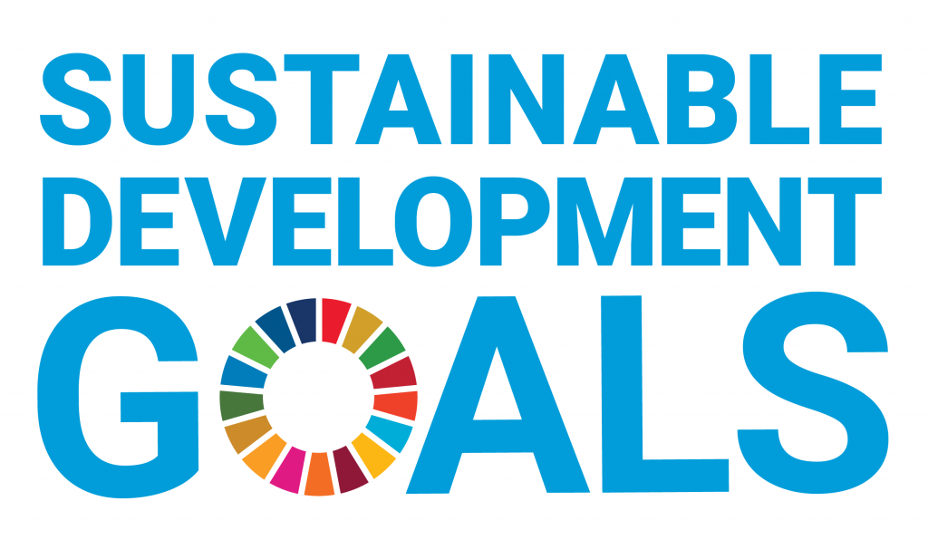
REPORT 2021

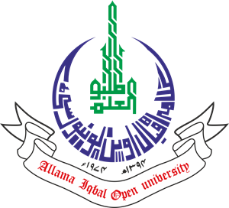

A conceptual report of key facts and figures about the Allama Iqbal Open University’s impact upon and progress towards the UN Sustainable Development Goals
October, 2022

Allama Iqbal Open University
Office of Research, Innovation & Commercialization (ORIC)
Block No. 21, Allama Iqbal Open University, Sector H-8, Islamabad, Pakistan
Telephone No. 051-9250096, 051-9057725/7423. Email: oric@aiou.edu.pk

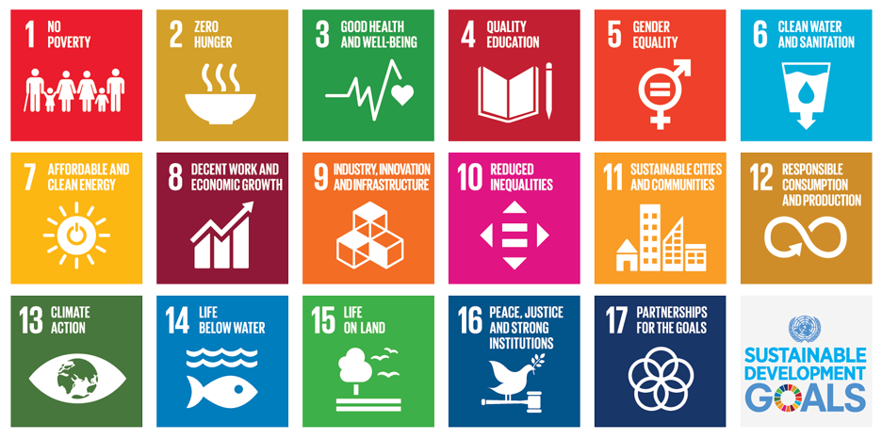
The Allama Iqbal Open University was established in 1974 to provide educational opportunities to the masses and those who cannot leave their homes and jobs. It was the second Open University in the world and the first in Asia and Africa. During all these past years, the University has more than fulfilled this promise and has opened new opportunities for millions, particularly women, and supplemented the efforts of the federal and provincial governments in a big way and that too without becoming a burden on their resources.
At present, the University have four faculties (Faculty of Sciences, Faculty of Social Sciences & Humanities, Faculty of Arabic & Islamic Studies and Faculty of Education) comprised of 35 academic departments with an average student enrolment of more than 1.4 million per year, where more than 50% are females, and more than 2000 courses are being offered. AIOU has a network of 54 regional offices/campuses throughout Pakistan. More than 70 percent of its students are employed.
AIOU Started its LMS network even before Covid-19 and has the biggest network named Agahi for online tutorship. Agahi has a complete image of students’ tutorial record and alternative relevant info as well as their profile. AIOU has well established Institute of Educational Technology (IET) having in-house facilities to produce TV, Radio and non-broadcast programmes. AIOU is also a member of the “PTV Tele-school” production team which is a dedicated channel for tele education. The University has its own printing press named Print Production Unit producing lacs of course books and billions of pages of other supplementary materials and admission forms etc. AIOU has strong collaborative networks with national and international universities and other organizations.
About this report: This document is a conceptual report of the Allama Iqbal Open University’s impact upon and progress towards the United Nations Sustainable Development Goals. The data and narrative in this report are factually based on the available data from areas spanning research impact, education, responsible operations, and public engagement. Allama Iqbal Open University is a world-leading distance learning institution and understands its role in tackling the SDGs.

TABLE OF CONTENTS

Introduction: Sustainable Development Goals at AIOU ------------------------------------------------xx
Sustainable Development Goal 1 – NO POVERTY------------------------------------------------------1
Sustainable Development Goal 2 – ZERO HUNGER ---------------------------------------------------4
Sustainable Development Goal 3 – GOOD HEALTH AND WELL BEING-------------------------6
Sustainable Development Goal 4 – QUALITY EDUCATION------------------------------------------9
Sustainable Development Goal 5 – GENDER EQUALITY--------------------------------------------12
Sustainable Development Goal 6 - CLEAN WATER AND SANITATION--------------------------15
Sustainable Development Goal 7 – AFFORDABLE AND CLEAN ENERGY ---------------------16
Sustainable Development Goal 8 – DECENT WORK AND ECONOMIC GROWTH -----------18
Sustainable Development Goal 9 – INDUSTRY, INNOVATION AND INFRASTRUCTURE--20
Sustainable Development Goal 10 – REDUCED INEQUALITIES ----------------------------------22
Sustainable Development Goal 11 – SUSTAINABLE CITIES AND COMMUNITIES-----------24
Sustainable Development Goal 12 – RESPONSIBLE CONSUMPTION AND PRODUCTION-26
Sustainable Development Goal 13 – CLIMATE ACTION-----------------------------------------------27
Sustainable Development Goal 14 – LIFE BELOW WATER ------------------------------------------28
Sustainable Development Goal 15 – LIFE ON LAND ---------------------------------------------------29
Sustainable Development Goal 16 – PEACE, JUSTICE AND STRONG INSTITUTIONS------32
Sustainable Development Goal 17 – PARTNERSHIPS FOR THE GOALS-------------------------34
Appendix: ------------------------------------------------------------------------------------------------------------xx
Methodology and sources ---------------------------------------------------------------------------------------xx
Keywords ------------------------------------------------------------------------------------------------------------xx

INTRODUCTION
The 2030 Agenda for Sustainable Development and the 17 Sustainable Development Goals (SDGs) were adopted by all UN member states in 2015 and set out an ambitious plan for ending poverty, fighting inequality, and building peaceful, just and sustainable societies by 2030. Achieving the SDGs will require the concerted efforts of all members of society. Universities are particularly well-placed to contribute to the creation of a sustainable future through their research and teaching activities. Universities at the forefront of research generate new knowledge and innovations that provide solutions to the interconnected social, economic, and environmental challenges captured in the SDGs. As educators, universities equip students with the knowledge and skills that enable them to contribute to creating a sustainable future.
Being one of the world’s leading research-oriented distance learning institutions and one of the universities to have social responsibility as a core goal in Pakistan, AIOU is playing a leading role in tackling the SDGs in four ways – through research, teaching-learning process, public engagement activities and responsible campus operations.
This report on SDGs by AIOU has introduced several case studies on some of the initiatives that are contributing towards the UN goals. They are inspiring examples of how Allama Iqbal Open University champions education, research and best practice for sustainable development. The University offers a range of degrees and individual initiatives that cover vital issues raised by the SDGs. Conducting cutting-edge and critical research on the SDGs, implementation and effects; employees’ contribution to policy agendas through their work with development agencies and other organizations.
At Allama Iqbal Open University, the role of the university in sustainable development extends beyond its role in research and teaching. AIOU is also contributing to the SDGs through their policies and practice and working hard to ensure continuous improvement and lead by example. Additionally, there are many sustainability-related activities and operations happening across all campuses related to research, innovation, teaching, operations, outreach, and partnership that are identified as being related to SDGs.
AIOU recognizes and embraces its responsibility in the transition to a sustainable future. The University is committed to ensuring that all activities, be it research, teaching, community service or operations, advance to a place that is better for humanity and the planet. In this report, the outline of some of the many activities in the University that contribute to the achievement of the SDGs is placed. Since, it is not possible to capture all the amazing work of our staff and students that occurs across research, teaching, engagement/outreach and operations. However, the selection presented here gives an appreciation of the kinds of activities happening within the University that are setting a path to a more ‘sustainable future for all’.
SDG Report 2020 by Allama Iqbal Open University provides examples of a range of initiatives our people are leading in pursuit of the goals set in the UN agenda 2030.

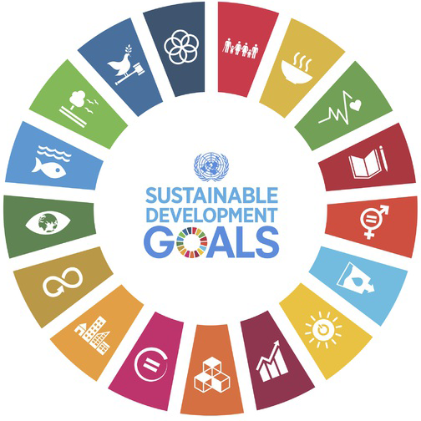

ALLAMA IQBAL OPEN UNIVERSITY, ISLAMABAD PAKISTAN
Office of Research, Innovation & Commercialization (ORIC)

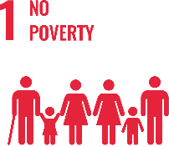
SUSTAINABLE DEVELOPMENT GOAL 1 – NO POVERTY

End poverty in all its forms everywhere

- RESEARCH & INNOVATION
- Allama Iqbal Open University in completely understands the current financial scenario of the motherland and it is thus working with all its attributes to serve the nation and pave the way towards a prosperous future. The university in the context of No Poverty can proudly boast the work of its faculty members as in the last 10 years university has published 156 Research Publications that are relevant to target SDG
- 15 Research grants have been won by the various faculty members that are relevant to target SDG
- TEACHING & STUDENTS
- Various departments of the university are running about 32 courses that are relevant to target SDG
- Link to course inventory http://oric.aiou.edu.pk/?page_id=1748
- Student support schemes/Facilities provided to students relevant to target SDG
- Financial support scheme SSF-101
- Earn to Learn Scheme Ssf-102
- Merit Scholarship Scheme Ssf-103
- Final Year Project Grant Ssf-105
- Scholarship for Communities Scheme Ssf-106
- Matric Free Education Plan (Balochistan,Fata & Gilgit Baltistan)
- OPERATIONS
- The department of Business administration and the department of the commonwealth is eagerly working with all their elements to uphold no poverty through various courses, publications, activities and student internships. Overall, 15 faculty members are currently engaged in the working of this SDG and adding their due share in the betterment of life of people
- The approval and sanction of Disparity Reduction Allowance on 11th June 2021 was a milestone in the improvement of the financial condition of the employees and their families.
- AIOU is the only university of Pakistan which has established its own endowment fund and from the current fiscal year, all payments of pension would be made from its interest.
- The pension check of the Employ is given on the day of retirement.
- PUBLIC ENGAGEMENT
- Webinar on “Innovation & Entrepreneurship” on Wednesday, the 3rd of February 2021
- One Day Interactive Workshop on “Awareness of Opportunities for International Career Paths”- A Initiative for Faculty Development and Students Career Opportunities
- Webinar on “Turning Research into Business” on September 15, 2020
- One-Day Workshop on ‘Startup Entrepreneurship- Owning your Future’ – 5th Dec 2019
- Seminar on “Entrepreneurship” – 12 Sep 2019
- Online Session on “TiE University Program and its Service Offerings” on Tuesday, 1st February, 2022ne-Day Ceremony on “Entrepreneurial and Research Award” on 1st June, 2022
- One Day Webinar on “Entrepreneurial Ideas in Humanities and Social Sciences”, March 10, 2021
- Webinar on “Innovation & Entrepreneurship” on Wednesday, the 3rd February, 2021

- OUTREACH & PARTNERSHIP
- Inclusive Education in Pakistan: Experiences and Lessons Learned from the Engage Project that is Funded by: USAID and was Concluded in 2009-10
- Establishment of National Center of Curriculum Studies and Educational Assessment at AIOU (NCCS&EA): Funded by the Higher Education Commission, Pakistan that was concluded in 2015-16 with a capital cost of Rs. 24.244 mils.
- Girl Power Program (GPP): Funded by PLAN Int that was concluded in 2015-16with a Capital Cost of Rs. 7,36,80916/
- Building Skills for Life (BS4L) (Elementary): Funded by DFID, PLAN Int. for Sajawal/Thatta that was concluded in 2015-16 with a Capital Cost: Rs.2,09,51094/
- Building Skills for Life (BS4L) (Matric): Funded by DFID, PLAN Int. for Sajawal/Thatta that was Concluded in 2016-18 with a Capital Cost: Rs. 75,00000 (approximately)
- Empowering Girls from Marginalized Rural Families for Continuing Education: Funded by UNESCO & PLAN Int. --- Sanjh Preet was Concluded in 2018 with a Capital Cost: of Rs. 38,22,176/
- Content Development and Capacity Building … CA13-100: Funded by Common Wealth of Learning (COL) that was Concluded in 2016-2017 with a Capital Cost: CAD 22704 /
- One Day Interactive Workshop on “Awareness of Opportunities for International Career Paths”- A Initiative for Faculty Development and Students Career Opportunities
- **Skill Development Course in "Hospitality and Customer Care'' **
- AIOU in collaboration with Serena Fort, Shigar, Directorate of Technical Education and Skill Development, GB, and Alight, Pakistan is offering a 5-6 weeks course 'Hospitality and Customer Care' to the youth of Gilgit and Baltistan.

- UNIVERSITY ACTIVITY/NEWS RELATED TO SDG
Laptop Distribution Ceremony for AIOU Students on Dec 26, 2020
https://www.urdupoint.com/en/pakistan/laptop-distribution-ceremony-for-aiou-student-79387.html
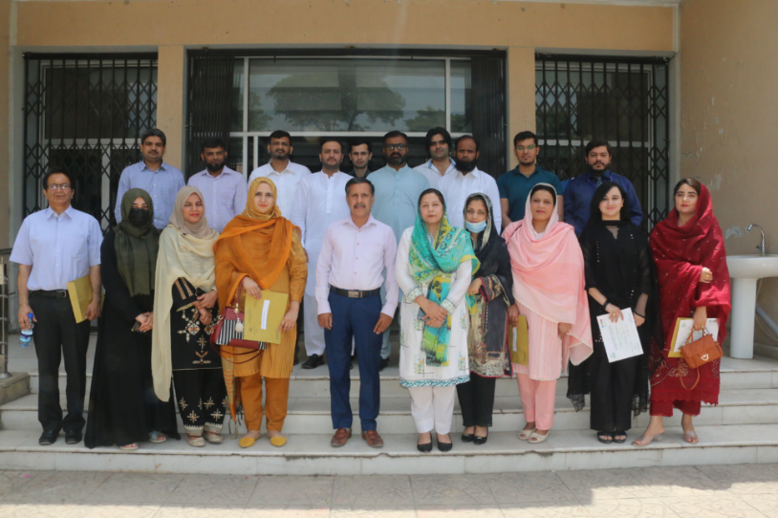
One-Day Ceremony on “Entrepreneurial and Research Award” on 1st June, 2022
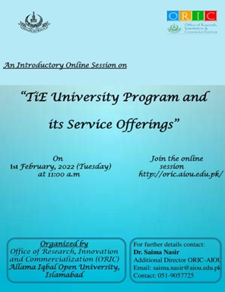
Online Session on “TiE University Program and its Service Offerings” on Tuesday, 1st February, 2022

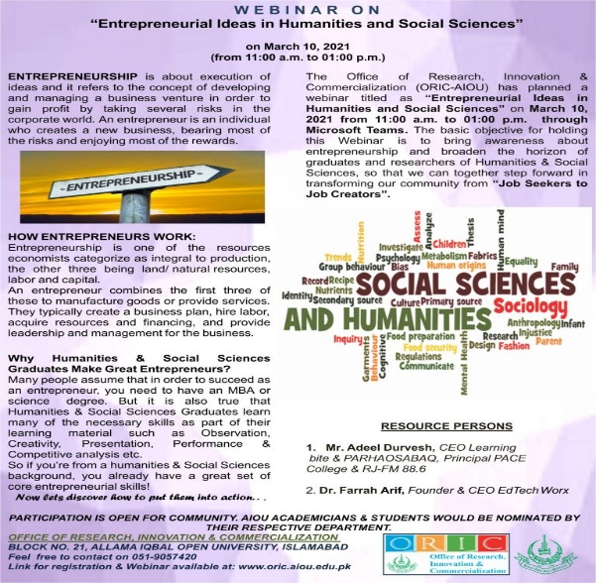
One Day Webinar on “Entrepreneurial Ideas in Humanities and Social Sciences”, March 10, 2021
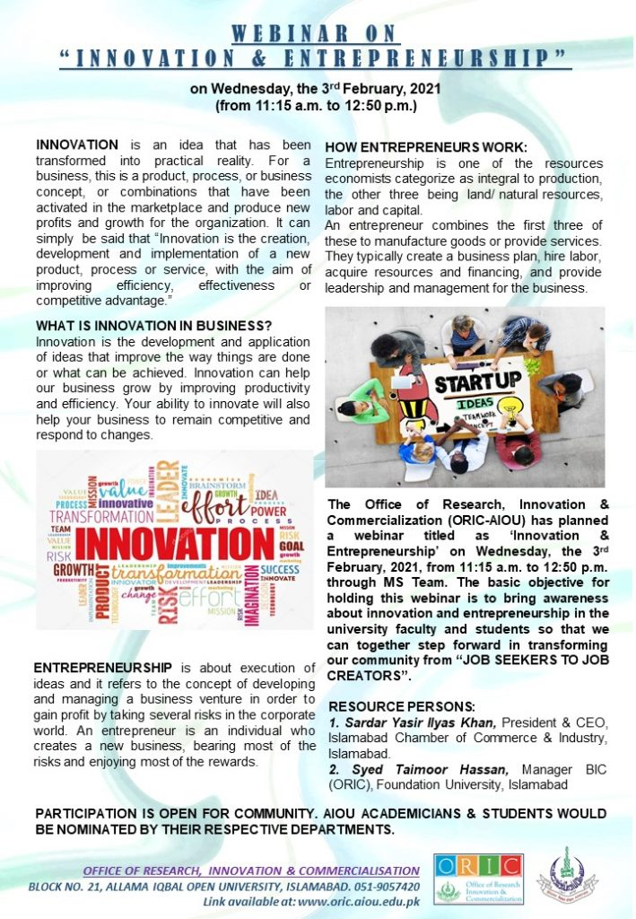
Webinar on “Innovation & Entrepreneurship” on Wednesday, the 3rd February, 2021
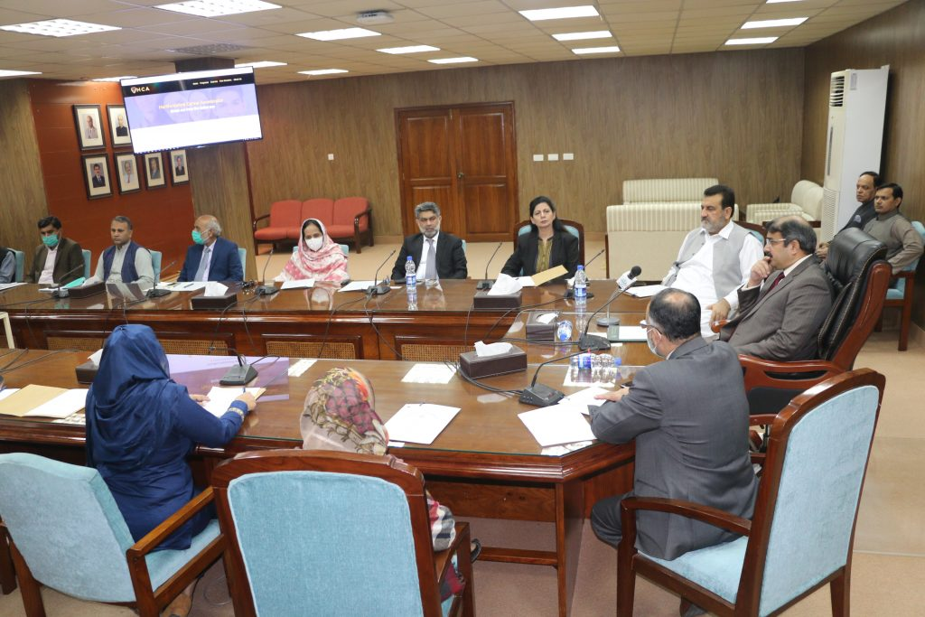
One Day Interactive Workshop on “Awareness of Opportunities for International Career Paths”- A Initiative for Faculty Development and Students Career Opportunities
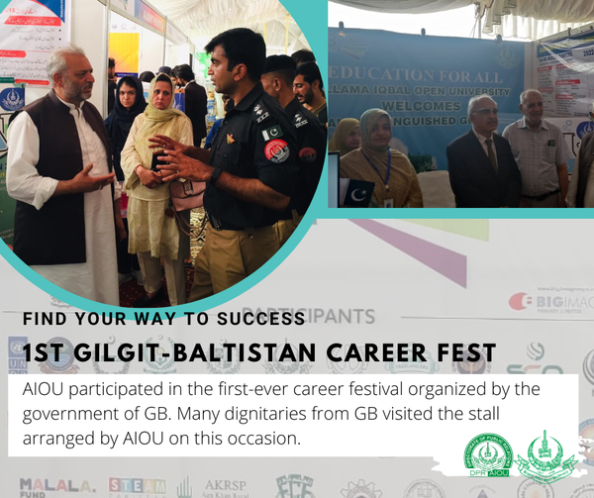
**Skill Development Course in "Hospitality and Customer Care'' **
AIOU in collaboration with Serena Fort, Shigar, Directorate of Technical Education and Skill Development, GB, and Alight, Pakistan is offering a 5-6 weeks course 'Hospitality and Customer Care' to the youth of Gilgit and Baltistan.

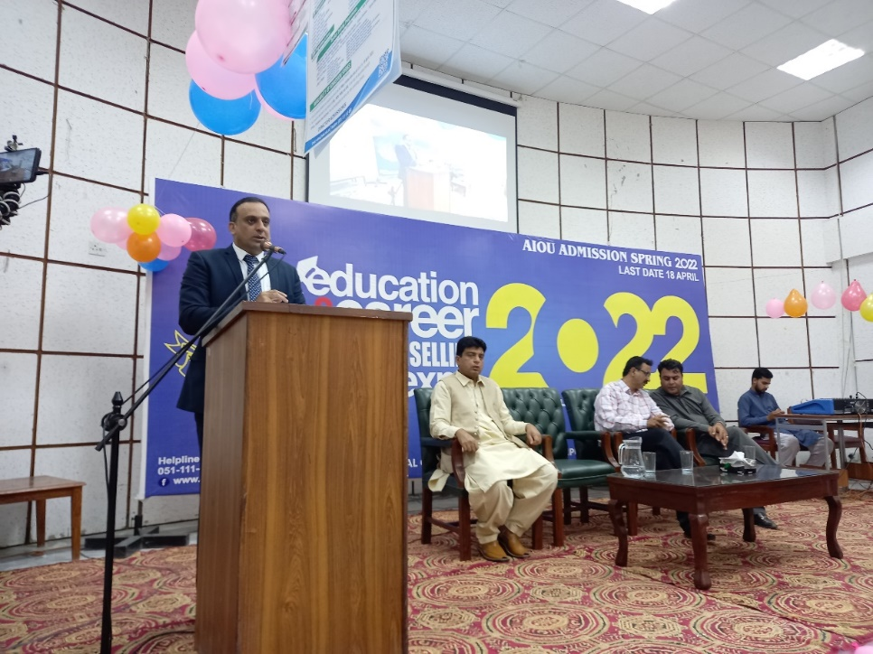
Regional Campaign for Career Counselling
- 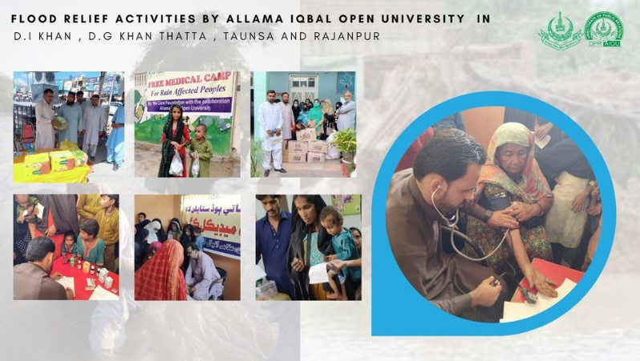
- AIOU Waives Fee For Flood Victims (https://www.urdupoint.com/en/pakistan/aiou-waives-fee-for-flood-victims-1560166.html)
- AIOU Holds RDs Conference For Inclusion Of Out-of-school Children (https://www.urdupoint.com/en/pakistan/aiou-holds-rds-conference-for-inclusion-of-ou-1542190.html)
- Pak army delegation lauds AIOU services for Gwadar
- AIOU Relaunches English Access Microscholarship Program (https://propakistani.pk/2022/04/14/aiou-relaunches-english-access-microscholarship-program/)
- 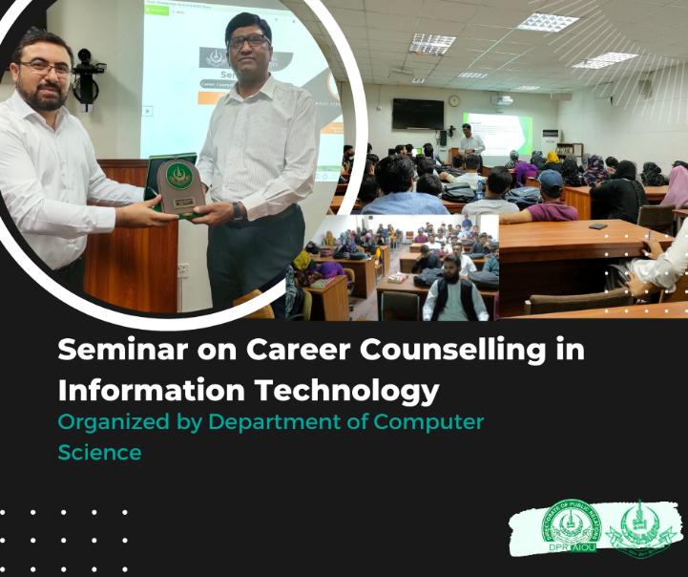
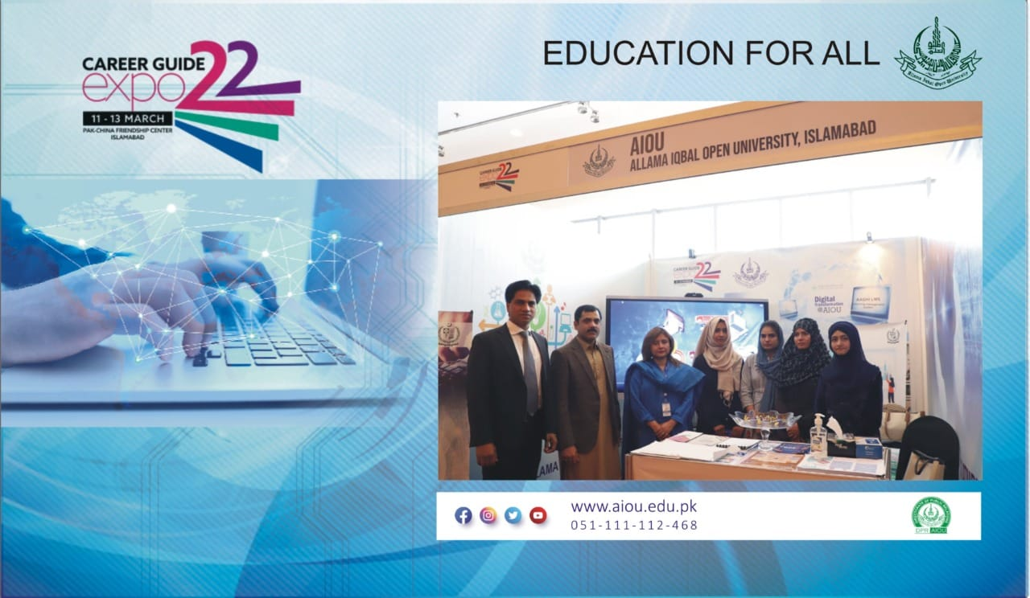
- Free Accessible Lecturers
https://www.youtube.com/watch?v=UhO8XHFUcDg

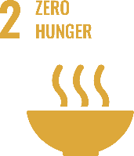
SUSTAINABLE DEVELOPMENT GOAL 2 – ZERO HUNGER

End hunger, achieve food security and improved nutrition and promote sustainable agriculture

- RESEARCH & INNOVATION
- The university can proudly boast the work of its faculty members in the context of Zero Hunger, as in the last 10 years university has published 175 Research Publications that are relevant to target SDG Research Publications relevant to target SDG
- 29 Research grants have been won by the various faculty members that are relevant to target SDG
- TEACHING & STUDENTS
- Number of courses relevant to target SDG 38 and only agricultural sciences is running about 13 relevant courses
- Link to course inventory http://oric.aiou.edu.pk/?page_id=1748
- FINANCIAL SUPPORT SCHEME SSF-101
- EARN TO LEARN SCHEME SSF-102
- MERIT SCHOLARSHIP SCHEME SSF-103
- FINAL YEAR PROJECT GRANT SSF-105
- SCHOLARSHIP FOR COMMUNITIES SCHEME SSF-106
- OPERATIONS
- The department of department of Environmental design and health and nutritional Sciences and Agricultural sciences is eagerly working with all its attributes in the upholding of zero hunger by various courses, publications, activities and student internships. Overall, 16 faculty members are currently engaged in the working of this SDG and adding their due share in the betterment of life of people.
- PUBLIC ENGAGEMENT
- Department of Agricultural Sciences is giving Technical and generating Skills in the Farmers of the Locality.
- Framers Day is organized
- Field Demonstration facilities are given to the farmers
- Webinar on “Innovation & Entrepreneurship” on Wednesday, the 3rd February, 2021
- One Day Interactive Workshop on “Awareness of Opportunities for International Career Paths”- A Initiative for Faculty Development and Students Career Opportunities
- Webinar on “Turning Research into Business” on September 15, 2020
- One Day Workshop on ‘Startup Entrepreneurship- Owning your Future’ – 5th Dec 2019
- Seminar on “Entrepreneurship” – 12 Sep 2019
- OUTREACH & PARTNERSHIP:
- Department of Agriculture Sciences is working with national and international universities PCRWR, NARC, PARC, AARI, Faisalabad, Aurat Foundation, The network of consumer protection, FAO. Asian Disaster Preparedness Center (ADPC) to promote activities related to zero hunger.
- Building Skills for Life (BS4L) (Elementary): Funded by DFID, PLAN Int. for Sajawal/Thatta that was concluded in 2015-16 with a Capital Cost: Rs.2,09,51094/
- Building Skills for Life (BS4L) (Matric): Funded by DFID, PLAN Int. for Sajawal/Thatta that was Concluded in 2016-18 with a Capital Cost: Rs. 75,00000 (approximately)
- Empowering Girls from Marginalized Rural Families for Continuing Education: Funded by UNESCO & PLAN Int. --- Sanjh Preet that was Concluded in: 2018 with a Capital Cost: Rs. 38,22,176/
- Content Development and Capacity Building … CA13-100 : Funded by Common Wealth of Learning (COL) that was Concluded in: 2016-2017 with a Capital Cost: CAD 22704 /
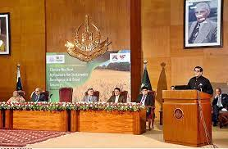
1st International Conference on ”Climate Resilient Agriculture for Sustainable Development & Food Security”
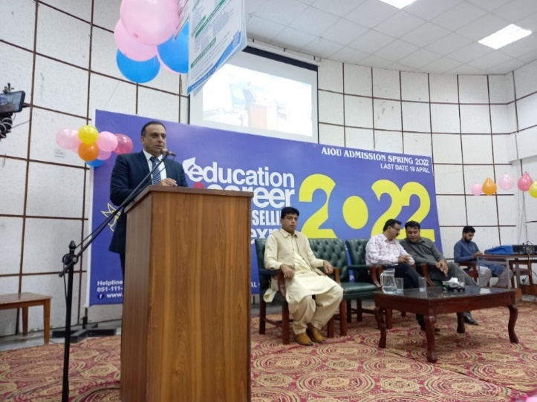

- FREE ACCESSIBLE LECTURERS ON SDG 2
https://www.youtube.com/watch?v=UhO8XHFUcDg

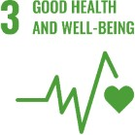
SUSTAINABLE DEVELOPMENT GOAL 3 – GOOD HEALTH AND WELL BEING

Ensure healthy lives and promote well-being for all at all ages.

- RESEARCH & INNOVATION
- The university can proudly boast the work of its faculty members in the context of Good Health and Wellbeing, as in the last 10 years university has published 478 Research Publications that are relevant to target SDG Research Publications relevant to target SDG
- 54 Research grants have been won by the various faculty members that are relevant to target SDG
- TEACHING & STUDENTS
- Various departments of the university are running about 104 courses that are relevant to target SDG
- Link to course inventory http://oric.aiou.edu.pk/?page_id=1748
- OPERATIONS:
- The department of department of Environmental design and health and nutritional Sciences, Agricultural sciences and environmental sciences are eagerly working with all their attributes in the upholding of Good Health and Wellbeing by various courses, publications, activities and student internships. Overall, 21 faculty members are currently engaged in the working of this SDG and adding their due share in the betterment of life of people.
- Policy: Smoke Free Campus, Enforcement of Tobacco Control Laws in Universities of Pakistan on 12th September, 2017
- PUBLIC ENGAGEMENT
- Seminar on awareness related to “PREVENTION OF BREAST CANCER” has been organized by EDHNS.
- Online Interactive Session on “Breast Cancer Awareness and Screening” held on March 25, 2021
- Training of foster mothers from Rawalpindi division related to child health
- OUTREACH & PARTNERSHIP
- Network for human social development (NHSD)
- Shifa International Hospital
- Scaling up nutrition Pakistan (SUN)
- UNISEF
- University of Dundee
- Kings College London
- Nine Wells Hospital Dundee
- Shifa Eye Trust
- Health Services Academy
- Institute Of Community Ophthalmology
- Rawalpindi Eye Donor Organization REDO
- Marie Adelaide Leprosy Centre
- UNIVERSITY ACTIVITY/NEWS RELATED TO SDG
- First International Conference on Health and Environment in March 2018
- One Day Seminar Eat Right Stay Active in April 2015
- Health And Sustainability March 2019
- Breast Cancer Awareness November 2019
- One Day Community Outreach Event on “Nutrition for Healthier Living”
- Online Interactive Session on “Breast Cancer Awareness and Screening” held on March 25, 2021
- AIOU launches dengue awareness campaign

- NEWS
AIOU launched BS Physical Education programme
https://nation.com.pk/14-oct-2019/aiou-to-launch-bs-physical-education-programme
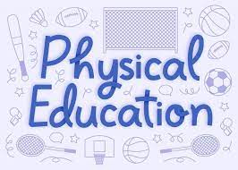
Early childhood development (ECD) conference arranged by Rupani foundation in collaboration with Allama Iqbal Open University, Islamabad.
https://deafreach.com/early-childhood-development-conference-in-islamabad/
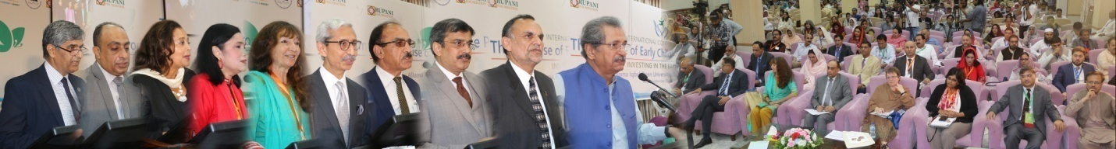
Seminar on Health & Sustainability held at AIOU, ISB
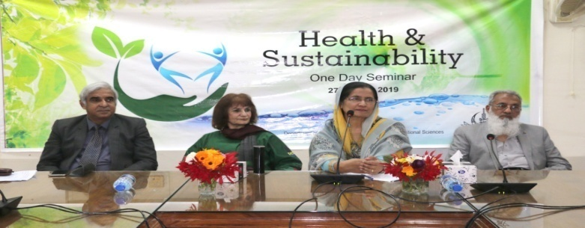
https://e-updates.com/seminar-on-health-sustainability-held-at-aiou-isb/
AIOU holds national seminar on Breast Cancer
https://leadpakistan.com.pk/news/aiou-holds-national-seminar-on-breast-cancer/
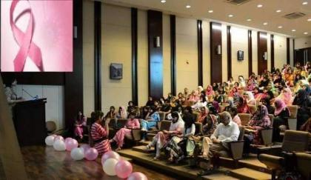
Euro-Pak Int’l moot on physical education
https://dailytimes.com.pk/481023/euro-pak-intl-moot-on-physical-education-to-be-held-on-friday/
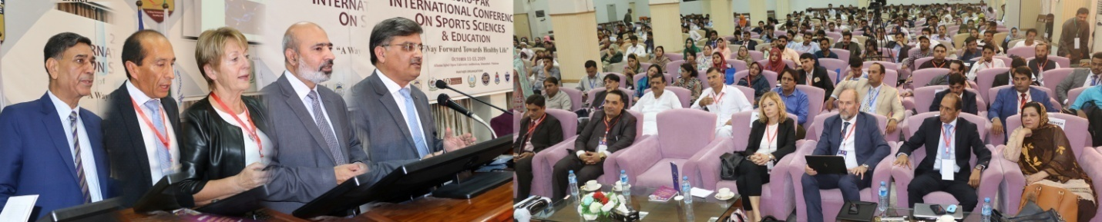
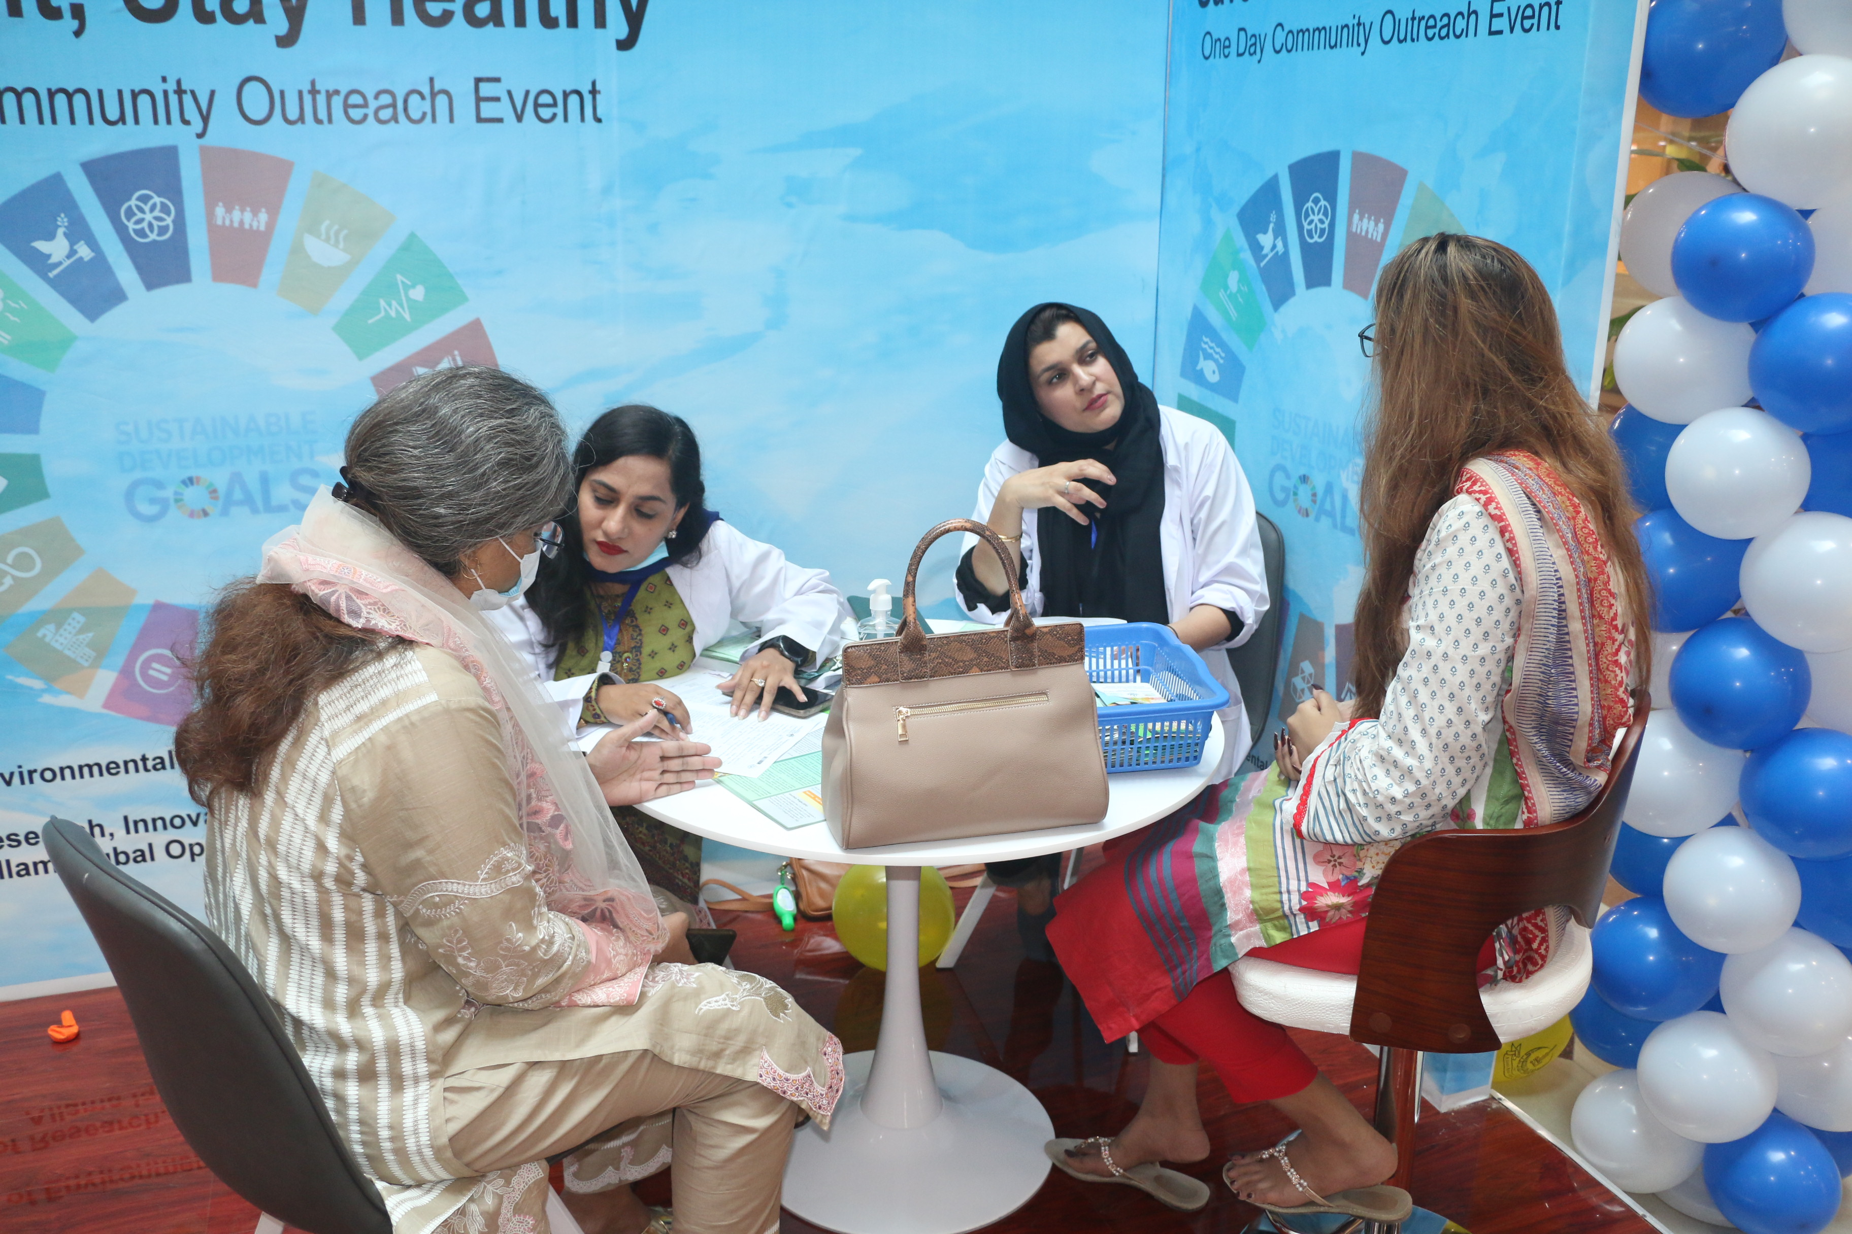
One Day Community Outreach Event on “Nutrition for Healthier Living”
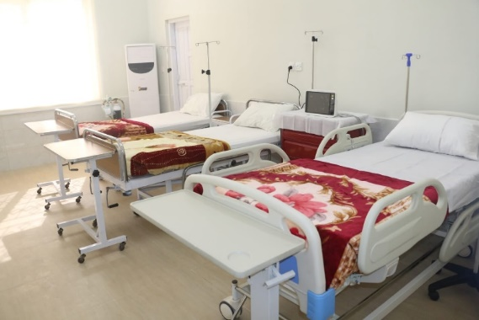
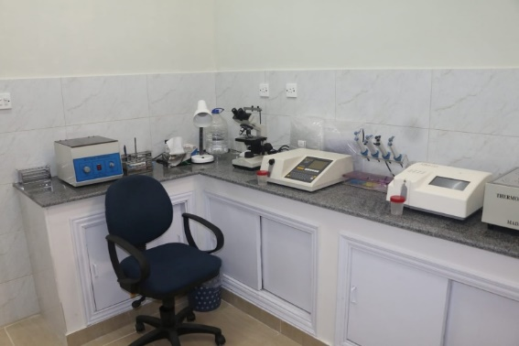
AIOU Health Facilities

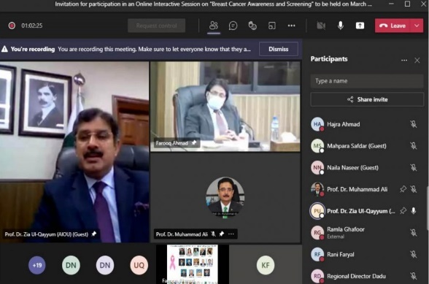
Online Interactive Session on “Breast Cancer Awareness and Screening” held on March 25, 2021
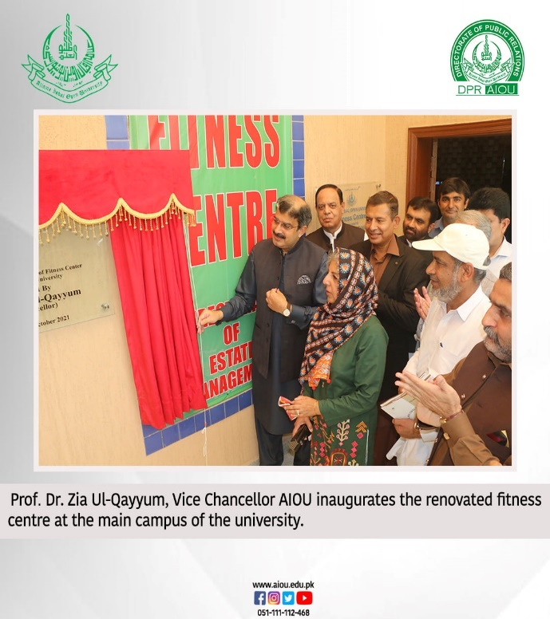
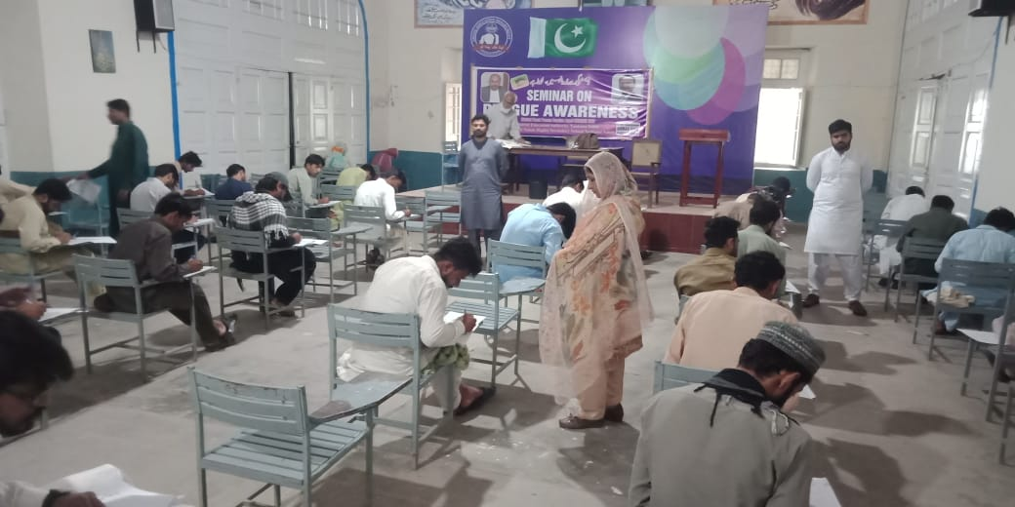
- AIOU launches dengue awareness campaign (https://dailytimes.com.pk/861484/aiou-launches-dengue-awareness-campaign/)
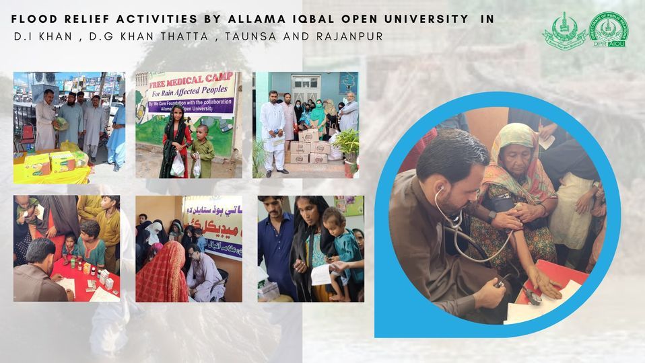
- Free Accessible Lecturers on SDG 3
https://www.youtube.com/watch?v=UhO8XHFUcDg

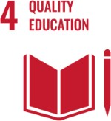
SUSTAINABLE DEVELOPMENT GOAL 4 – QUALITY EDUCATION

Ensure inclusive and equitable quality education and promote lifelong learning opportunities for all

- RESEARCH & INNOVATION
- The university can proudly boast the work of its faculty members in the context of Quality Education, as in the last 10 years university has published 944 Research Publications that are relevant to target SDG (370)
- 106 Research grants have been won by the various faculty members that are relevant to target SDG (75)
- TEACHING & STUDENTS
- AIOU awarded 85 PhD, 630 MPhil degrees in 2021 (https://pakobserver.net/aiou-awarded-85-phd-630-mphil-degrees-in-2021/)
- Various departments of the university are running about 117 courses that are relevant to target SDG
- Link to course inventory http://oric.aiou.edu.pk/?page_id=1748
- Financial Support Scheme SSF-101
- Earn to Learn Scheme SSF-102
- Merit Scholarship Scheme SSF-103
- Final Year Project Grant SSF-105
- Scholarship for Communities Scheme SSF-106
- OPERATIONS
- The faculty of education and the department of Environmental design and health and nutritional Sciences, Agricultural sciences and environmental sciences are eagerly working with all their attributes in the upholding of quality education by various courses, publications, activities and student internships. Overall, 42 faculty members are currently engaged in the working of this SDG and adding their due share in the betterment of life of people.
- PUBLIC ENGAGEMENT
- One Day Webinar on “Entrepreneurial Ideas in Humanities and Social Sciences”, March 10, 2021
- Webinar on “Innovation & Entrepreneurship” on Wednesday, the 3rd February, 2021
- AIOU INTERNAL FUNDED RESEARCH PROJECT GRANTS 2020-21
- One Day Workshop on ‘Startup Entrepreneurship- Owning your Future’ – 5th Dec 2019

- OUTREACH & PARTNERSHIP
- Inclusive Education in Pakistan: Experiences and Lessons Learned from the Engage Project that is Funded by: USAID and it was Concluded in: 2009-10
- Establishment of National Center of Curriculum Studies and Educational Assessment at AIOU (NCCS&EA): Funded by Higher Education Commission, Pakistan that was concluded in 2015-16 with a capital cost of Rs. 24.244 mil.
- Girl Power Program (GPP): Funded by PLAN Int that was concluded in 2015-16with a Capital Cost of Rs. 7,36,80916/
- Building Skills for Life ( BS4L) (Elementary): Funded by DFID, PLAN Int. for Sajawal/Thatta that was concluded in 2015-16 with a Capital Cost: Rs.2,09,51094/
- Building Skills for Life ( BS4L) (Matric): Funded by DFID, PLAN Int. for Sajawal/Thatta that was Concluded in 2016-18 with a Capital Cost: Rs. 75,00000 (approximately)
- Empowering Girls from Marginalized Rural Families for Continuing Education: Funded by UNESCO & PLAN Int. --- Sanjh Preet that was Concluded in: 2018 with a Capital Cost: Rs. 38,22,176/
- Content Development and Capacity Building … CA13-100 : Funded by Common Wealth of Learning (COL) that was Concluded in: 2016-2017 with a Capital Cost: CAD 22704 /
- AIOU, JICA commit to raise literacy rate in Pakistan (https://dailytimes.com.pk/994519/aiou-jica-commit-to-raise-literacy-rate-in-pakistan/)
- AIOU collaborates with JICA for women empowerment (https://www.thenews.com.pk/print/988237-aiou-collaborates-with-jica-for-women-empowerment)
International collaborations with the other academic institutes
- USEFP Fulbright Scholarship
- Commonwealth
- Association of Commonwealth Universities (ACU) / Chevening
- Erasmus +
- Australia Award Scholarship
- DAAD, Germany
- Chinese Scholarship Council (CSC)
- Jiangsu University, China
  - University of Leicester, UK
- UNIVERSITY ACTIVITY/NEWS RELATED TO SDG

AIOU considered best for distance learning: digital transformation policy started for promotion of education via internet
https://dailytimes.com.pk/461817/aiou-considered-best-for-distance-learning/
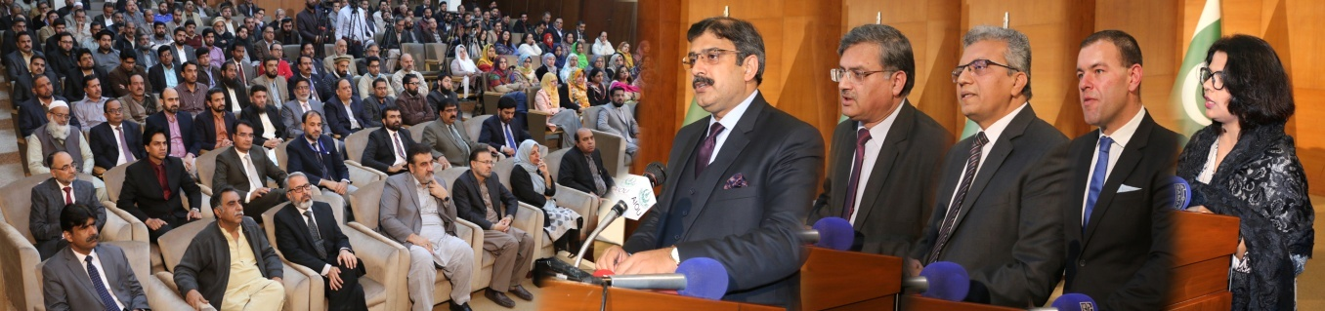
AIOU celebrates World Literacy Day
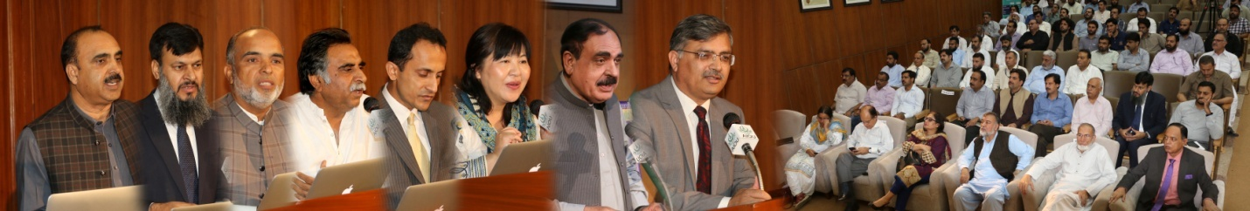
Two-day book fair held at AIOU
https://www.thenews.com.pk/print/545075-two-day-book-fair-held-at-aiou
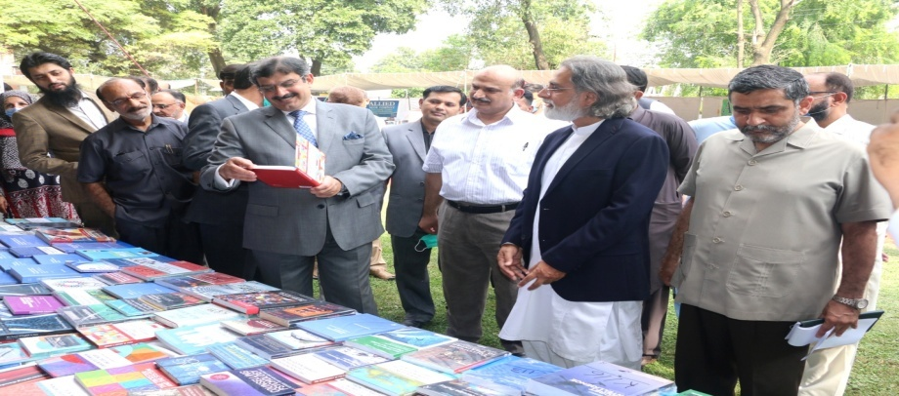
Oracle : AIOU to promote digital transformation through cooperative partnership
https://www.marketscreener.com/quote/stock/ORACLE-CORPORATION-13620698/news/Oracle-AIOU-to-promote-digital-transformation-through-cooperative-partnership-30144316/
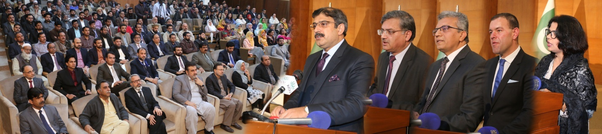
POTOHAR Literacy Festival held at AIOU
https://www.thenews.com.pk/print/459436-potohar-literary-festival-held-at-aiou
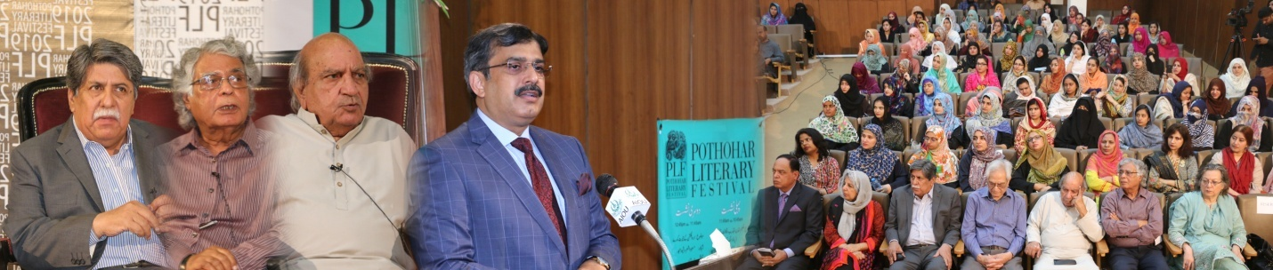
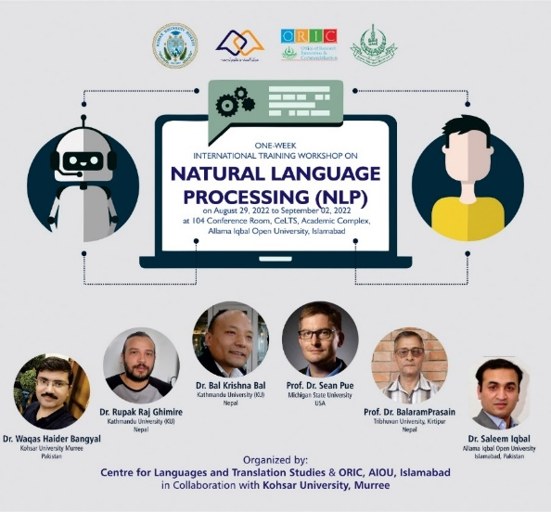
National Language Processing Conference
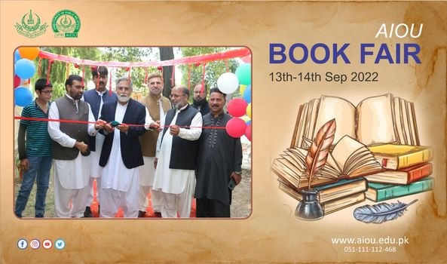
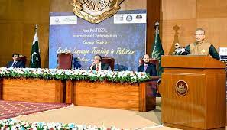
International Conference on emerging trends in English language teaching in Pakistan
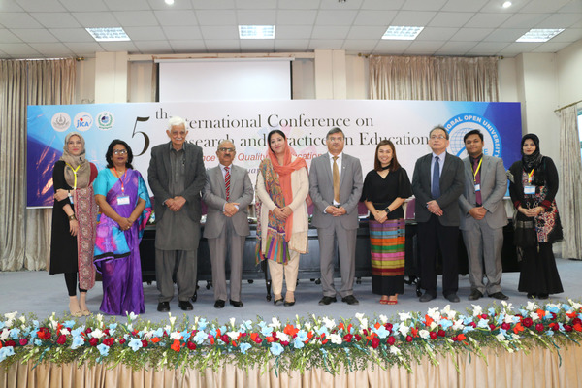
6th International Conference on Research and Practices in Education
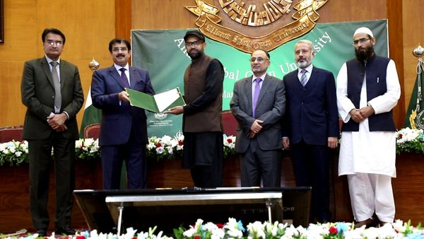
Prof. Dr. Zia Ul-Qayyum, VC AIOU awarding confirmation letters to the qualified employees for the Professional Development Program. An MoU was signed between AIOU and the University of Leicester, UK for the Professional Development of the Faculty and Staff of AIOU.
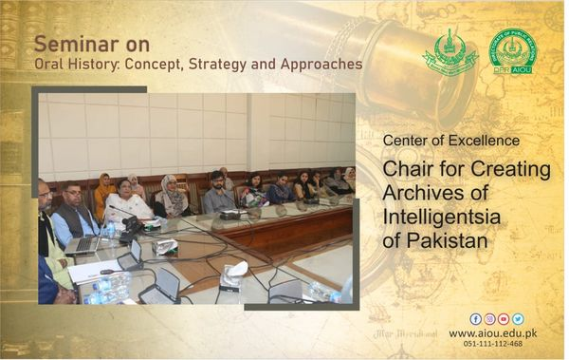

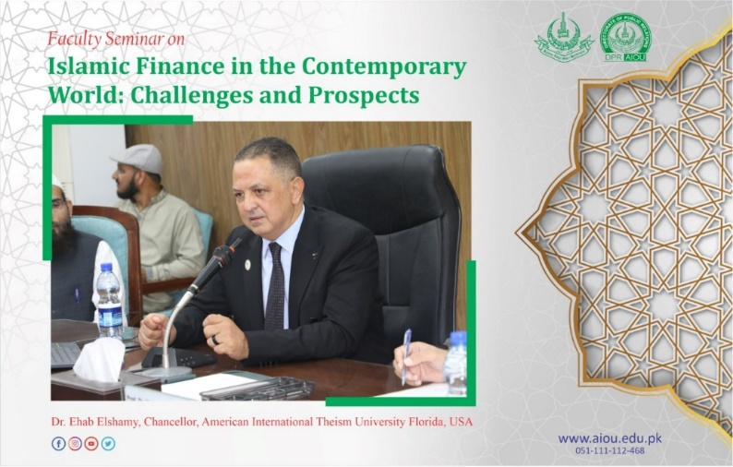
Faculty Seminar on Islamic Finance in the Contemporary World: Challenges and Prospects
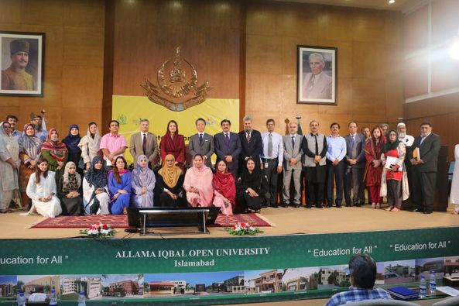
AIOU in collaboration with MoFE&PT, NCHD & JICA-AQAL organized a symposium to celebrate International Literacy Day. Ms. Zeb Jaffar , Parlimentary Secretary for Ministry of Federal Education and Professional Training graced the occasion as Chief Guest.
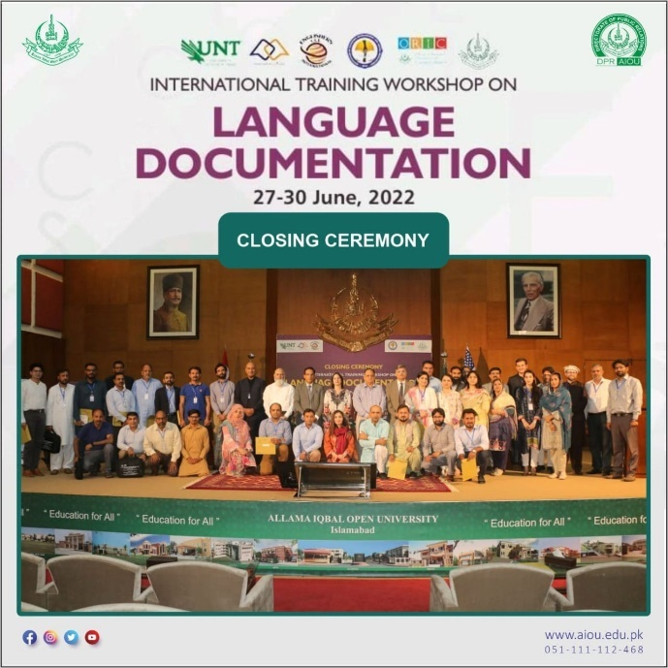
International Training Workshop on Language Documentation
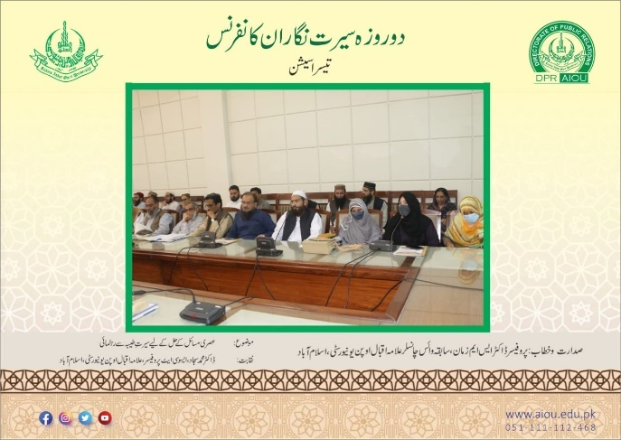
Seerat Nigaran Conference
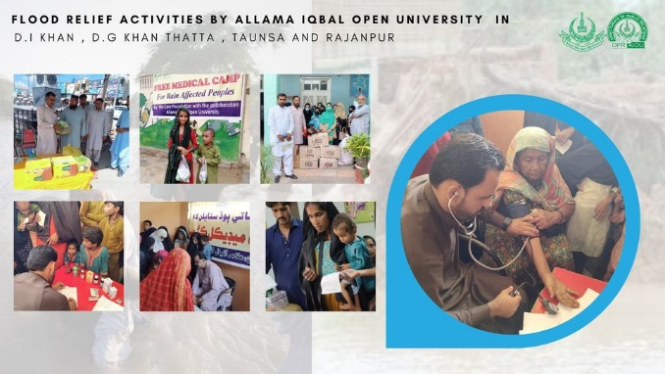
Flood Releif Activities by AIOU
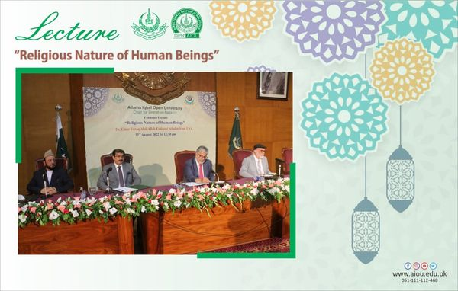
An extension lecture on "Religious Nature of Human Beings" by Eminent Islamic Religious Scholar from USA , was organized by Seerat Chair , Centre of Excellence, AIOU. Dr Mukhtar Ahmed , Chairman HEC presided over the session.
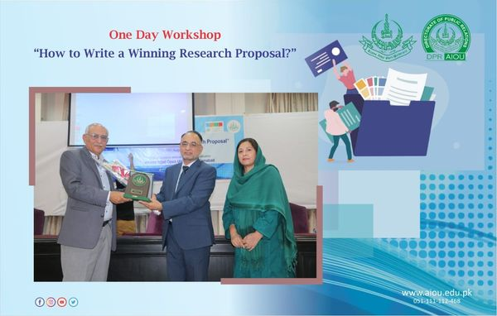
ORIC AIOU organized One-Day workshop on “How to Write a Winning Research Proposal”
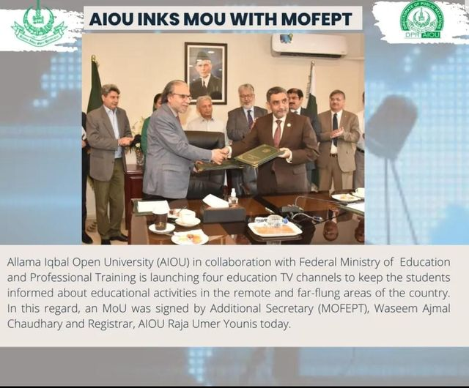
- Free Accessible Lecturers on SDG 4
https://www.youtube.com/watch?v=UhO8XHFUcDg

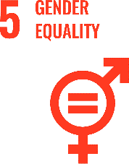
SUSTAINABLE DEVELOPMENT GOAL 5 – GENDER EQUALITY

Achieve gender equality and empower all women and girls

- RESEARCH & INNOVATION
- The university can proudly boast the work of its faculty members in the context of Gender Equality, as in the last 10 years university has published 122 Research Publications that are relevant to target SDG Research Publications relevant to target SDG
- 15 Research grants have been won by the various faculty members that are relevant to target SDG
- TEACHING & STUDENTS
- Various departments of the university are running about 21 courses that are relevant to target SDG
- Link to course inventory http://oric.aiou.edu.pk/?page_id=1748
- OPERATIONS
- The department of Gender Studies is eagerly working with all its resources in the upholding of quality education by various courses, publications, activities and student internships. Overall, 4 faculty members are currently engaged in the working of this SDG and adding their due share in the betterment of life of people.
- Adoption of Protection against Harassment of Women at the Workplace Act No. 6 of 2010 on 12th July, 2011
- PUBLIC ENGAGEMENT
- Online Interactive Session on “Breast Cancer Awareness and Screening” held on March 25, 2021
- Health Benefits of Open Urban Spaces for Adolescent Girls April 2016
- OUTREACH & PARTNERSHIP
- Girl Power Program (GPP): Funded by PLAN Int that was concluded in 2015-16with a Capital Cost of Rs. 7,36,80916/
- Empowering Girls from Marginalized Rural Families for Continuing Education: Funded by UNESCO & PLAN Int. --- Sanjh Preet that was Concluded in: 2018 with a Capital Cost: Rs. 38,22,176/
- AIOU collaborates with JICA for women empowerment (https://www.thenews.com.pk/print/988237-aiou-collaborates-with-jica-for-women-empowerment)

- UNIVERSITY ACTIVITY/NEWS RELATED TO SDG
AIOU VC Dr. Zia ul-Qayyum directed to offer free education to transgender
https://thefortress.com.pk/aiou-vc-directed-to-offere-free-education-to-transgender/
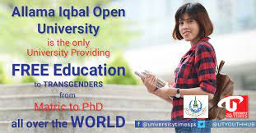
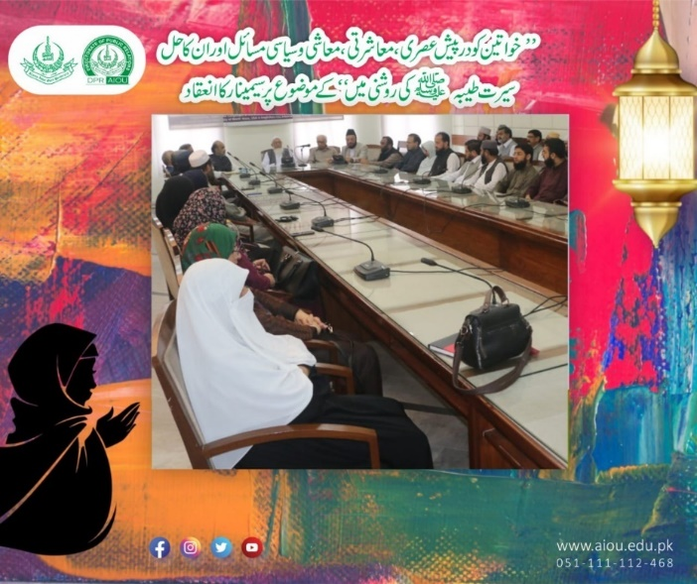
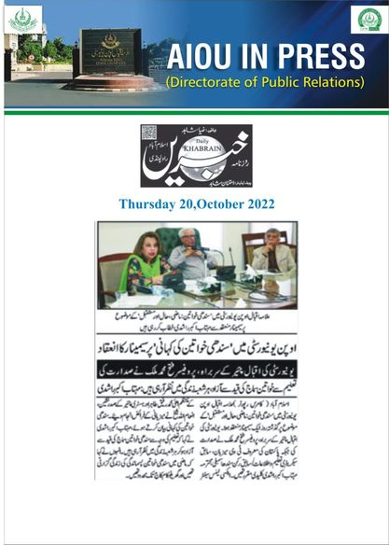
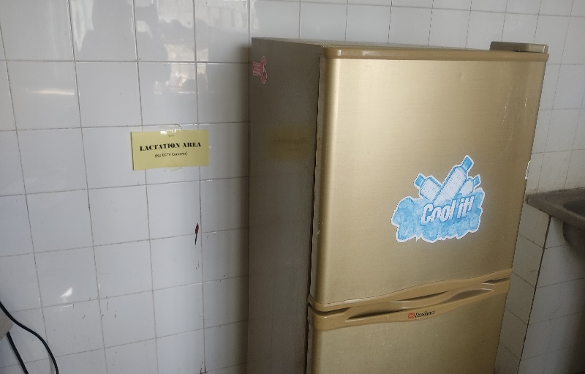
Lactation room in all departments. Overall, there is no restriction on keeping babies in offices. Mothers can feed and take care of their kids in their own offices
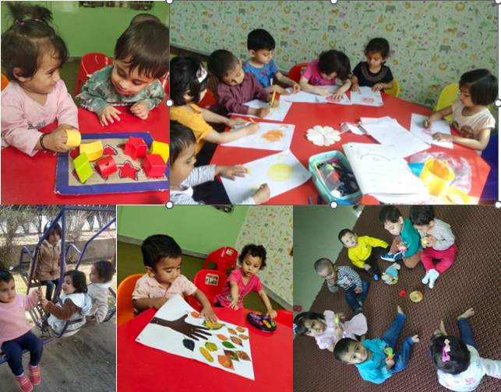
Campus facilities for maternity and Childcare
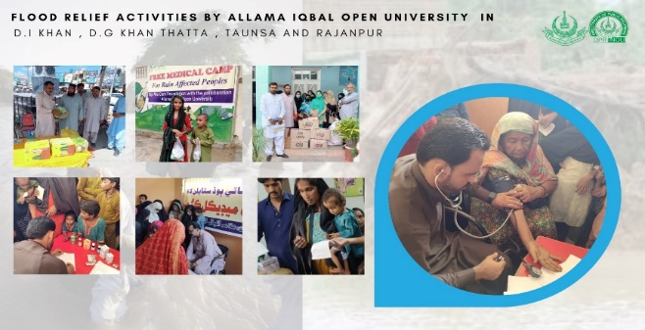
- Free Accessible Lecturers on SDG 5
https://www.youtube.com/watch?v=UhO8XHFUcDg

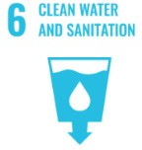
SUSTAINABLE DEVELOPMENT GOAL 6 - CLEAN WATER AND SANITATION

Ensure availability and sustainable management of water and sanitation for all

- RESEARCH & INNOVATION
- The university can proudly boast the work of its faculty members in the context of Clean Water and Sanitation, as in the last 10 years university has published 47 Research Publications that are relevant to target SDG
- 10 Research grants have been won by the various faculty members that are relevant to target SDG
- TEACHING & STUDENTS
- Various departments of the university are running about 16 courses that are relevant to target SDG
- Link to course inventory http://oric.aiou.edu.pk/?page_id=1748
- Student support schemes/Facilities provided to students relevant to target SDG (data from DSA)
- OPERATIONS
- The department of Environmental Sciences and department of Environmental design and health and nutritional Sciences are eagerly working with all their resources for the cause of clean water and sanitation by various courses, publications, activities and student internships. Overall, 19 faculty members are currently engaged in the working of this SDG and adding their due share in the betterment of life of people.
- A water meter is installed to measure the amount of rainwater that has been used. More than 60% of used water is recycled and re-used.
- The recycled water is also use for garden sprinkler system, toilet flush, cooling system and used in forests.
- Water filtration Systems are installed. Stored water is filtered and used for drinking
- Rainwater Harvesting Sites have been developed for groundwater recharge

Automatic Taps are installed in newly constructed buildings and renovated washrooms which has reduced the water usage

Toilet tanks with 4.5 L/Flush have been installed to save on water usage.

Showers with lower speed i.e. 9L/min have been installed in hostels, guest house and AIOU colony flats.

Most of washing machines being used at residential colony are manual which use lesser water as compared to normal automatic washing machines.
- Water filtration plants are installed and treated water is used for drinking
- treated water is saved in underground water tanks and is used for gardening
- Treated water is used in toilet flush
- Treated water is used in botanical Garden
- Treated water is used for construction requirements

Allama Iqbal Open university has overall Pollution Control Policy which states that:

“Toxic and hazardous waste can shall not be dumped in the university water system by any means. University lake and stream shall not be used for waste disposal. No kind of pollution shall be tolerated in the university premises and the culprits shall be fined heavily if found guilty.”
- PUBLIC ENGAGEMENT
- Public engagement activities relevant to target SDG (DSA data)
- OUTREACH & PARTNERSHIP
- Collaboration and work with any other agency relevant to target SDG
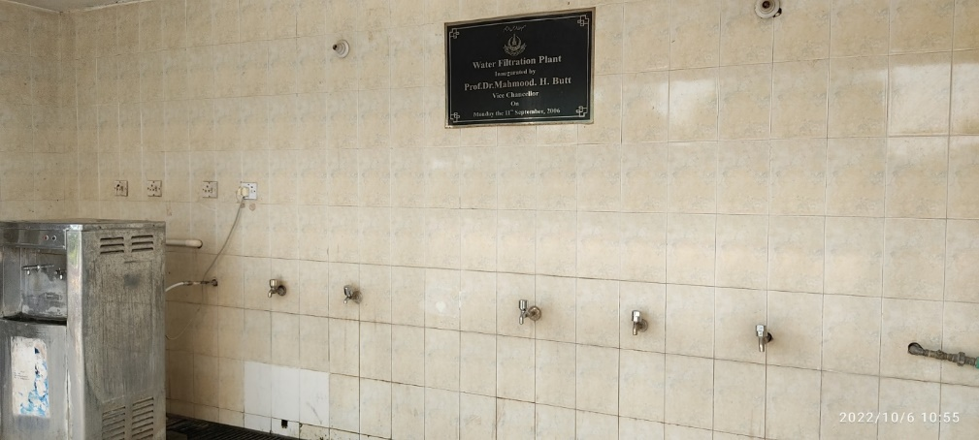
Water filtration Systems are installed. Stored water is filtered and used for drinking
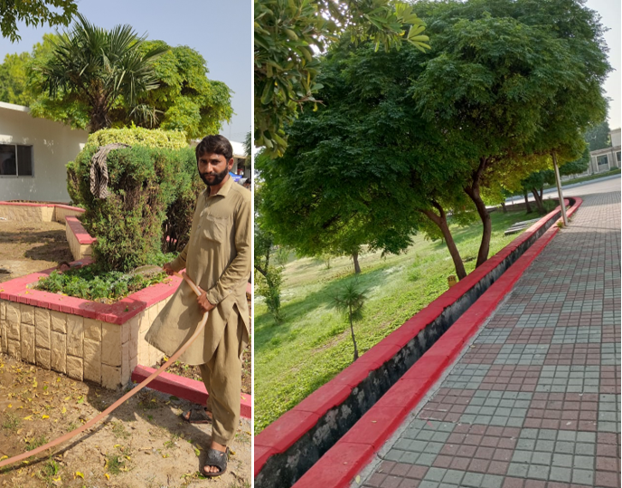

Recycled water is used for watering plants and other gardening purposes

- Free Accessible Lecturers on SDG 6
https://www.youtube.com/watch?v=UhO8XHFUcDg

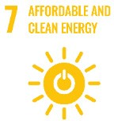
SUSTAINABLE DEVELOPMENT GOAL 7 – AFFORDABLE AND CLEAN ENERGY

Ensure access to affordable, reliable, sustainable and modern energy for all

- RESEARCH & INNOVATION:
- The university can proudly boast the work of its faculty members in the context of Affordable and Clean Energy, as in the last 10 years university has published 69 Research Publications that are relevant to target SDG
- 46 Research grants have been won by the various faculty members that are relevant to target SDG
- TEACHING & STUDENTS
- Various departments of the university are running about 10 courses that are relevant to target SDG
- Link to course inventory http://oric.aiou.edu.pk/?page_id=1748
- Student support schemes/Facilities provided to students relevant to target SDG (data from DSA)
- OPERATIONS
- The department of Agricultural Sciences and department of Environmental design and health and nutritional Sciences are eagerly working with all their resources for Affordable and Clean Energy by various courses, publications, activities and student internships. Overall, 11 faculty members are currently engaged in the working of this SDG and adding their due share in the betterment of life of people
- UNIVERSITY ACTIVITY/NEWS RELATED TO SDG
International conference on nano-materials modelling held at AIOU
https://dailytimes.com.pk/357988/international-conference-on-nano-materials-modelling-held-at-aiou/
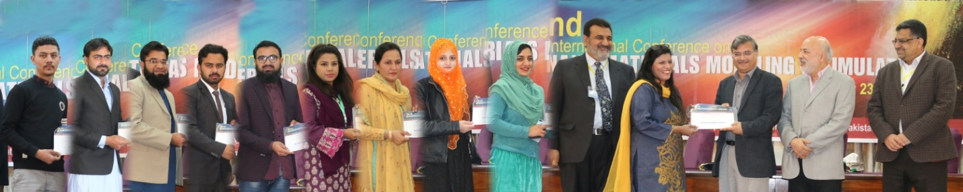
National Conference on Emerging Sciences held at AIOU
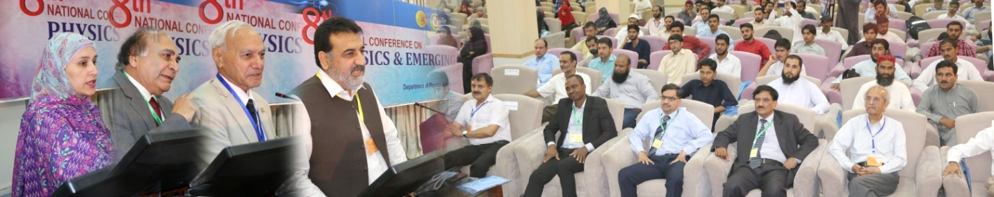
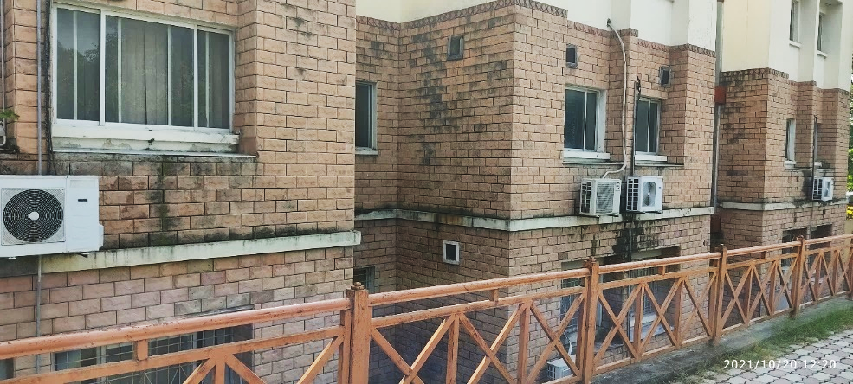
Energy efficient inverters (Combined Cooling Heating and Power Integration Unit)

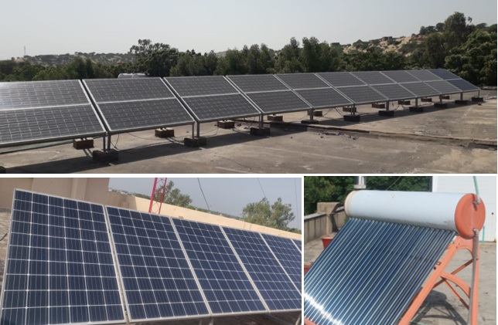
- Solar Panels installed at main campus and some regional campuses
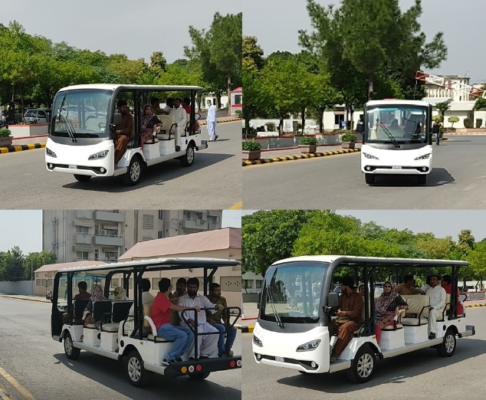

Zero emission vehicles for in-campus shuttle service
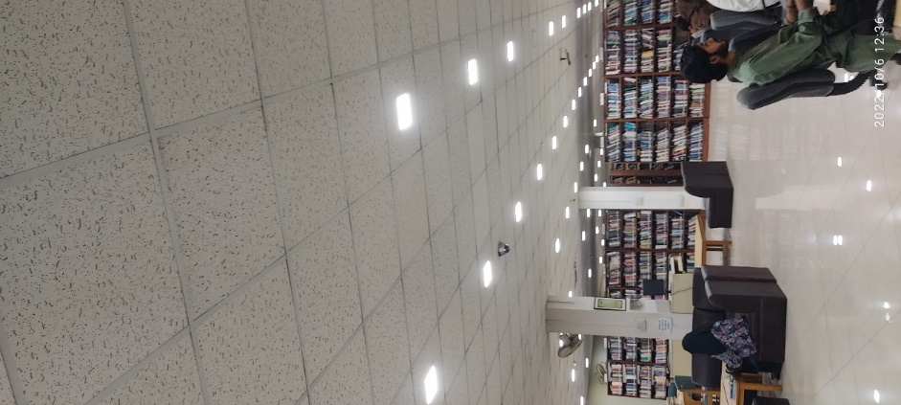
Energy savers being used to to save energy consumption

- Free Accessible Lecturers on SDG 7
https://www.youtube.com/watch?v=UhO8XHFUcDg

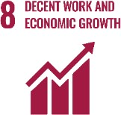
SUSTAINABLE DEVELOPMENT GOAL 8 – DECENT WORK AND ECONOMIC GROWTH

Promote sustained, inclusive and sustainable economic growth, full and productive employment and decent work for all

- RESEARCH & INNOVATION
- The university can proudly boast the work of its faculty members in the context of DECENT WORK AND ECONOMIC GROWTH as in the last 10 years university has published 222 Research Publications that are relevant to target SDG
- 22 Research grants have been won by the various faculty members that are relevant to target SDG
- TEACHING & STUDENTS
- 184 educational programs from basic level to doctorate level that are directly and indirectly related to SDG 8
- 334 Various certificates, diplomas and professional courses to target the scheme of SDG 8
- Link to course inventory http://oric.aiou.edu.pk/?page_id=1748
- Financial Support Scheme SSF-101
- Earn To Learn Scheme SSF-102
- Merit Scholarship Scheme SSF-103
- Final Year Project Grant SSF-105
- Scholarship For Communities Scheme SSF-106
- Matric Free Education Plan (Balochistan,FATA & Gilgit Baltistan)
- OPERATIONS
- The department of Agricultural Sciences and department of Environmental Sciences are eagerly working with all their resources for DECENT WORK AND ECONOMIC GROWTH by various courses, publications, activities and student internships. Overall, 11 faculty members are currently engaged in the working of this SDG and adding their due share in the betterment of life of people
- House Building Finance
- Car Advance
- PUBLIC ENGAGEMENT
- AIOU BIG IDEAS COMPETITION
- Webinar on “Innovation & Entrepreneurship” on Wednesday, the 3rd February, 2021
- One Day Interactive Workshop on “Awareness of Opportunities for International Career Paths”- A Initiative for Faculty Development and Students Career Opportunities
- AIOU INTERNAL FUNDED RESEARCH PROJECT GRANTS 2020-21
- One Day Workshop on ‘Startup Entrepreneurship- Owning your Future’ – 5th Dec 2019
- UNIVERSITY ACTIVITY/NEWS RELATED TO SDG
- COVID Honorarium to 500 employees
- Un-deducted salary in covid crisis
- Any news cuttings, web links or any activity pictures relevant to target SDG (Google + DSA)
- ANY OTHER
Allama Iqbal Open University (AIOU) in collaboration with Qarshi University (QU), University of Veterinary and Animal Sciences (UVAS) and University of Management and Technology (UMT) organized two-day international conference on ‘Collective action for knowledge economy with technology (cake-tech) held at Allama Iqbal Open University (AIOU) Islamabad held on February-25-26, 2019.
https://www.vu.edu.pk/newsdetails.aspx?type=&newsid=3011
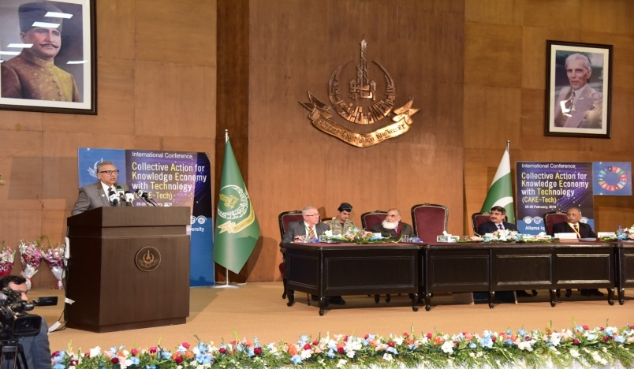
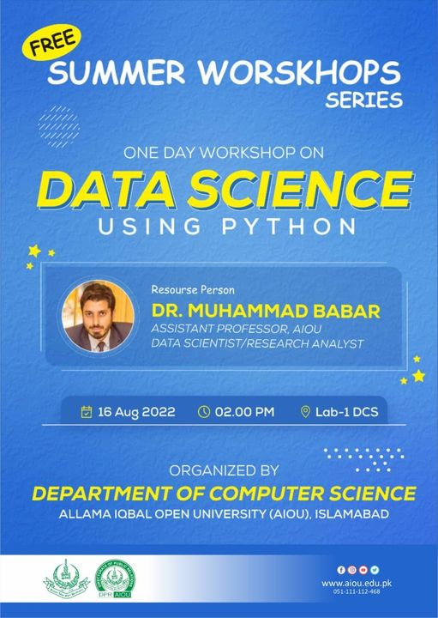
- Free Accessible Lecturers on SDG 8
https://www.youtube.com/watch?v=UhO8XHFUcDg

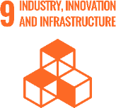
SUSTAINABLE DEVELOPMENT GOAL 9 – INDUSTRY, INNOVATION AND INFRASTRUCTURE

Build resilient infrastructure, promote inclusive and sustainable industrialization and foster innovation

- RESEARCH & INNOVATION
- The university can proudly boast the work of its faculty members in the context of INDUSTRY, INNOVATION AND INFRASTRUCTURE as in the last 10 years university has published 177 Research Publications that are relevant to target SDG
- 20 Research grants have been won by the various faculty members that are relevant to target SDG
- TEACHING & STUDENTS
- Various departments of the university are running about 40 courses that are relevant to target SDG
- Link to course inventory http://oric.aiou.edu.pk/?page_id=1748
- OPERATIONS
- The department of Agricultural Sciences Chemistry Department, Physics Department and Department of Environmental design and health and nutritional Sciences are eagerly working with all their resources for INDUSTRY, INNOVATION AND INFRASTRUCTURE by various courses, publications, activities and student internships. Overall, 36 faculty members are currently engaged in the working of this SDG and adding their due share in the betterment of life of people
- AIOU’s any policy relevant to target SDG. Please give its link. (Policy reference with name and year of initiation)
- PUBLIC ENGAGEMENT
- AIOU BIG IDEAS COMPETITION
- One Day Webinar on “Entrepreneurial Ideas in Humanities and Social Sciences”, March 10, 2021
- AIOU INTERNAL FUNDED RESEARCH PROJECT GRANTS 2020-21
- One Day Workshop on ‘Startup Entrepreneurship- Owning your Future’ – 5th Dec 2019
- UNIVERSITY ACTIVITY/NEWS RELATED TO SDG
Allama Iqbal Open University (AIOU) in collaboration with Qarshi University (QU), University of Veterinary and Animal Sciences (UVAS) and University of Management and Technology (UMT) organized two-day international conference on ‘Collective action for knowledge economy with technology (cake-tech) held at Allama Iqbal Open University (AIOU) Islamabad held on February-25-26, 2019.
https://www.vu.edu.pk/newsdetails.aspx?type=&newsid=3011

Aiou considered best for distance learning: digital transformation policy started for promotion of education via internet
https://dailytimes.com.pk/461817/aiou-considered-best-for-distance-learning/
Aiou striving to facilitate 1.4 mn students by incorporating use of latest technology
https://www.technologytimes.pk/2020/10/07/aiou-striving-to-facilitate-1-4-mn-students-by-incorporating-use-of-latest-technology/
AIOU to start 18 technical courses from January 15, 2020
Https://www.geo.tv/latest/266338-aiou-to-start-18-technical-courses-from-january-15
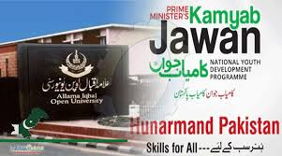
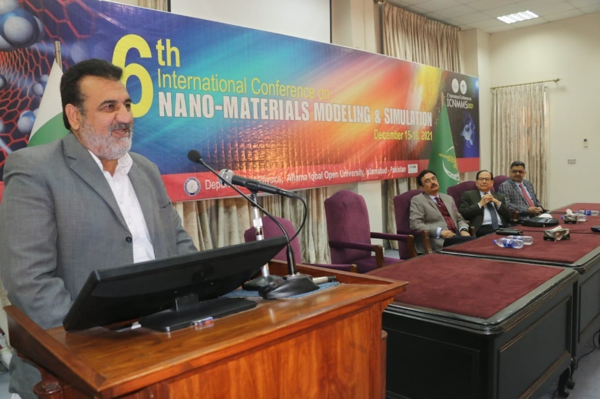
6th International Conference on Nano-Materials Modeling and Simulation

- Free Accessible Lecturers on SDG 9
https://www.youtube.com/watch?v=UhO8XHFUcDg

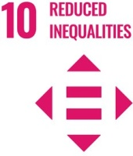
SUSTAINABLE DEVELOPMENT GOAL 10 – REDUCED INEQUALITIES

Reduce inequality within and among countries

- RESEARCH & INNOVATION
- The university can proudly boast the work of its faculty members in the context of REDUCED INEQUALITIES as in the last 10 years university has published 99 Research Publications that are relevant to target SDG
- 11 Research grants have been won by the various faculty members that are relevant to target SDG
- TEACHING & STUDENTS
- Various departments of the university are running about 03 courses that are relevant to target SDG
- Link to course inventory http://oric.aiou.edu.pk/?page_id=1748
- OPERATIONS
- The department of Special Education and Gender Studies are eagerly working with all their resources for REDUCED INEQUALITIES by various courses, publications, activities and student internships. Overall, 9 faculty members are currently engaged in the working of this SDG and adding their due share in the betterment of life of people
- Adoption of Protection against Harassment of Women at the Workplace Act No. 6 of 2010 on 12th July, 2011
- UNIVERSITY ACTIVITY/NEWS RELATED TO SDG
AIOU VC Dr. Zia ul-Qayyum directed to offer free education to transgender
https://thefortress.com.pk/aiou-vc-directed-to-offere-free-education-to-transgender/
AIOU holds solidarity walk to project Kashmir cause
https://www.thenews.com.pk/print/610211-aiou-holds-solidarity-walk-to-project-kashmir-cause
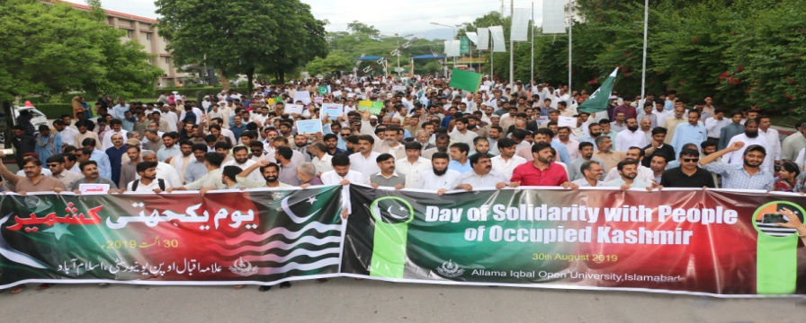
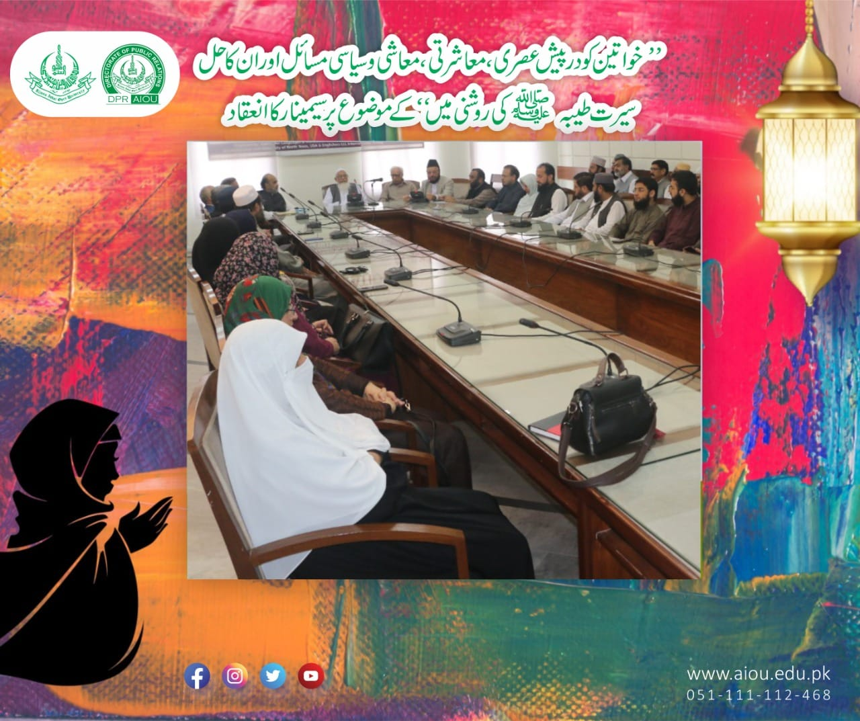
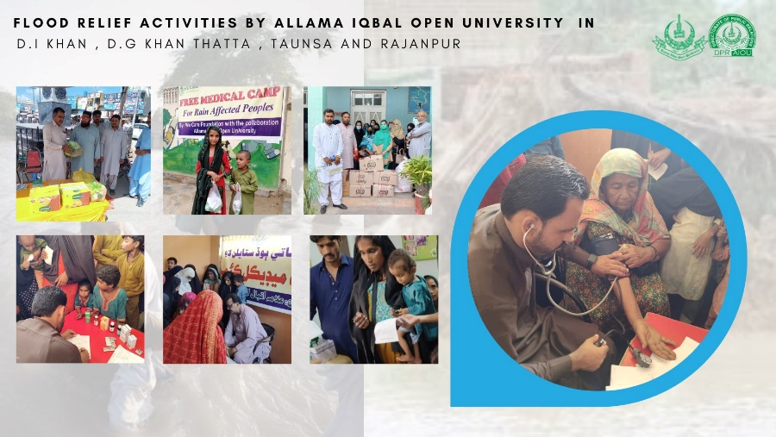

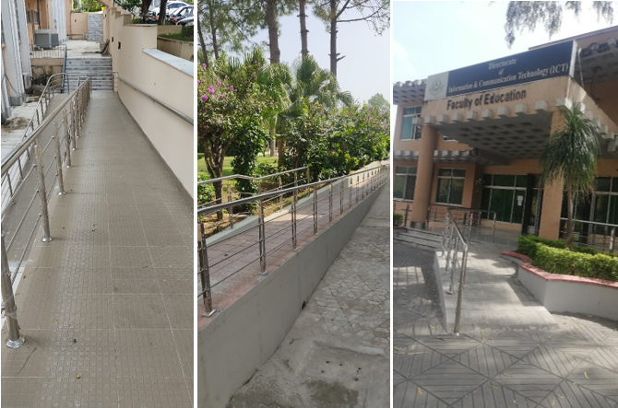
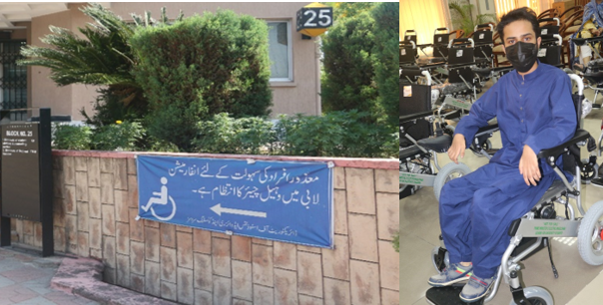
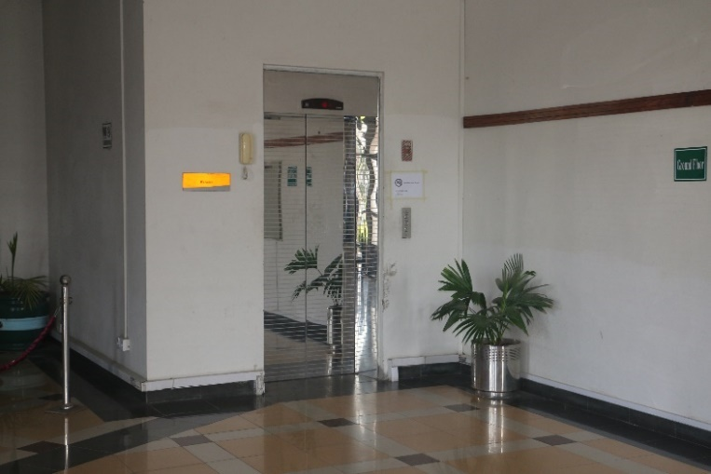
Campus facilities for disable, special needs and or maternity care
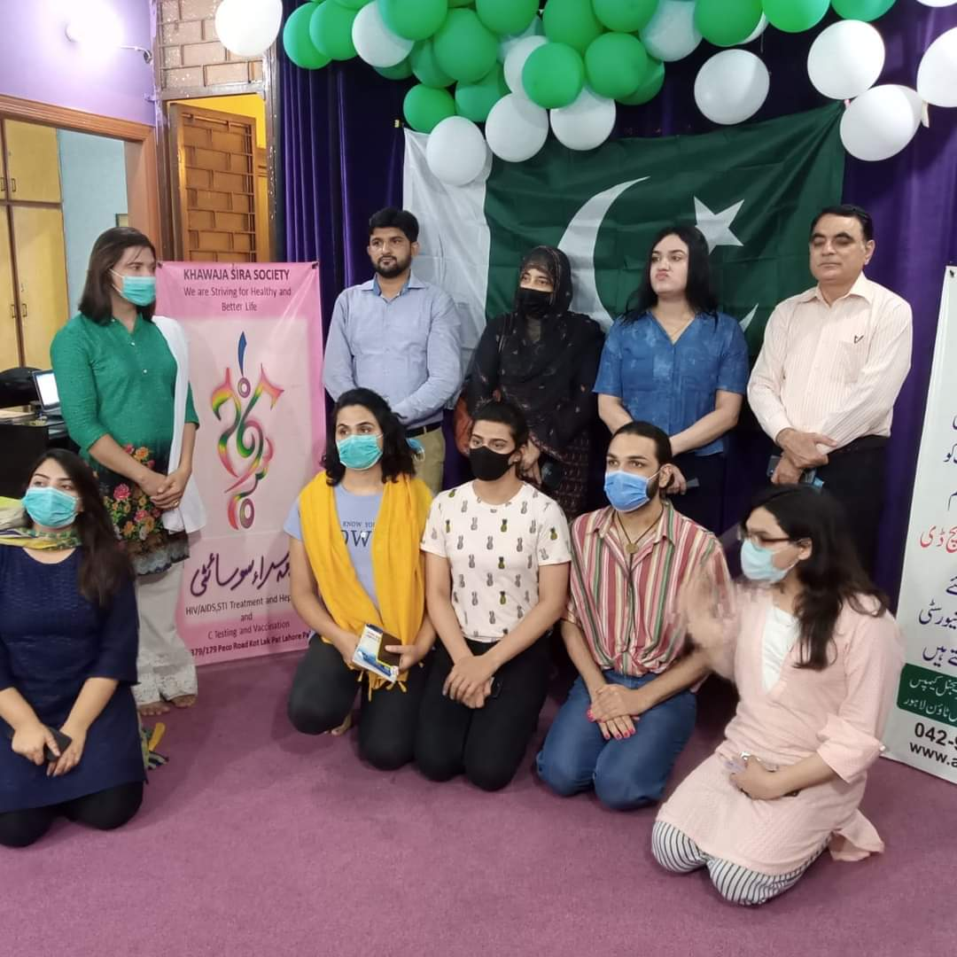
Seminar for Transgenders
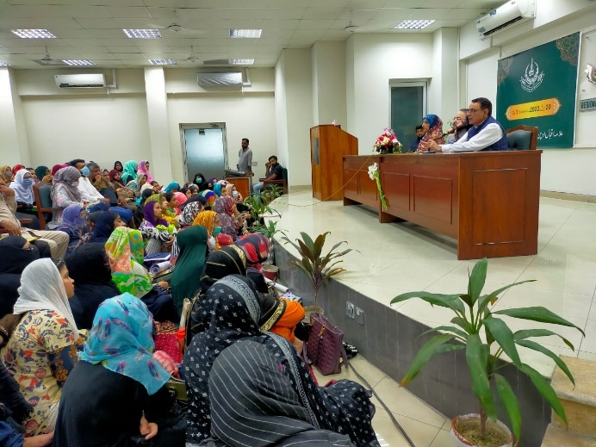
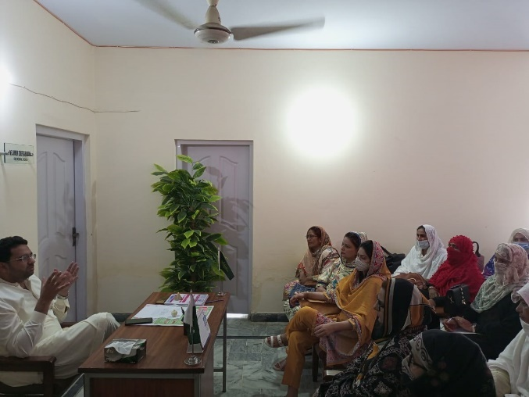
Capacity Building Workshop

AIOU gives fee concession to disabled students (https://pakobserver.net/aiou-gives-fee-concession-to-disabled-students/)

Afghan education Minister seeks AIOU’s help in reconstruction of educational infrastructure

AIOU introduces skill development course in GB (thenews.com.pk/print/975754-aiou-introduces-skill-development-course-in-gbenhance their practical skills.)

AIOU relaunches scholarship programme (https://www.thenews.com.pk/print/949862-aiou-relaunches-scholarship-programme)

AIOU offers fee concession to deserving students

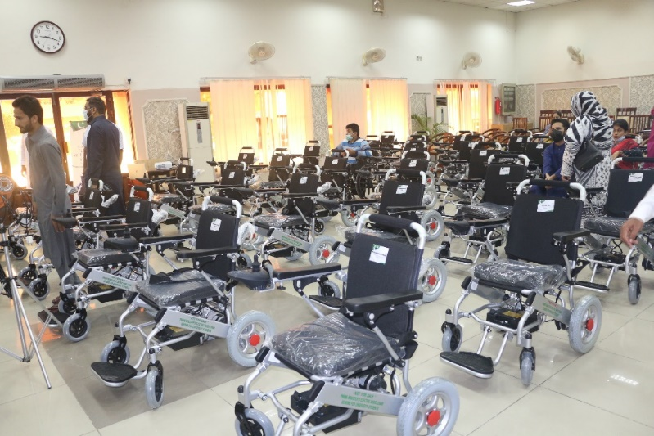
Free Wheel Chair Scheme for Disabled

- Free Accessible Lectures on SDG 10
https://www.youtube.com/watch?v=UhO8XHFUcDg

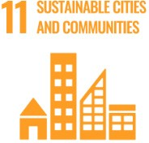
SUSTAINABLE DEVELOPMENT GOAL 11 – SUSTAINABLE CITIES AND COMMUNITIES

Make cities and human settlements inclusive, safe, resilient and sustainable

- RESEARCH & INNOVATION
- The university can proudly boast the work of its faculty members in the context of SUSTAINABLE CITIES AND COMMUNITIES as in the last 10 years university has published 92 Research Publications that are relevant to target SDG
- 50 Research grants have been won by the various faculty members that are relevant to target SDG
- TEACHING & STUDENTS
- Various departments of the university are running about 36 courses that are relevant to target SDG
- Link to course inventory http://oric.aiou.edu.pk/?page_id=1748
- OPERATIONS
- The department of Agricultural Sciences and department of Environmental Sciences are eagerly working with all their resources for SUSTAINABLE CITIES AND COMMUNITIES by various courses, publications, activities and student internships. Overall, 11 faculty members are currently engaged in the working of this SDG and adding their due share in the betterment of life of people
- Smoke Free Campus, Enforcement of Tobacco Control Laws in Universities of Pakistan on 12th September, 2017
Zero Emission Vehicles (ZEV) Policy on Campus, Zero Emission vehicles will soon join the AIOU transport fleet to facilitate the movement of students and staff within he university premises.
All purchase formalities have been completed.
- Shuttle/bus stand to reduce entry of private vehicles
- Out of Campus Parking for private vehicles
- Encouragement to use carpool services
- Restriction on vehicles entry at academic area and hostels
- Shifting of Public facilitation Center from inside campus to the gate
- https://www.urdupoint.com/en/pakistan/allama-iqbal-open-university-aiou-launches-603176.html

- OUTREACH & PARTNERSHIP
  - Shifa International Hospital
  - Scaling up nutrition Pakistan (SUN)
  - UNISEF
  - University of Dundee
- UNIVERSITY ACTIVITY/NEWS RELATED TO SDG
National Conference on ‘Hum Pakistani’ Narrative
http://www.paighamepakistan.com/national-conference-on-hum-pakistani-narrative/
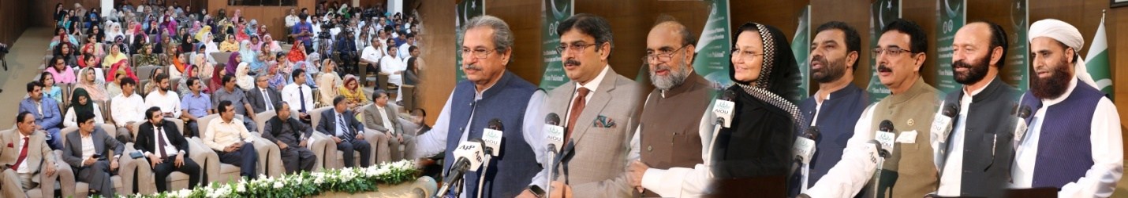
Road Safety Lecture at AIOU
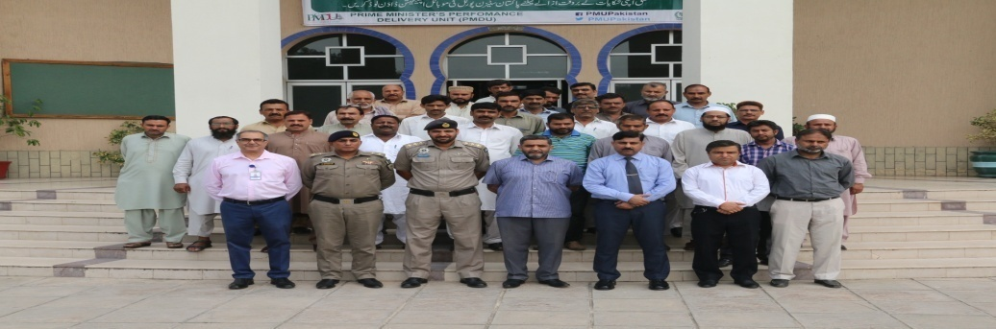

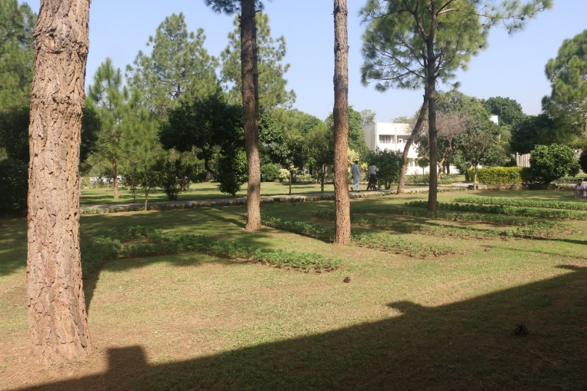
University owns plant nursing system

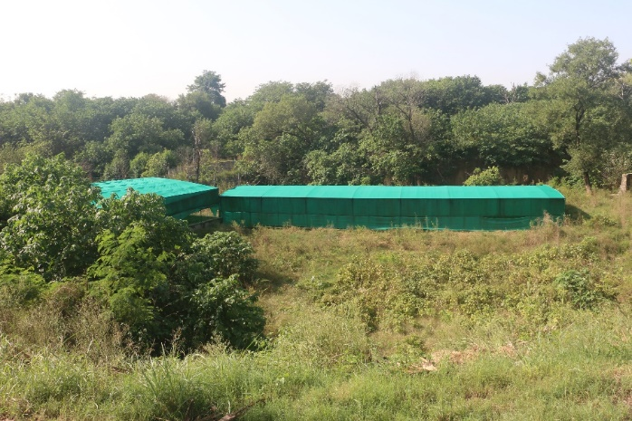
“AIOU’s Green Houses”

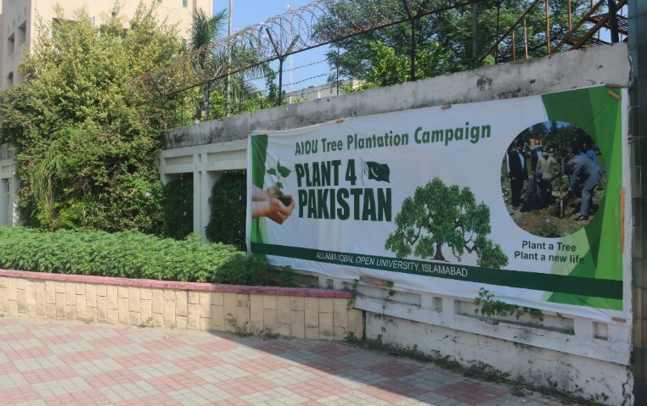
Plant a tree Program
1st International Conference on ”Climate Resilient Agriculture for Sustainable Development & Food Security”
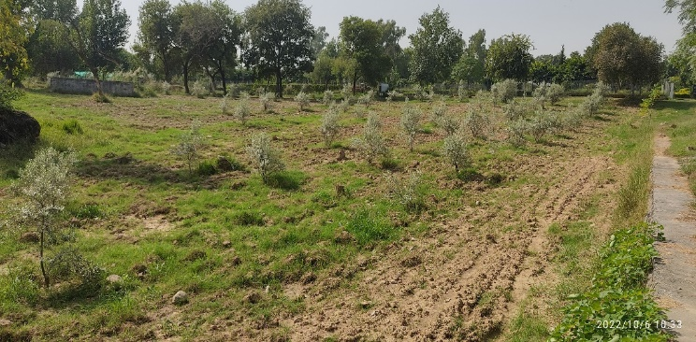
Olive orchard planted by AIOU

Old furniture is recycled by making new furniture items from them or using them for bio-fuel purposes
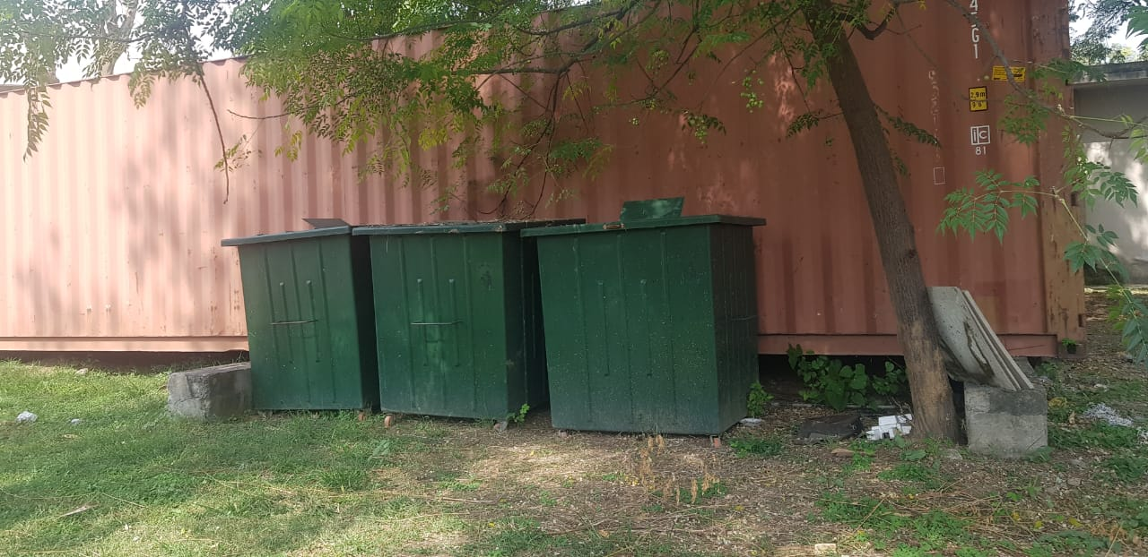
Organic waste is collected in separate bins and is processed at agricultural department for production of high-quality compost

- Free Accessible Lecturer on SDG 11
https://www.youtube.com/watch?v=UhO8XHFUcDg

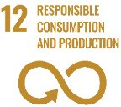
SUSTAINABLE DEVELOPMENT GOAL 12 – RESPONSIBLE CONSUMPTION AND PRODUCTION

Ensure sustainable consumption and production patterns

- RESEARCH & INNOVATION
- The university can proudly boast the work of its faculty members in the context of RESPONSIBLE CONSUMPTION AND PRODUCTION as in the last 10 years university has published 57 Research Publications that are relevant to target SDG
- 16 Research grants have been won by the various faculty members that are relevant to target SDG
- TEACHING & STUDENTS
- Number of courses relevant to target SDG are 19 among them 13 courses are offered by agricultural sciences department
- Link to course inventory http://oric.aiou.edu.pk/?page_id=1748
- OPERATIONS
- The department of Agricultural Sciences and department of Environmental Sciences are eagerly working with all their resources for SUSTAINABLE CITIES AND COMMUNITIES by various courses, publications, activities and student internships. Overall, 11 faculty members are currently engaged in the working of this SDG and adding their due share in the betterment of life of people
Energy efficient inverters (Combined Cooling Heating and Power Integration Unit)

- Solar Panels installed at main campus and some regional campuses

Zero emission vehicles for in-campus shuttle service
Energy savers being used to to save energy consumption

- Free Accessible Lecturers on SDG 12
https://www.youtube.com/watch?v=UhO8XHFUcDg
- ANY OTHER
- “Carbon Footprint Assessment of Allamah Iqbal open University” is a report made by Biology Department declaring the institute to be green university as the carbon consumption in AIOU per head is 0.7 tons.

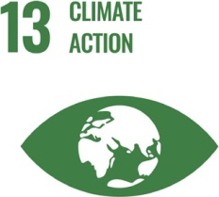
SUSTAINABLE DEVELOPMENT GOAL 13 – CLIMATE ACTION

Take urgent action to combat climate change and its impacts

- RESEARCH & INNOVATION
- The university can proudly boast the work of its faculty members in the context of CLIMATE ACTION as in the last 10 years university has published 59 Research Publications that are relevant to target SDG
- 72 Research grants have been won by the various faculty members that are relevant to target SDG
- TEACHING & STUDENTS
- Various departments of the university are running about 31 courses that are relevant to target SDG
- Link to course inventory http://oric.aiou.edu.pk/?page_id=1748
- OPERATIONS
- The department of Agricultural Sciences and department of Environmental Sciences are eagerly working with all their resources for CLIMATE ACTION by various courses, publications, activities and student internships. Overall, 11 faculty members are currently engaged in the working of this SDG and adding their due share in the betterment of life of people
- Smoke Free Campus, Enforcement of Tobacco Control Laws in Universities of Pakistan on 12th September, 2017
- UNIVERSITY ACTIVITY/NEWS RELATED TO SDG
AIOU holds awareness walk for PM’s Green Pakistan campaign
https://dailytimes.com.pk/335388/aiou-holds-awareness-walk-for-pms-green-pakistan-campaign/
- VC AIOU Stresses For Efforts To Combat Threats Of Climate Change (https://www.urdupoint.com/en/pakistan/vc-aiou-stresses-for-efforts-to-combat-threat-1559104.html)

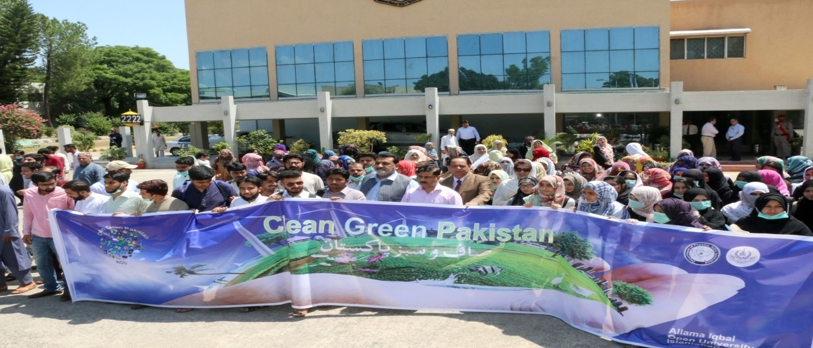
AIOU Olive tree plantation drive at Main Campus, Islamabad
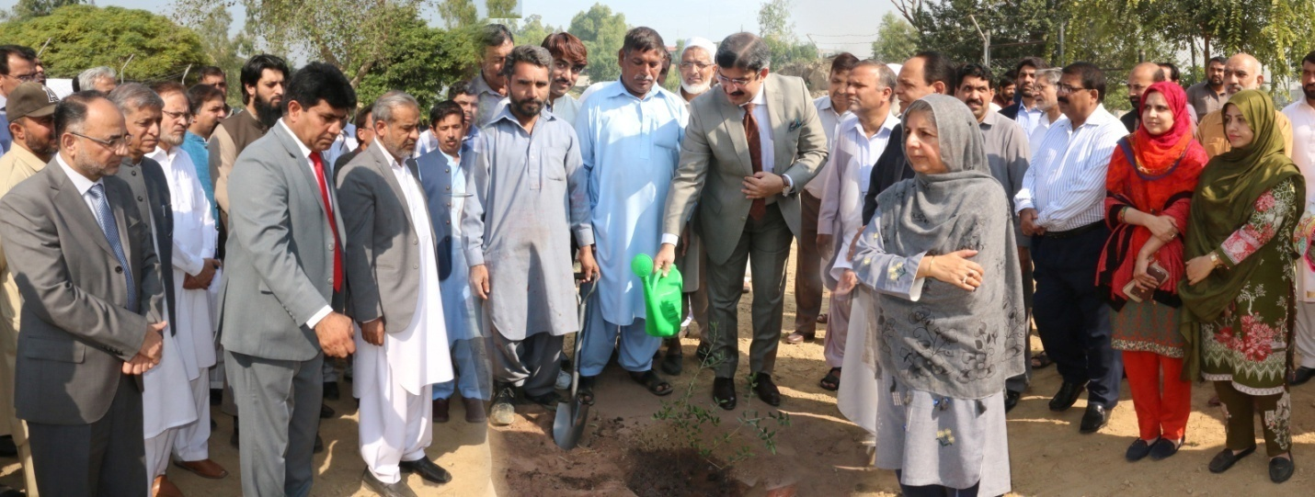
Spring Tree Plantation Campaign begins at AIOU
https://www.pakistanpoint.com/en/story/576085/spring-tree-plantation-campaign-begins-at-allama-iqbal.html
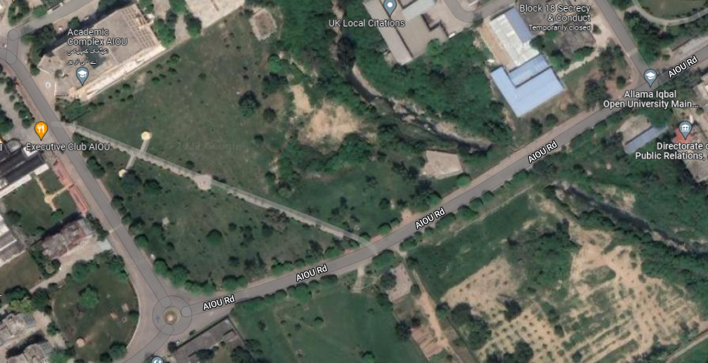
Google map showing planted vegetation at AIOU

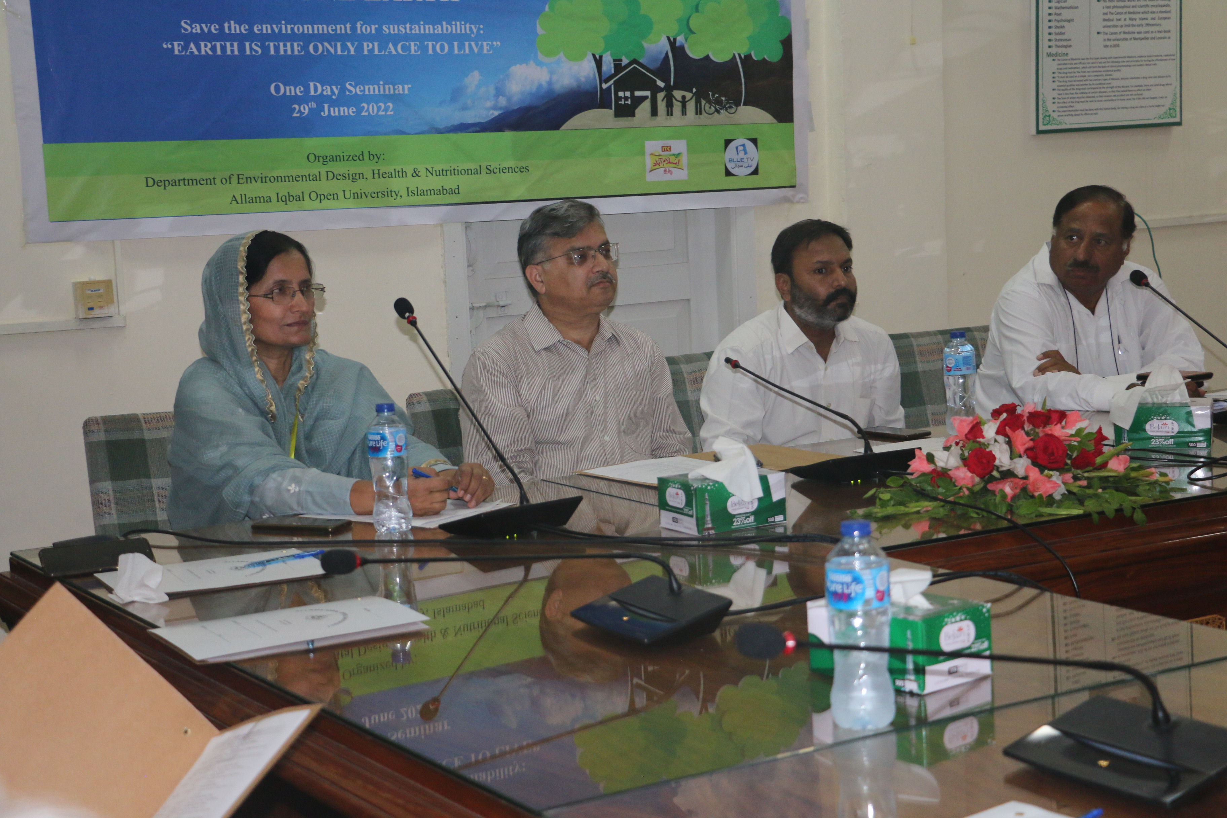
One-day Seminar on “World Environment Day” on June 29, 2022

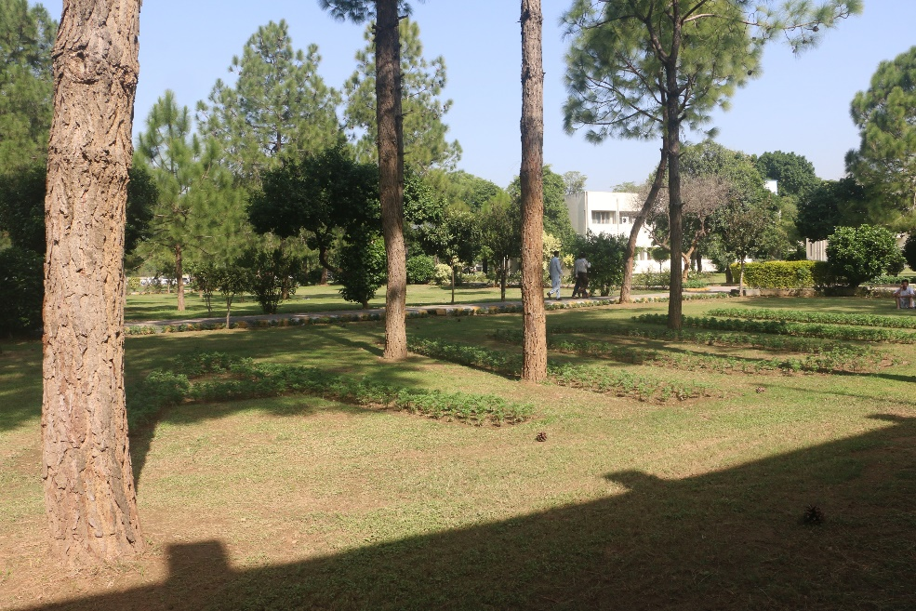
University owns plant nursing system

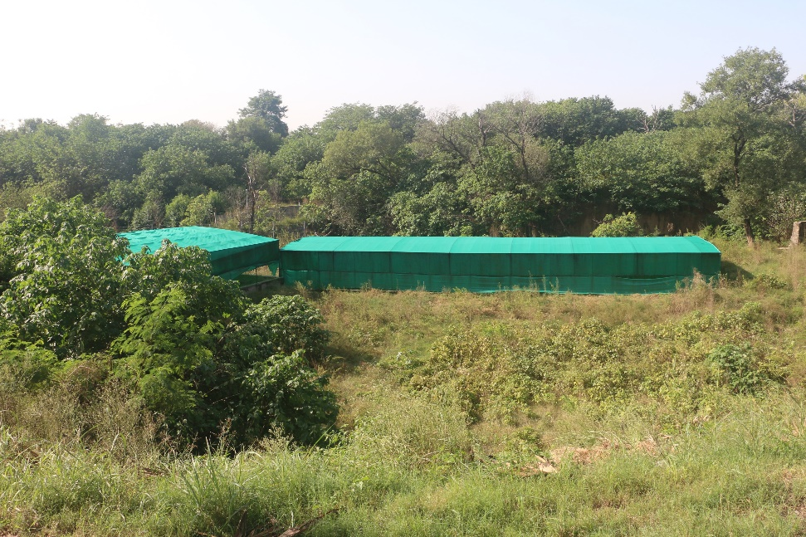
“AIOU’s Green Houses”

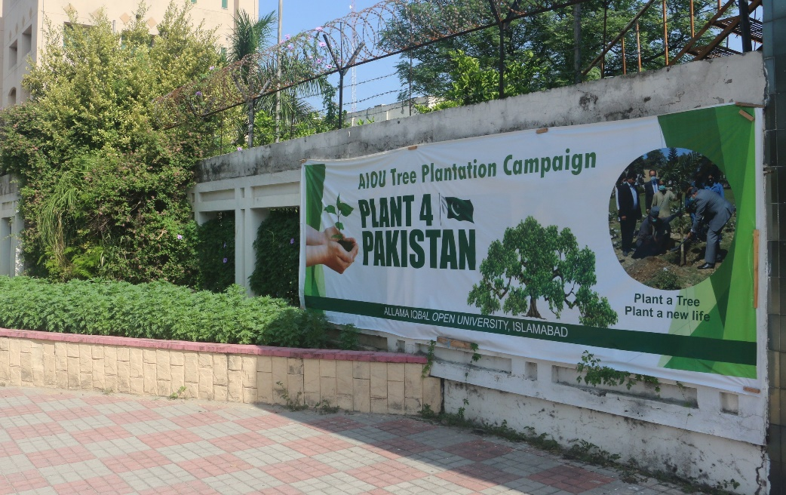
Plant a tree Program
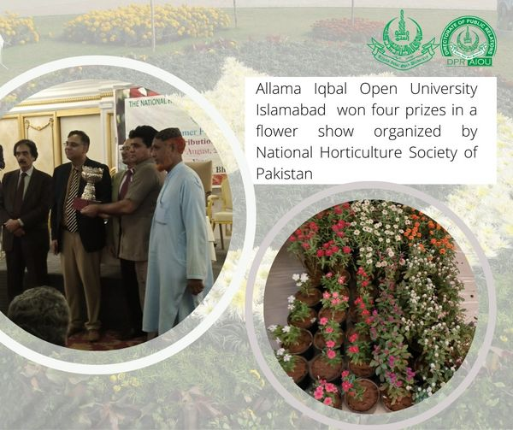
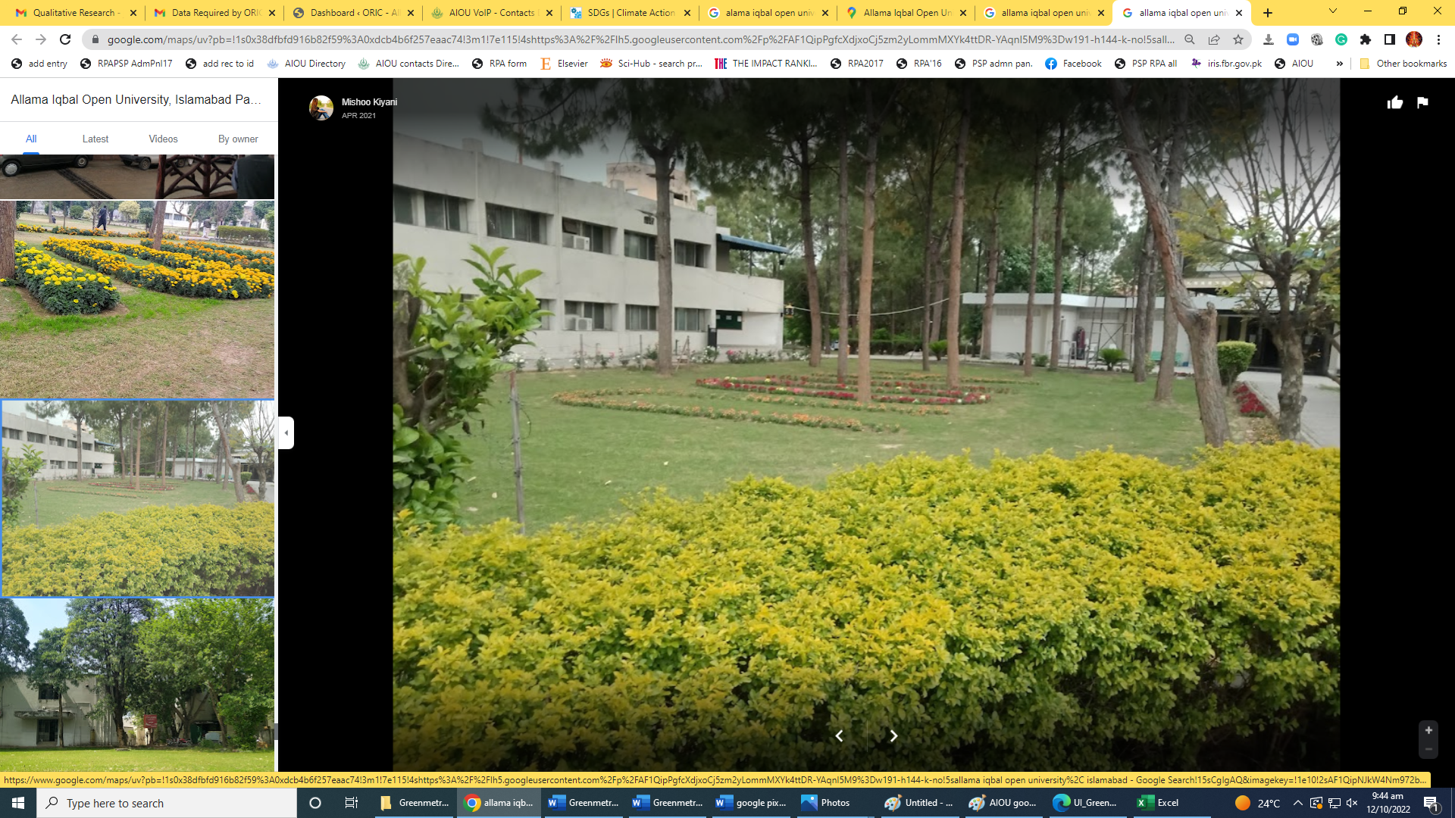
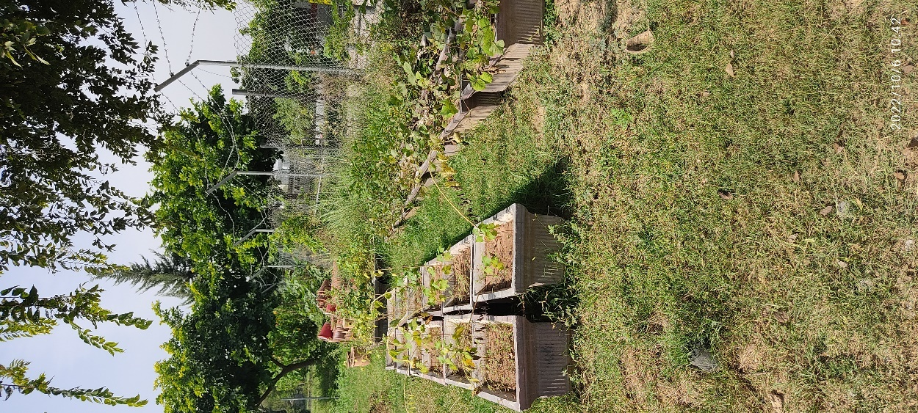
Planted vegetation at different university parts

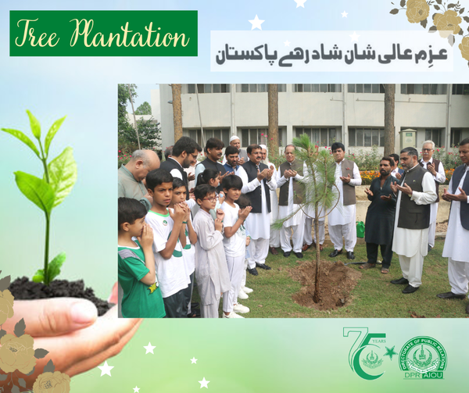
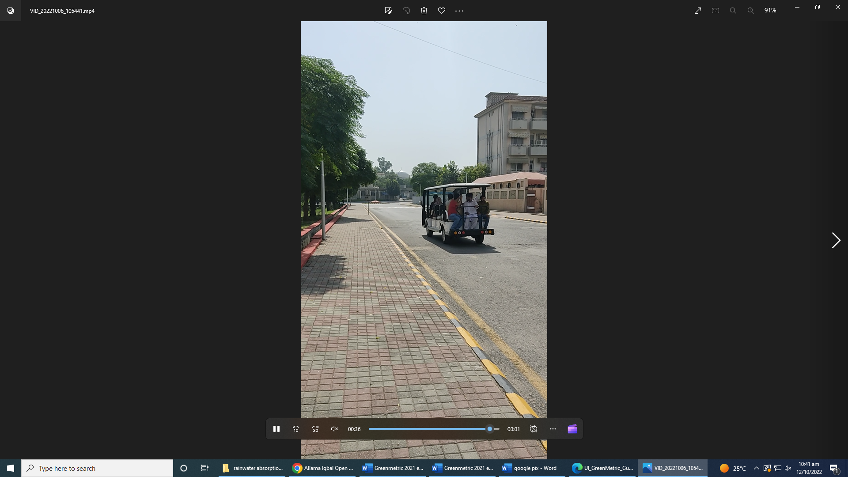
Zero-Emission Vehicle

- Free Accessible Lecturers on SDG 13
- https://www.youtube.com/watch?v=UhO8XHFUcDg

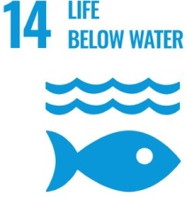
SUSTAINABLE DEVELOPMENT GOAL 14 – LIFE BELOW WATER

Conserve and sustainably use the oceans, seas and marine resources for sustainable development

- RESEARCH & INNOVATION
- The university can proudly boast the work of its faculty members in the context of LIFE BELOW WATER as in the last 10 years university has published 25 Research Publications that are relevant to target SDG
- 7 Research grants have been won by the various faculty members that are relevant to target SDG
- TEACHING & STUDENTS
- Various departments of the university are running about 08 courses that are relevant to target SDG
- Link to course inventory http://oric.aiou.edu.pk/?page_id=1748
- OPERATIONS
- The department of Agricultural Sciences is eagerly working with all their resources for LIFE BELOW WATER by various courses, publications, activities and student internships. Overall, 8 faculty members are currently engaged in the working of this SDG and adding their due share in the betterment of life of people
- University has built various water absorption areas and rain water collection repository.
- AIOU has constructed three water recharge wells at the campus with the technical assistance of the PCRWR team in 2021. These wells are fully operational and play their role in recharging depleted zones of underground water. Maximum rainwater is being harvested from catchment areas and sent back to underground from aquifer recharge.
- Rain water collection points are installed at main campus and some of the regional campuses where collected rain water from the roofs of the buildings is discharged into the local ponds and canals around the buildings. The rainwater collected is used mainly for toilet flushing and for watering the plants inside the building and washing buses.
- AIOU plays an active role in creating mass awareness on water conservation.
- Additional Links: https://www.youtube.com/watch?v=H4kVmG4Zlj4
- https://www.youtube.com/watch?v=VvY4AaclyIE
- Free Accessible Lecturers on SDG 14
- https://www.youtube.com/watch?v=UhO8XHFUcDg

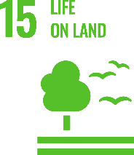
SUSTAINABLE DEVELOPMENT GOAL 15 – LIFE ON LAND

Protect, restore and promote sustainable use of terrestrial ecosystems, sustainably manage forests, combat desertification, and halt and reverse land degradation and halt biodiversity loss

- RESEARCH & INNOVATION
- The university can proudly boast the work of its faculty members in the context of LIFE ON LAND as in the last 10 years university has published 116 Research Publications that are relevant to this SDG.
- 19 Research grants have been won by the various faculty members that are relevant to target SDG
- TEACHING & STUDENTS
- Various departments of the university are running about 27 courses that are relevant to target SDG
- Link to course inventory http://oric.aiou.edu.pk/?page_id=1748
- Student support schemes/Facilities provided to students relevant to target SDG (data from DSA)
- OPERATIONS
- The department of Agricultural Sciences, Department of Biology and Department of Environmental Sciences are eagerly working with all their resources for LIFE ON LAND by various courses, publications, activities and student internships. Overall, 16 faculty members are currently engaged in the working of this SDG and adding their due share in the betterment of life of people
- AIOU’s any policy relevant to target SDG. Please give its link. (Policy reference with name and year of initiation)
- UNIVERSITY ACTIVITY/NEWS RELATED TO SDG
Green Pakistan: AIOU holds plantation drive
https://tribune.com.pk/story/1661390/green-pakistan-aiou-holds-plantation-drive
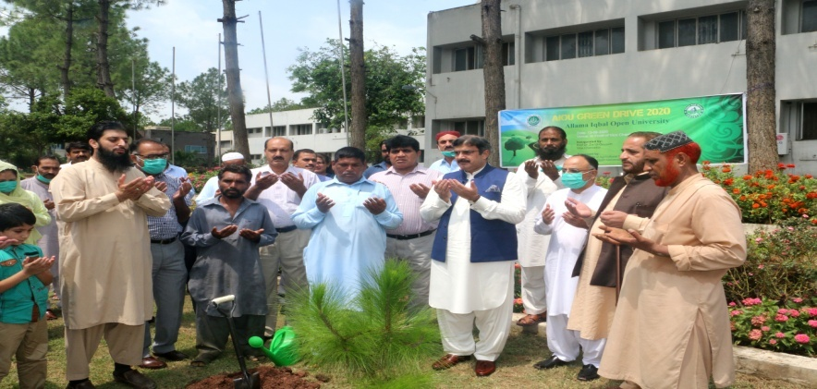
AIOU holds awareness walk for PM’s Green Pakistan campaign
https://dailytimes.com.pk/335388/aiou-holds-awareness-walk-for-pms-green-pakistan-campaign/
AIOU Olive tree plantation drive at Main Campus, Islamabad
Spring Tree Plantation Campaign begins at AIOU
https://www.pakistanpoint.com/en/story/576085/spring-tree-plantation-campaign-begins-at-allama-iqbal.html
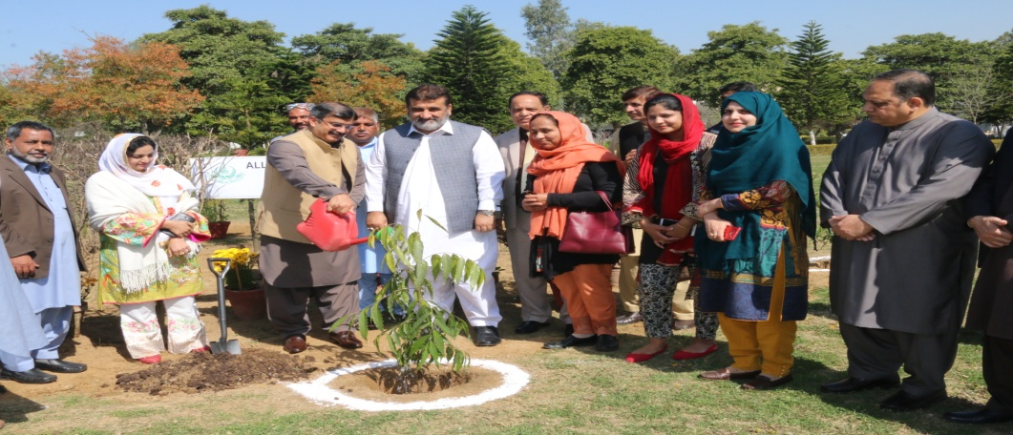

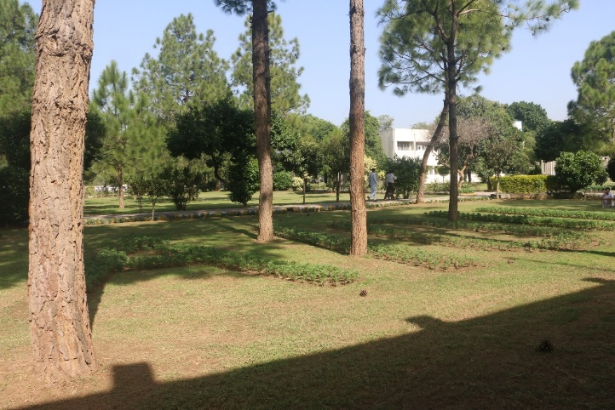
University owns plant nursing system

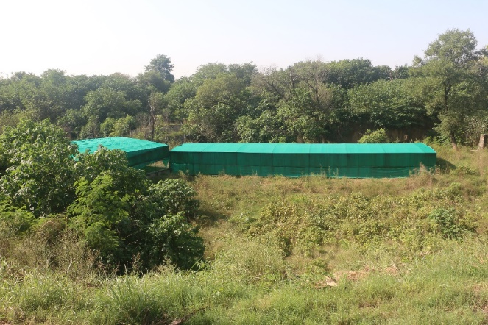
“AIOU’s Green Houses”

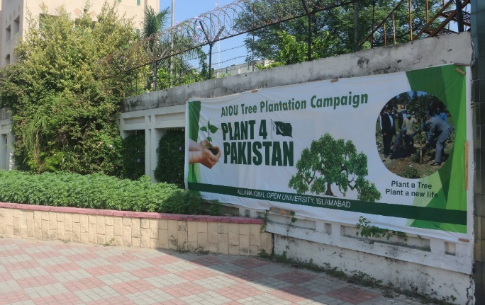
Plant a tree Program

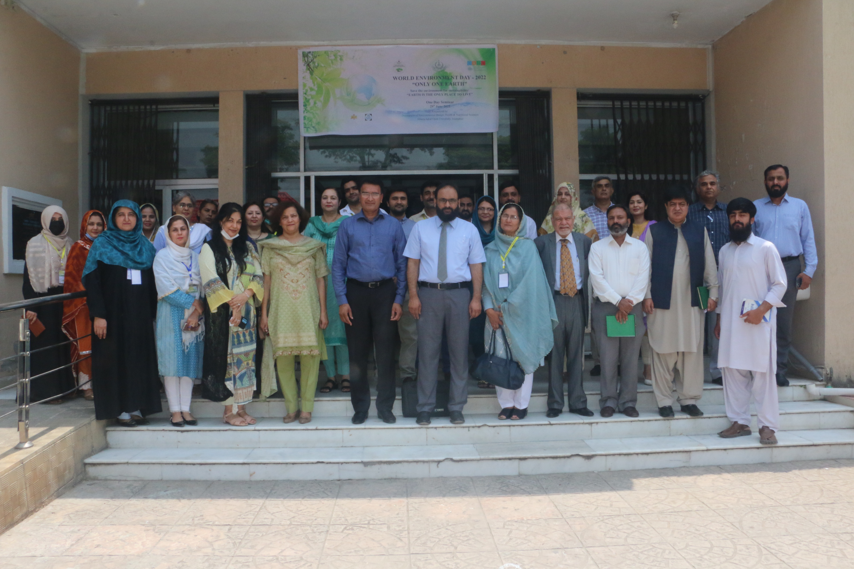
One-day Seminar on “World Environment Day” on June 29, 2022
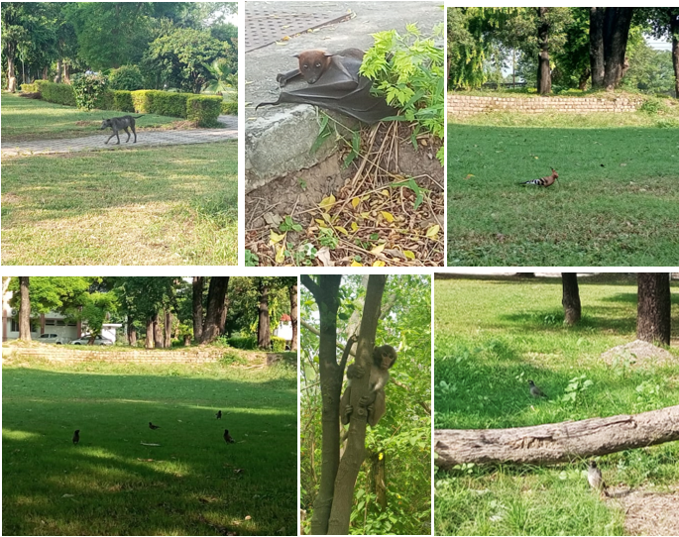
Animals/Wildlife at AIOU
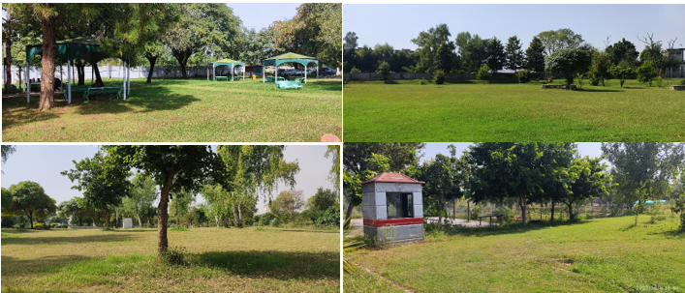

Carbon free Zones

- Free Accessible Lecturers on SDG 15
https://www.youtube.com/watch?v=UhO8XHFUcDg

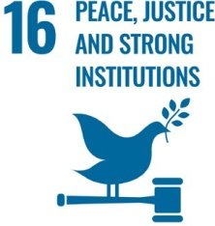
SUSTAINABLE DEVELOPMENT GOAL 16 – PEACE, JUSTICE AND STRONG INSTITUTIONS

Promote peaceful and inclusive societies for sustainable development, provide access to justice for all and build effective, accountable and inclusive institutions at all levels

- RESEARCH & INNOVATION
- The university can proudly boast the work of its faculty members in the context of PEACE, JUSTICE AND STRONG INSTITUTIONS as in the last 10 years university has published 184 Research Publications that are relevant to target SDG (34)
- 08 Research grants have been won by the various faculty members that are relevant to target SDG (01)
- TEACHING & STUDENTS
- Various departments of the university are running about 10 courses that are relevant to target SDG
- Link to course inventory http://oric.aiou.edu.pk/?page_id=1748
- OPERATIONS
- The department of Sociology, Law Department and Department of Islamic Jurisprudence are eagerly working with all their resources for PEACE, JUSTICE AND STRONG INSTITUTIONS by various courses, publications, activities and student internships. Overall, 09 faculty members are currently engaged in the working of this SDG and adding their due share in the betterment of life of people
- UNIVERSITY ACTIVITY/NEWS RELATED TO SDG
AIOU holds solidarity walk to project Kashmir cause
https://www.thenews.com.pk/print/610211-aiou-holds-solidarity-walk-to-project-kashmir-cause
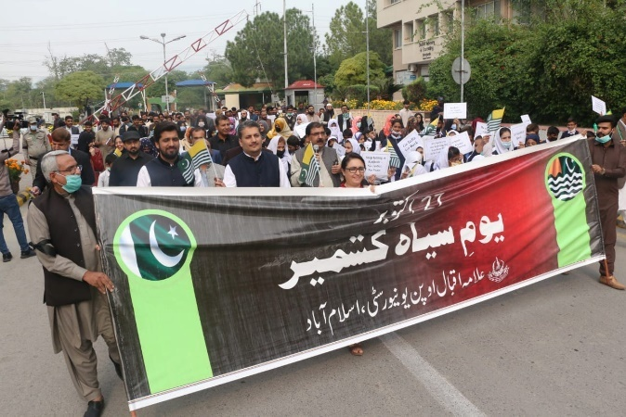
Christmas Celebration at AIOU
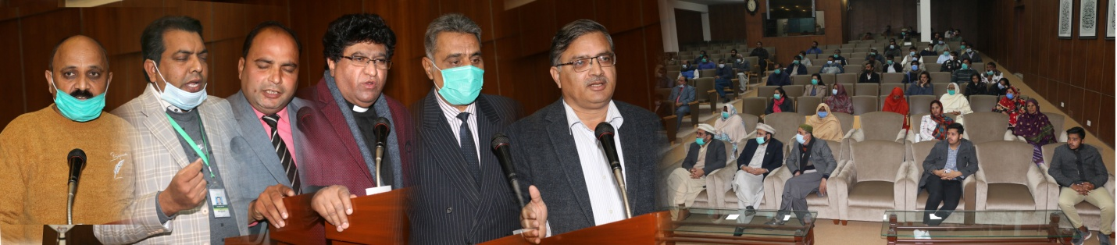
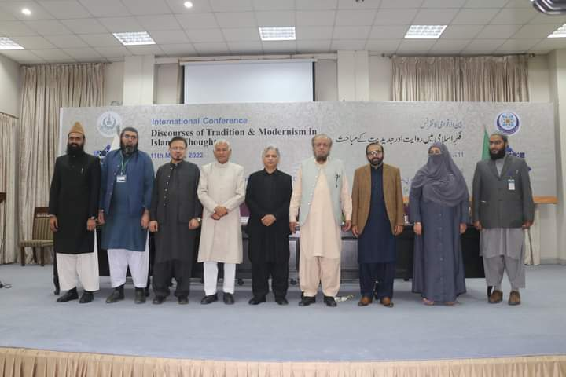
International Conference on Discourses of Tradition and Modernism in Islamic Thought
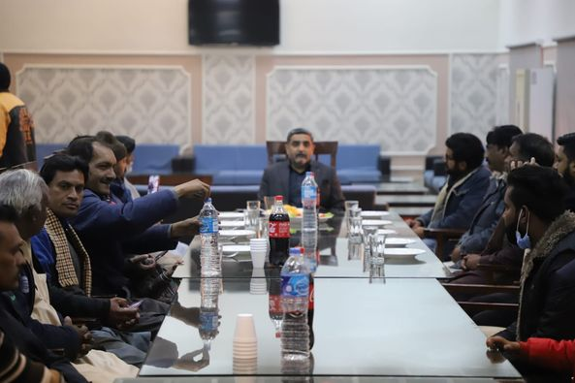
Christmas Celebrations
Lunch on the eve of Chrsitmas to celebrate with Love and Joy.

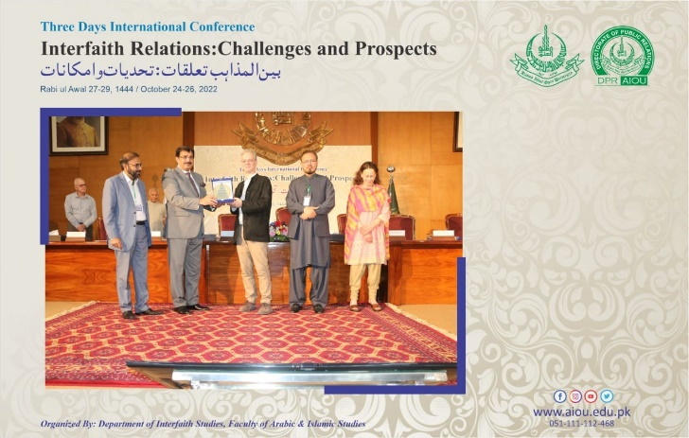
International Conference on Interfaith Relations, Challenges and Prospects
- Free Accessible Lecturers on SDG 16
https://www.youtube.com/watch?v=UhO8XHFUcDg

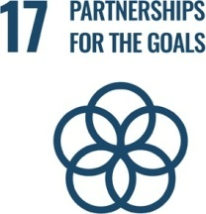
SUSTAINABLE DEVELOPMENT GOAL 17 – PARTNERSHIPS FOR THE GOALS

Strengthen the means of implementation and revitalize the global partnership for sustainable development

- RESEARCH & INNOVATION
- The university can proudly boast the work of its faculty members in the context of PARTNERSHIPS FOR THE GOALS as in the last 10 years university has published 81Research Publications that are relevant to target SDG (16)
- 10 Research grants have been won by the various faculty members that are relevant to target SDG (06)
- TEACHING & STUDENTS
- Various departments of the university are running about 5 courses that are relevant to target SDG
- Link to course inventory http://oric.aiou.edu.pk/?page_id=1748
- Student support schemes/Facilities provided to students relevant to target SDG (data from DSA)
- OPERATIONS
- The faculty of sciences, faculty of education, department of business administration and commerce Department are eagerly working with all their resources for PEACE, PARTNERSHIPS FOR THE GOALS by various courses, publications, activities and student internships. Overall, 114 faculty members are currently engaged in the working of this SDG and adding their due share in the betterment of life of people
- AIOU’s any policy relevant to target SDG. Please give its link. (Policy reference with name and year of initiation)
- OUTREACH & PARTNERSHIP
- AIOU reaches out to international students

International collaborations with the other academic institutes
- USEFP Fulbright Scholarship
- Commonwealth
- Association of Commonwealth Universities (ACU) / Chevening
- Erasmus +
- Australia Award Scholarship
- DAAD, Germany
- Chinese Scholarship Council (CSC)
- Jiangsu University, China
- University of Leicester, UK
- UNIVERSITY ACTIVITY/NEWS
AIOU to provide education to afghan refugees
https://nation.com.pk/20-apr-2020/aiou-to-provide-education-to-afghan-refugees

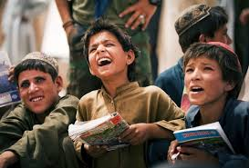

Aiou and Zong ink mou to facilitate students, employees
https://islamabadpost.com.pk/aiou-zong-ink-mou-to-facilitate-students-employees/
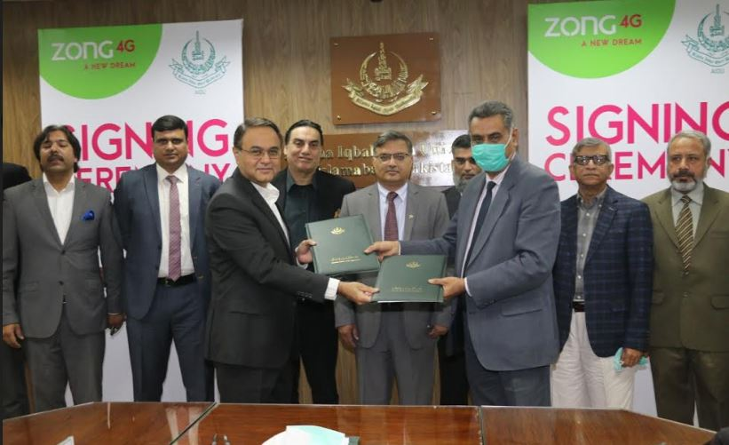
AIOU signs MOU with Hazara University for cooperation
https://dnanews.com.pk/aiou-signs-mou-hazara-university-cooperation/
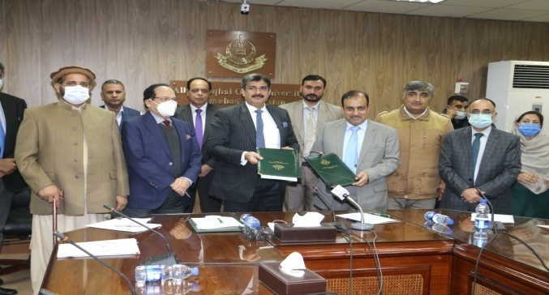

Alight Pakistan signs MOU with AIOU

http://millionkidstoschool.org/p_detail.php?act=news-events&post=alight-pakistan-signs-mou-with-aiou&i=iyiwe

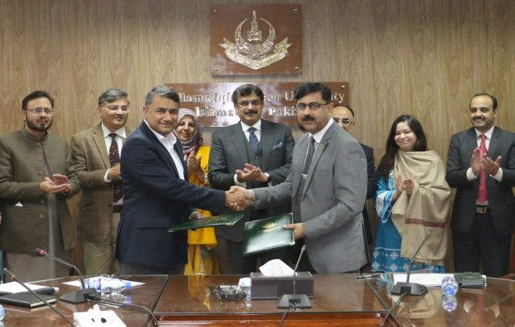

Universitas Terbuka (UT) signed a memorandum of understanding (MOU) with Allama Iqbal Open University (AIOU)

https://www.ut.ac.id/en/news/2019/10/ut-collaborates-aiou-pakistan

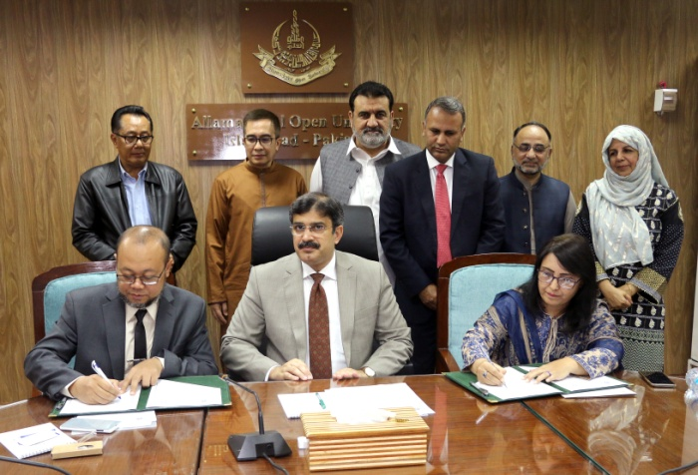
Two Chinese language centers being set up at AIOU

https://dailytimes.com.pk/405677/two-chinese-language-centres-being-set-up-at-aiou/

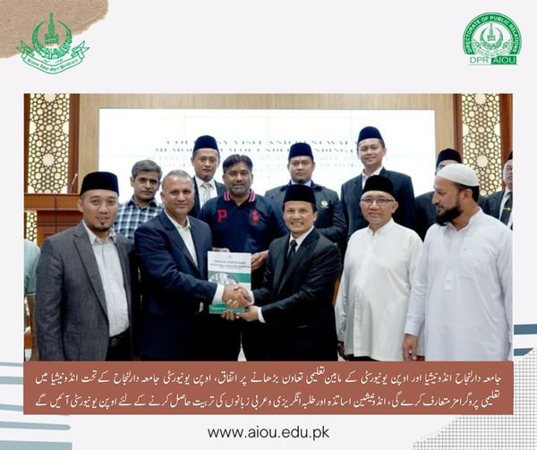
- AIOU Collaboration with Indonesian Open University
- AIOU reaches out to international students (https://tribune.com.pk/story/2343680/aiou-reaches-out-to-international-students)
- Professors, academicians from Turkey visit AIOU (https://www.app.com.pk/national/professors-academicians-from-turkey-visit-aiou/)
- AIOU Inks MoU With Necmettin Erbakan University, Turkey (https://www.urdupoint.com/en/pakistan/aiou-inks-mou-with-necmettin-erbakan-universi-1569301.html)
- AIOU all set to establish regional office in Afghanistan (https://dailytimes.com.pk/853984/aiou-all-set-to-establish-regional-office-in-afghanistan/)
- AIOU starts six-week training course in GB’ Skardu to boost tourism sector (https://dailytimes.com.pk/821992/aiou-starts-six-week-training-course-in-gb-skardu-to-boost-tourism-sector/)
- AIOU Announces Fully Funded PhD Scholarships for UK (https://propakistani.pk/2022/08/30/aiou-announces-fully-funded-phd-scholarships-for-uk/)

- 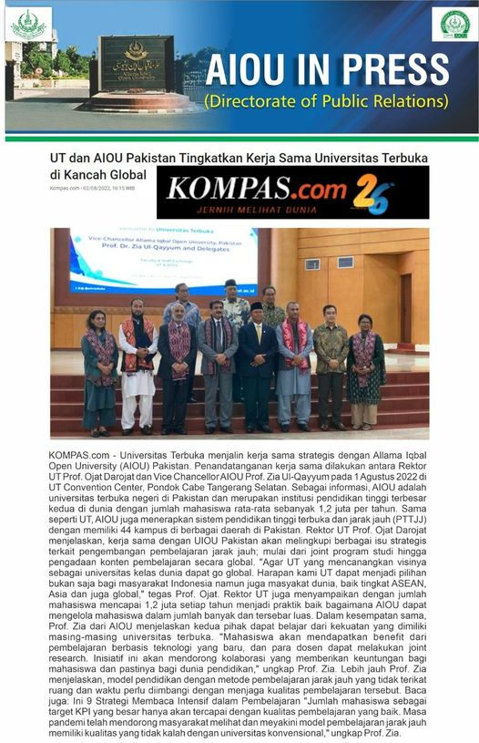
- AIOU delegation meets Indonesian education officials

(https://www.thenews.com.pk/print/980381-aiou-delegation-meets-indonesian-education-officials)
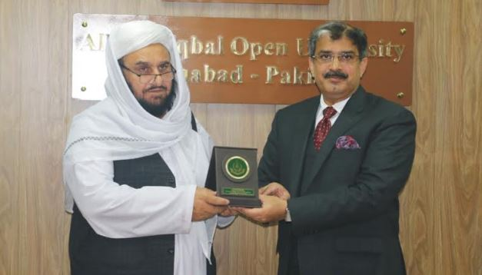
- Afghan education Minister seeks AIOU’s help in reconstruction of educational infrastructure (https://www.app.com.pk/national/afghan-education-minister-seeks-aious-help-in-reconstruction-of-educational-infrastructure/)

- 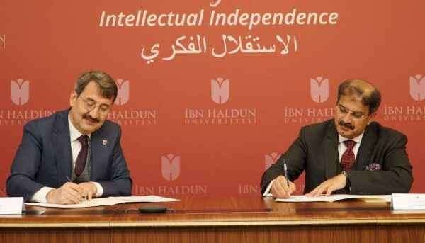 Ibn Haldun University (IHU) and Pakistan’s largest and the world’s second largest university, Allama Iqbal Open University (AIOU), signed a Memorandum of Understanding today at Ibn Haldun University Main Campus.( https://www.ihu.edu.tr/en/ibn-haldun-university-signs-mou-with-allama-iqbal-open-university)

- 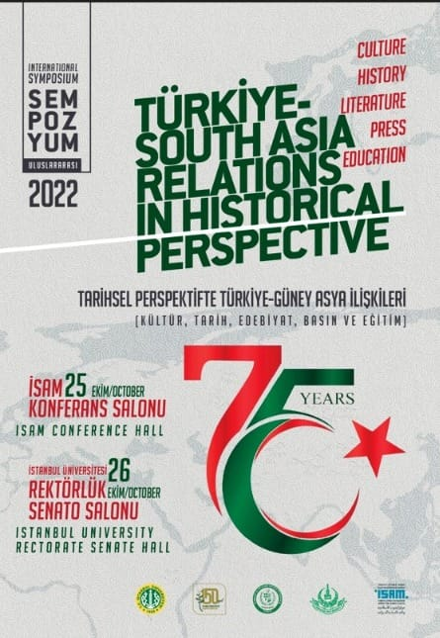
- AIOU in-collaboration with University of Istanbul organizing two days international symposium "Turkiye-South Asia Relations in Historical Perspectives (Pakistan Embassy in Turkey is our partner and celebrating 75 years of Pakistan-Turkiye Friendship).
- AIOU to host CINVU general assembly (https://www.thenews.com.pk/print/956563-aiou-to-host-cinvu-general-assembly-tomorrow)
- 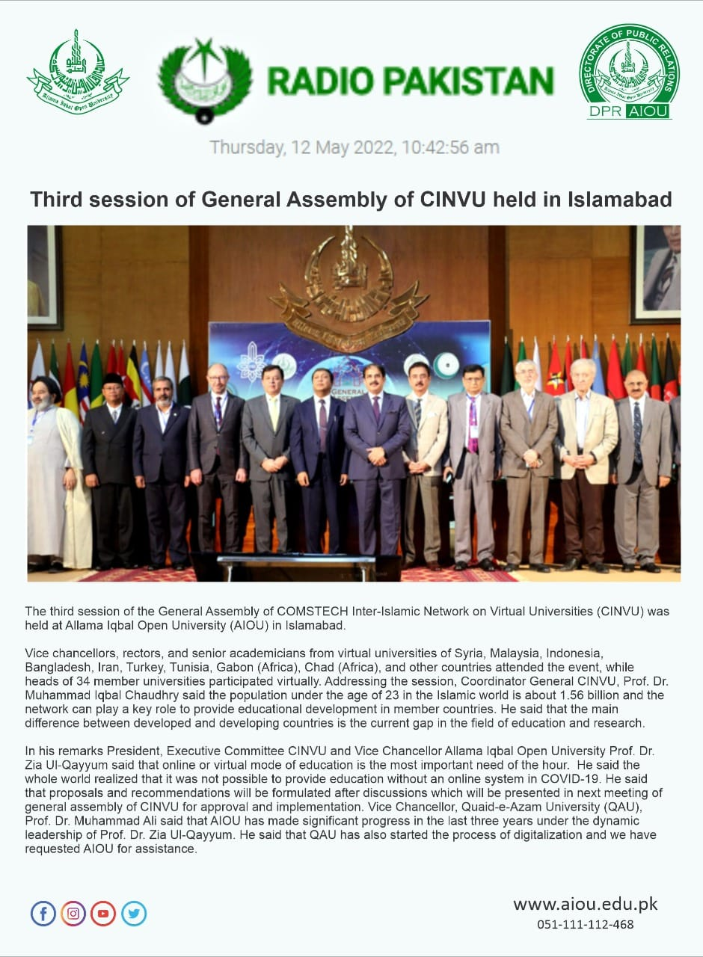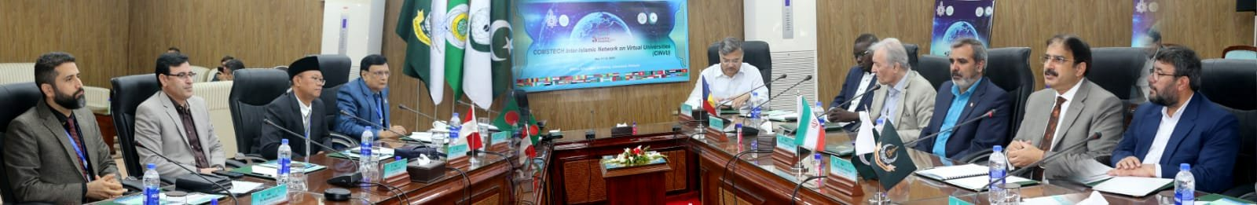

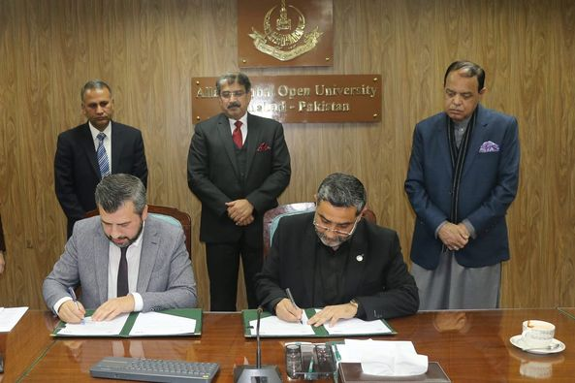

AIOU signs letter of Intent with ILKE Foundation Istanbul.

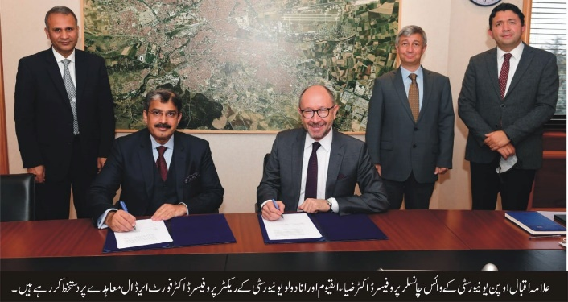

Allama Iqbal Open University (AIOU) and Anadolu University, Turkey signed an MoU for developing exchange programmes for academia, students, administrative staff and assisting each other in the relevant academic fields for their mutual benefit.
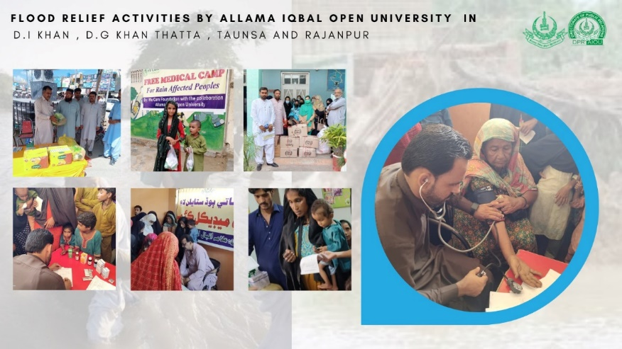
- Free Accessible Lecturers on SDG 17
https://www.youtube.com/watch?v=UhO8XHFUcDg

2021

ALLAMA IQBAL OPEN UNIVERSITY, ISLAMABAD PAKISTAN
Office of Research, Innovation & Commercialization (ORIC)

