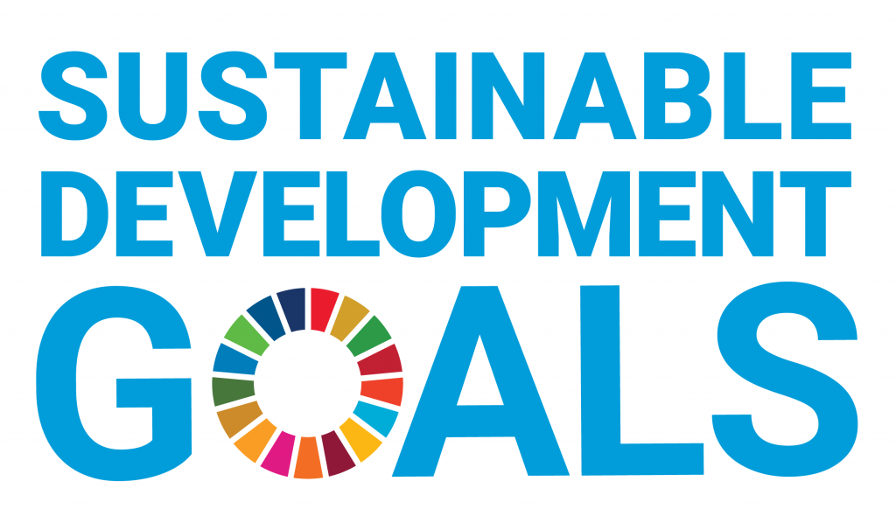

By

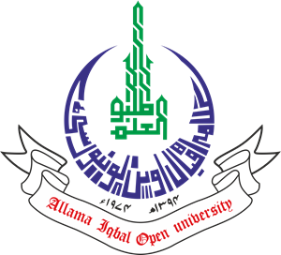

A conceptual report of key facts and figures about the Allama Iqbal Open University’s impact upon and progress towards the UN Sustainable Development Goals
November, 2020

Allama Iqbal Open University
Office of Research, Innovation & Commercialization (ORIC)
Block No. 21, Allama Iqbal Open University, Sector H-8, Islamabad, Pakistan
Telephone No. 051-9250096, 051-9057725/7423. Email: oric@AIOU.edu.pk

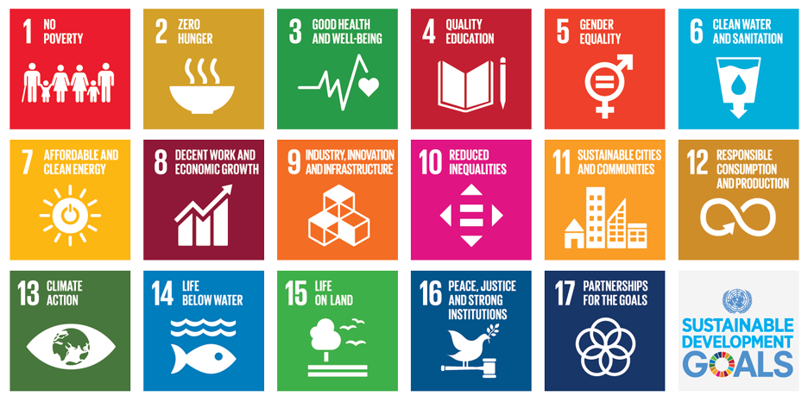
The Allama Iqbal Open University was established in 1974 with the main objectives of providing educational opportunities to masses and to those who cannot leave their homes and jobs. It was the second Open University in the world and first in Asia and Africa. During all these past years, the University has more than fulfilled this promise and has opened up new opportunities for millions, particularly women, and supplemented the efforts of the federal and provincial governments in a big way and that too without becoming a burden on their resources.
At present the University have four faculties (Faculty of Sciences, Faculty of Social Sciences & Humanities, Faculty of Arabic & Islamic Studies and Faculty of Education) comprised of 35 academic departments with average student enrolment of more than 1.4 million per year, where more than 50% are females, and more than 2000 courses are being offered. AIOU has a network of 54 regional offices/campuses throughout the Pakistan. More than 70 percent of its students are employed.
AIOU Started its LMS network even before Covid-19 and has biggest network named Agahi for online tutorship. Agahi has complete image of students’ tutorial record and alternative relevant info as well as their profile. AIOU has well established Institute of Educational Technology (IET) having in-house facilities for production of TV, Radio and non-broadcast programmes. AIOU is also a member of “PTV Tele-school” production team which is a dedicated channel for tele education. The University has its own printing press named Print Production Unit producing lacs of course books and billions of pages of other supplementary materials and admission forms etc. AIOU has strong collaborative networks with national and international universities and other organizations.
About this report: This document is a conceptual report of the Allama Iqbal Open University’s impact upon and progress towards the United Nations Sustainable Development Goals. The data and narrative in this report are factually based on the available data from areas spanning research impact, education, responsible operations and public engagement. Allama Iqbal Open University is a world leading distance learning institution and understands its role in tackling the SDGs.

TABLE OF CONTENTS

Introduction: Sustainable Development Goals at AIOU------------------------------------------------xx
Sustainable Development Goal 1 – NO POVERTY------------------------------------------------------1
Sustainable Development Goal 2 – ZERO HUNGER ---------------------------------------------------4
Sustainable Development Goal 3 – GOOD HEALTH AND WELL BEING-------------------------6
Sustainable Development Goal 4 – QUALITY EDUCATION------------------------------------------9
Sustainable Development Goal 5 – GENDER EQUALITY--------------------------------------------12
Sustainable Development Goal 6 - CLEAN WATER AND SANITATION--------------------------15
Sustainable Development Goal 7 – AFFORDABLE AND CLEAN ENERGY ---------------------16
Sustainable Development Goal 8 – DECENT WORK AND ECONOMIC GROWTH -----------18
Sustainable Development Goal 9 – INDUSTRY, INNOVATION AND INFRASTRUCTURE--20
Sustainable Development Goal 10 – REDUCED INEQUALITIES ----------------------------------22
Sustainable Development Goal 11 – SUSTAINABLE CITIES AND COMMUNITIES-----------24
Sustainable Development Goal 12 – RESPONSIBLE CONSUMPTION AND PRODUCTION-26
Sustainable Development Goal 13 – CLIMATE ACTION-----------------------------------------------27
Sustainable Development Goal 14 – LIFE BELOW WATER ------------------------------------------28
Sustainable Development Goal 15 – LIFE ON LAND ---------------------------------------------------29
Sustainable Development Goal 16 – PEACE, JUSTICE AND STRONG INSTITUTIONS------32
Sustainable Development Goal 17 – PARTNERSHIPS FOR THE GOALS-------------------------34
Appendix: ------------------------------------------------------------------------------------------------------------xx
Methodology and sources ---------------------------------------------------------------------------------------xx
Keywords ------------------------------------------------------------------------------------------------------------xx

INTRODUCTION
The 2030 Agenda for Sustainable Development and the 17 Sustainable Development Goals (SDGs) were adopted by all UN member states in 2015 and set out an ambitious plan for ending poverty, fighting inequality and building peaceful, just and sustainable societies by 2030. Achieving the SDGs will require the concerted efforts of all members of society. Universities are particularly well-placed to contribute to the creation of a sustainable future through their research and teaching activities. Universities at the forefront of research generate new knowledge and innovations that provide solutions to the interconnected social, economic and environmental challenges captured in the SDGs. As educators, universities equip students with the knowledge and skills that enable them to contribute to creating a sustainable future.
Being one of the world’s leading research-oriented distance learning institutions and one of the universities to have social responsibility as a core goal in Pakistan, AIOU is playing a leading role in tackling the SDGs in four ways – through research, teaching learning process, public engagement activities and responsible campus operations.
This report on SDG’S by AIOU has introduced a number of case studies on some of the initiatives that are contributing towards the UN goals. They are inspiring examples of how Allama Iqbal Open University champions education, research and best practice for sustainable development. The University offers a range of degrees and individual initiatives that cover vital issues raised by the SDGs. Conducting cutting-edge and critical research on the SDGs, implementation and effects; employees’ contribution to policy agendas though their work with development agencies and other organizations.
At Allama Iqbal Open University, the role of university in sustainable development extends beyond its role in research and teaching. AIOU is also contributing to the SDGs through their policies and practice, and working hard to ensure continuous improvement and lead by example. Additionally, there are many sustainability related activities and operations happening across all campuses related to research, innovation, teaching, operations, outreach, and partnership that identified as being related to SDGs.
AIOUrecognizes and embraces its responsibility in the transition to a sustainable future. The University is committed to ensure that all activities, be it research, teaching, community service or operations, advance to a place that is better for humanity and planet. In this report, the outline of some of the many activities in the University that contribute to the achievement of the SDGs is placed. Since, it is not possible to capture all the amazing work of our staff and students that occurs across research, teaching, engagement/outreach and operations. However, the selection presented here gives an appreciation of the kinds of activities happening within the University that are setting a path to a more ‘sustainable future for all’.
SDG Report 2020 by Allama Iqbal Open University provides examples of a range of initiatives our people are leading in pursuit of the goals set in the UN agenda 2030.

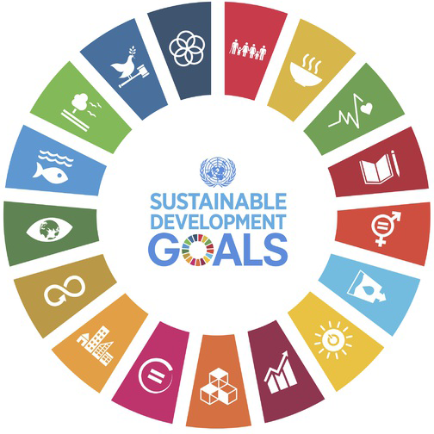

ALLAMA IQBAL OPEN UNIVERSITY, ISLAMABAD PAKISTAN
Office of Research, Innovation & Commercialization (ORIC)

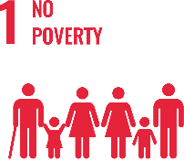
SUSTAINABLE DEVELOPMENT GOAL 1 – NO POVERTY

End poverty in all its forms everywhere

- RESEARCH & INNOVATION
- The university can proudly boast the work of its faculty members in the context of No Poverty, as in the last 10 years university has published 28 Research Publications that are relevant to SDG 1.
- 6 Research grants have been won by the various faculty members that are relevant to SDG 1.
- TEACHING & STUDENTS
- Various departments of the university are running about 32 academic courses that are relevant to SDG 1.
- Link to course inventory http://oric.aiou.edu.pk/?page_id=1748
- AIOU is providing student support schemes/facilities to students relevant to SDG 1:
- Financial Support Scheme Ssf-101
- Earn to Learn Scheme Ssf-102
- Merit Scholarship Scheme Ssf-103
- Final Year Project Grant Ssf-105
- Scholarship For Communities Scheme Ssf-106
- Matric Free Education Plan (Balochistan, Fata & Gilgit Baltistan)
- Free education to transgender from Matric till Ph.D.
- OPERATIONS
- The department of Business Administration and the department of Commonwealth is eagerly working with all its attributes in the upholding of no poverty by offering various academic courses, publications, activities and student internships. Overall, 15 faculty members are currently engaged in the working of this SDG and adding their due share in the betterment of life of people.
- The approval and sanction of Disparity Reduction Allowance 11thJune, 2021 was a milestone in the improvement of the financial condition of the employees and their families.

- PUBLIC ENGAGEMENT
- Webinar on “Innovation & Entrepreneurship” on Wednesday, the 3rd February, 2021.
- One Day Interactive Workshop on “Awareness of Opportunities for International Career Paths”- A Initiative for Faculty Development and Students Career Opportunities.
- Webinar on “Turning Research into Business” on September 15, 2020
- One Day Workshop on ‘Startup Entrepreneurship- Owning your Future’ – 5th Dec 2019
- Seminar on “Entrepreneurship” – 12 Sep 2019
- OUTREACH & PARTNERSHIP
- Inclusive Education in Pakistan: Experiences and Lessons Learned from the Engage Project that is Funded by: USAID and it was Concluded in: 2009-10
- Establishment of National Center of Curriculum Studies and Educational Assessment at AIOU (NCCS&EA): Funded by Higher Education Commission, Pakistan that was concluded in 2015-16 with a capital cost of Rs. 24.244 mil.
- Girl Power Program (GPP): Funded by PLAN Int that was concluded in 2015-16with a Capital Cost of Rs. 7,36,80916/
- Building Skills for Life (BS4L) (Elementary): Funded by DFID, PLAN Int. for Sajawal/Thatta that was concluded in 2015-16 with a Capital Cost: Rs.2,09,51094/
- Building Skills for Life (BS4L) (Matric): Funded by DFID, PLAN Int. for Sajawal/Thatta that was Concluded in 2016-18 with a Capital Cost: Rs. 75,00000 (approximately)
- Empowering Girls from Marginalized Rural Families for Continuing Education: Funded by UNESCO & PLAN Int. --- Sanjh Preet that was Concluded in: 2018 with a Capital Cost: Rs. 38,22,176/
- Content Development and Capacity Building … CA13-100 : Funded by Common Wealth of Learning (COL) that was Concluded in: 2016-2017 with a Capital Cost: CAD 22704 /
- UNIVERSITY ACTIVITY/NEWS RELATED TO SDG
- Laptop Distribution Ceremony for AIOU Students on Dec 26, 2020
https://www.urdupoint.com/en/pakistan/laptop-distribution-ceremony-for-AIOU-student-79387.html
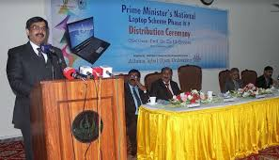

- More Laptop Distribution Pictures in different campuses
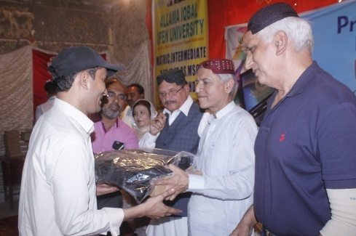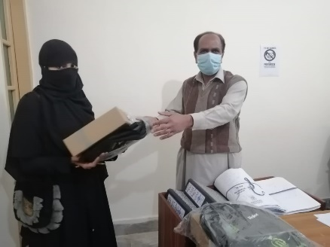

- Webinar on “Turning Research into Business” on September 15, 2020
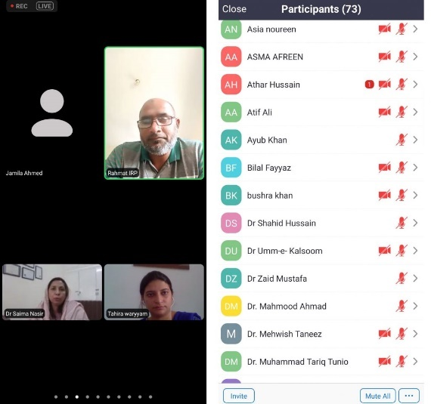
- Free Accessible Lecturers
https://www.youtube.com/watch?v=UhO8XHFUcDg

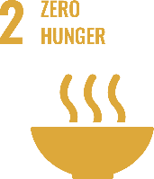
SUSTAINABLE DEVELOPMENT GOAL 2 – ZERO HUNGER

End hunger, achieve food security and improved nutrition and promote sustainable agriculture

- RESEARCH & INNOVATION
- The university can proudly boast the work of its faculty members in the context of Zero Hunger, as in the last 10 years the university has published 55 Research Publications that are relevant to SDG 2.
- 11 Research grants have been won by the various faculty members that are relevant to SDG 2.
- TEACHING & STUDENTS
- Number of academic courses relevant to SDG 2 are 38 and only Agricultural Sciences is running about 13 relevant courses.
- Link to course inventory http://oric.aiou.edu.pk/?page_id=1748
- AIOU is providing student support schemes/facilities to students relevant to SDG 2 such as:
- FINANCIAL SUPPORT SCHEME SSF-101
- EARN TO LEARN SCHEME SSF-102
- MERIT SCHOLARSHIP SCHEME SSF-103
- FINAL YEAR PROJECT GRANT SSF-105
- SCHOLARSHIP FOR COMMUNITIES SCHEME SSF-106
- OPERATIONS
- The department of Environmental Design, Health and Nutritional Sciences and Agricultural sciences is eagerly working with all its attributes in the upholding of Zero Hunger by offering various academic courses, publications, activities and student internships. Overall, 16 faculty members are currently engaged in the working of this SDG and adding their due share in the betterment of life of people.
- PUBLIC ENGAGEMENT
- Department of Agricultural Sciences is giving technical assistance and generating skills in the Farmers of the Locality.
- Framers Day is being organized at AIOU.
- Field Demonstration facilities are given to the farmers.
- Webinar on “Innovation & Entrepreneurship” on Wednesday, the 3rd February, 2021
- One Day Interactive Workshop on “Awareness of Opportunities for International Career Paths”- An Initiative for Faculty Development and Students Career Opportunities.
- Webinar on “Turning Research into Business” on September 15, 2020.
- One Day Workshop on ‘Startup Entrepreneurship- Owning your Future’ – 5th Dec 2019.
- Seminar on “Entrepreneurship” – 12 Sep 2019.
- OUTREACH & PARTNERSHIP:
- Department of Agriculture Sciences is working with national and International universities PCRWR, NARC, PARC, AARI, Faisalabad, Aurat Foundation, The network of consumer protection, FAO. Asian Disaster Preparedness Center (ADPC) to promote activities related to zero hunger.
- Building Skills for Life (BS4L) (Elementary): Funded by DFID, PLAN Int. for Sajawal/Thatta that was concluded in 2015-16 with a Capital Cost: Rs.2,09,51094/
- Building Skills for Life (BS4L) (Matric): Funded by DFID, PLAN Int. for Sajawal/Thatta that was Concluded in 2016-18 with a Capital Cost: Rs. 75,00000 (approximately)
- Empowering Girls from Marginalized Rural Families for Continuing Education: Funded by UNESCO & PLAN Int. --- Sanjh Preet that was Concluded in: 2018 with a Capital Cost: Rs. 38,22,176/
- Content Development and Capacity Building … CA13-100 : Funded by Common Wealth of Learning (COL) that was Concluded in: 2016-2017 with a Capital Cost: CAD 22704 /
- Farmers Training on Kitchen Gardening and Olives Plantation Drive
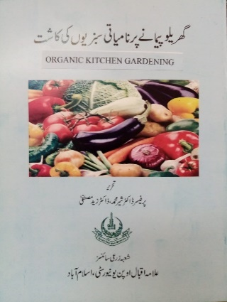
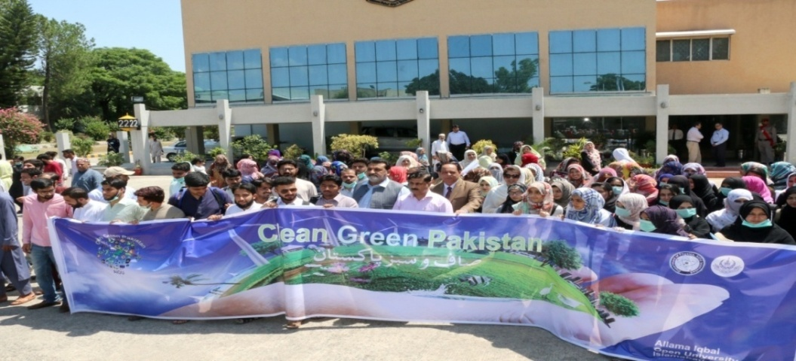
AIOU Olive tree plantation drive at Main Campus, Islamabad Kitchen Gardening Training
- Training of more than 2500 farmers across the country.
- Training on “Kitchen Gardening” to local community
- FREE ACCESSIBLE LECTURERS ON SDG 2
https://www.youtube.com/watch?v=UhO8XHFUcDg

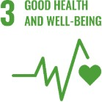
SUSTAINABLE DEVELOPMENT GOAL 3 – GOOD HEALTH AND WELL BEING

Ensure healthy lives and promote well-being for all at all ages.

- RESEARCH & INNOVATION
- The university can proudly boast the work of its faculty members in the context of Good Health and Wellbeing, as in the last 10 years university has published 144 Research Publications that are relevant to SDG 3.
- 21 Research grants have been won by the various faculty members that are relevant to SDG 3.
- TEACHING & STUDENTS
- Various departments of the university are running about 104 courses that are relevant to SDG 3.
- Link to course inventory http://oric.aiou.edu.pk/?page_id=1748
- OPERATIONS
- The department of Environmental Design, Health and Nutritional Sciences, and department of Agricultural Sciences are eagerly working with all their attributes in the upholding of Good Health and Wellbeing by offering various academic courses, publications, activities and student internships. Overall, 21 faculty members are currently engaged in the working of this SDG and adding their due share in the betterment of life of people.
- The policy of Smoke Free Campus: Enforcement of Tobacco Control Laws in Universities of Pakistan proposed on 12th September, 2017 is adopted by the university.
- PUBLIC ENGAGEMENT
- Seminar on awareness related to “PREVENTION OF BREAST CANCER” has been organized by department of Environmental Design, Health and Nutritional Sciences.
- Online Interactive Session on “Breast Cancer Awareness and Screening” held on March 25, 2021
- Training of foster mothers from Rawalpindi division related to child health
- OUTREACH & PARTNERSHIP
- Network for human social development (NHSD)
- Shifa International Hospital
- Scaling up nutrition Pakistan (SUN)
- UNISEF
- University of Dundee
- Kings College London
- Nine Wells Hospital Dundee
- Shifa Eye Trust
- Health Services Academy
- Institute Of Community Ophthalmology
- Rawalpindi Eye Donor Organization REDO
- Marie Adelaide Leprosy Centre
- UNIVERSITY ACTIVITY/NEWS RELATED TO SDG
- First International Conference on Health and Environment in March 2018
- One Day Seminar on “Eat Right Stay Active” in April 2015
- Seminar on Health And Sustainability held on March 2019
- Seminar on Breast Cancer Awareness held on November 2019
- Online Interactive Session on “Breast Cancer Awareness and Screening” held on March 25, 2021
- One Day Community Outreach Event on “Nutrition for Healthier Living” held on 07th October, 2021
- NEWS
- AIOU launched BS Physical Education program
https://nation.com.pk/14-oct-2019/AIOU-to-launch-bs-physical-education-programme
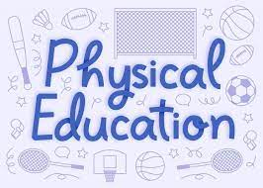
- Early childhood development (ECD) conference arranged by Rupani foundation in collaboration with Allama Iqbal Open University, Islamabad.
https://deafreach.com/early-childhood-development-conference-in-islamabad/
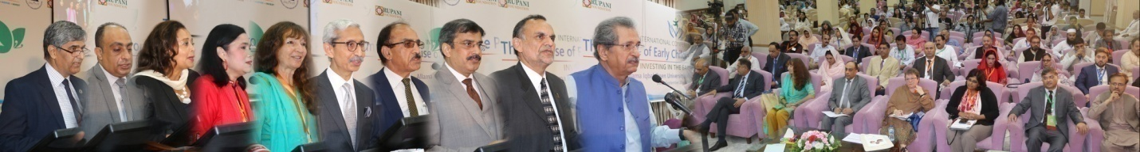
- Seminar on Health & Sustainability held at AIOU, ISB
https://e-updates.com/seminar-on-health-sustainability-held-at-AIOU-isb/
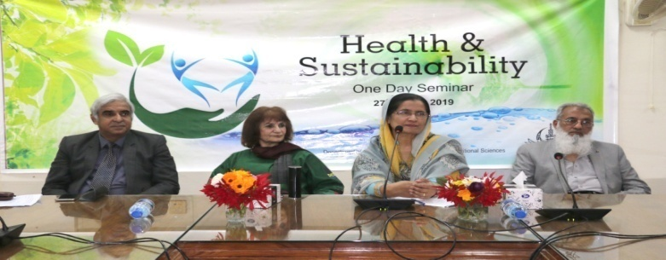
- AIOU holds national seminar on Breast Cancer
https://leadpakistan.com.pk/news/AIOU-holds-national-seminar-on-breast-cancer/
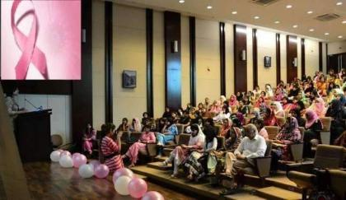
- Euro-Pak Int’l moot on physical education
https://dailytimes.com.pk/481023/euro-pak-intl-moot-on-physical-education-to-be-held-on-friday/
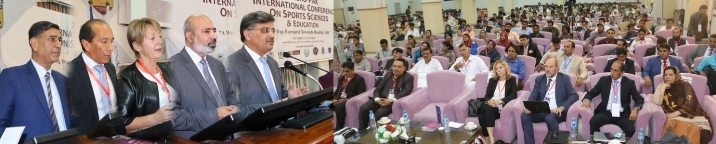
- Free Accessible Lecturers on SDG 3
https://www.youtube.com/watch?v=UhO8XHFUcDg

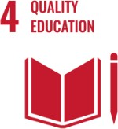
SUSTAINABLE DEVELOPMENT GOAL 4 – QUALITY EDUCATION

Ensure inclusive and equitable quality education and promote lifelong learning opportunities for all

- RESEARCH & INNOVATION
- The university can proudly boast the work of its faculty members in the context of Quality Education, as in the last 10 years university has published 370 Research Publications that are relevant to SDG 4.
- 75 Research grants have been won by the various faculty members that are relevant to SDG 4.
- TEACHING & STUDENTS
- Various departments of the university are running about 117 academic courses that are relevant to SDG 4.
- Link to course inventory http://oric.aiou.edu.pk/?page_id=1748
- AIOU is providing student support schemes/facilities to students relevant to SDG 4 such as:
- FINANCIAL SUPPORT SCHEME SSF-101
- EARN TO LEARN SCHEME SSF-102
- MERIT SCHOLARSHIP SCHEME SSF-103
- FINAL YEAR PROJECT GRANT SSF-105
- SCHOLARSHIP FOR COMMUNITIES SCHEME SSF-106
- OPERATIONS
- The faculty of Education, the department of Environmental Design, Health and Nutritional Sciences and the department of Agricultural Sciences are eagerly working with all their attributes in the upholding of quality education by offering various academic courses, publications, activities and student internships. Overall, 42 faculty members are currently engaged in the working of this SDG and adding their due share in the betterment of life of people.
- PUBLIC ENGAGEMENT
- One Day Webinar on “Entrepreneurial Ideas in Humanities and Social Sciences”, held on March 10, 2021
- Webinar on “Innovation & Entrepreneurship” held on Wednesday, the 3rd February, 2021
- AIOU INTERNAL FUNDED RESEARCH PROJECT GRANTS 2020-21
- One Day Workshop on ‘Startup Entrepreneurship- Owning your Future’ held on 5th Dec 2019.
- OUTREACH & PARTNERSHIP
- Inclusive Education in Pakistan: Experiences and Lessons Learned from the Engage Project that is Funded by: USAID and it was Concluded in: 2009-10
- Establishment of National Center of Curriculum Studies and Educational Assessment at AIOU (NCCS&EA): Funded by Higher Education Commission, Pakistan that was concluded in 2015-16 with a capital cost of Rs. 24.244 mil.
- Girl Power Program (GPP): Funded by PLAN Int that was concluded in 2015-16with a Capital Cost of Rs. 7,36,80916/
- Building Skills for Life ( BS4L) (Elementary): Funded by DFID, PLAN Int. for Sajawal/Thatta that was concluded in 2015-16 with a Capital Cost: Rs.2,09,51094/
- Building Skills for Life ( BS4L) (Matric): Funded by DFID, PLAN Int. for Sajawal/Thatta that was Concluded in 2016-18 with a Capital Cost: Rs. 75,00000 (approximately)
- Empowering Girls from Marginalized Rural Families for Continuing Education: Funded by UNESCO & PLAN Int. --- Sanjh Preet that was Concluded in: 2018 with a Capital Cost: Rs. 38,22,176/
- Content Development and Capacity Building … CA13-100 : Funded by Common Wealth of Learning (COL) that was Concluded in: 2016-2017 with a Capital Cost: CAD 22704 /
- International collaborations with the other academic institutes
- USEFP Fulbright Scholarship
- Commonwealth
- Association of Commonwealth Universities (ACU) / Chevening
- Erasmus +
- Australia Award Scholarship
- DAAD, Germany
- Chinese Scholarship Council (CSC)
- Jiangsu University, China
  - University of Leicester, UK
- UNIVERSITY ACTIVITY/NEWS RELATED TO SDG
- AIOU considered best for distance learning: digital transformation policy started for promotion of education via internet
https://dailytimes.com.pk/461817/AIOU-considered-best-for-distance-learning/
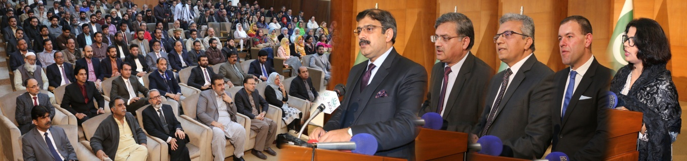

- AIOU celebrates World Literacy Day
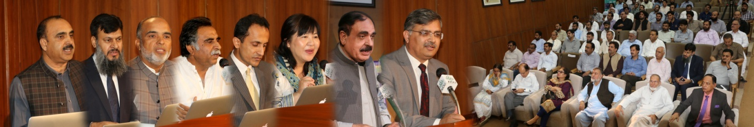
- Two-day book fair held at AIOU
https://www.thenews.com.pk/print/545075-two-day-book-fair-held-at-AIOU
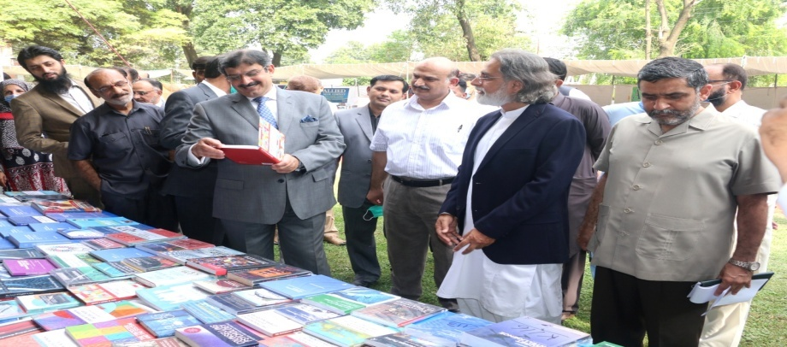
- Oracle :AIOU to promote digital transformation through cooperative partnership
https://www.marketscreener.com/quote/stock/ORACLE-CORPORATION-13620698/news/Oracle-AIOU-to-promote-digital-transformation-through-cooperative-partnership-30144316/
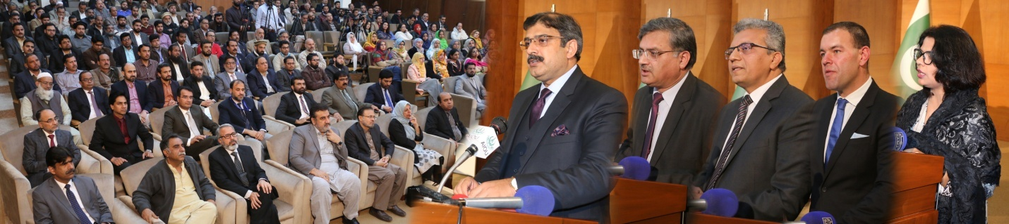
- POTOHAR Literacy Festival held at AIOU
https://www.thenews.com.pk/print/459436-potohar-literary-festival-held-at-AIOU
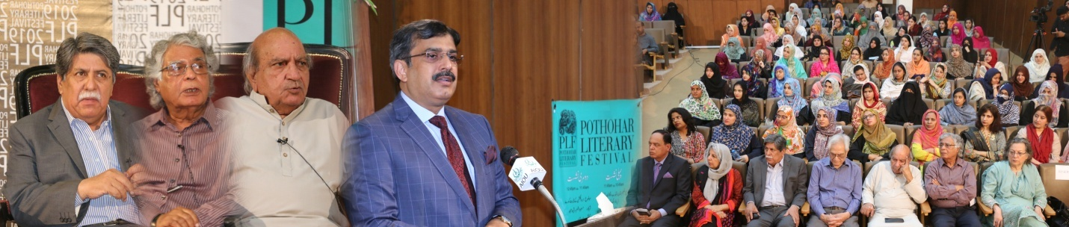
- Free Accessible Lecturers on SDG 4
https://www.youtube.com/watch?v=UhO8XHFUcDg

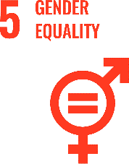
SUSTAINABLE DEVELOPMENT GOAL 5 – GENDER EQUALITY

Achieve gender equality and empower all women and girls

- RESEARCH & INNOVATION
- The university can proudly boast the work of its faculty members in the context of Gender Equality, as in the last 10 years university has published 30 Research Publications that are relevant to SDG 5.
- 10 Research grants have been won by the various faculty members that are relevant to SDG 5.
- TEACHING & STUDENTS
- Various departments of the university are running about 21 academic courses that are relevant to SDG 5.
- Link to course inventory http://oric.aiou.edu.pk/?page_id=1748
- OPERATIONS
- The department of Gender Studies is eagerly working with all its resources in the upholding of quality education by offering various academic courses, publications, activities and student internships. Overall, 4 faculty members are currently engaged in the working of SDG5 and adding their due share in the betterment of life of people.
- The University has adopted the Protection against Harassment of Women at the Workplace Act No. 6 of 2010 on 12th July, 2011.
- PUBLIC ENGAGEMENT
- Online Interactive Session on “Breast Cancer Awareness and Screening” held on March 25, 2021.
- Health Benefits of Open Urban Spaces for Adolescent Girls held on April 2016.
- OUTREACH & PARTNERSHIP
- Girl Power Program (GPP): Funded by PLAN Int that was concluded in 2015-16 with a Capital Cost of Rs. 7,36,80916/-
- Empowering Girls from Marginalized Rural Families for Continuing Education: Funded by UNESCO & PLAN Int. --- Sanjh Preet that was Concluded in: 2018 with a Capital Cost: Rs. 38,22,176/-
- UNIVERSITY ACTIVITY/NEWS RELATED TO SDG
- Webinars, seminars, conferences and workshops are regularly held at AIOU. 50% of Resource persons of these events are always women showing presence of women empowerment at every part of AIOU.
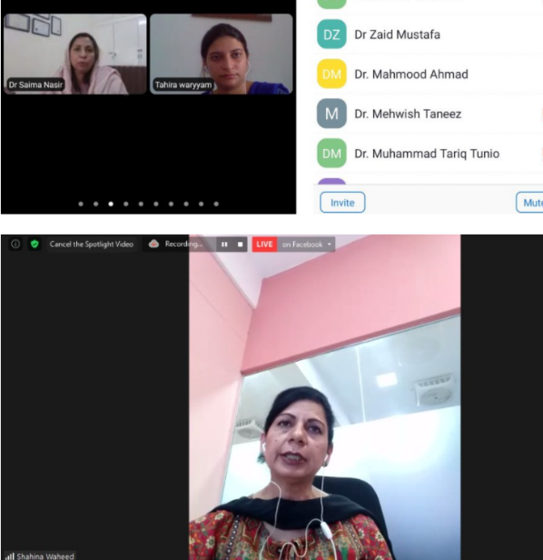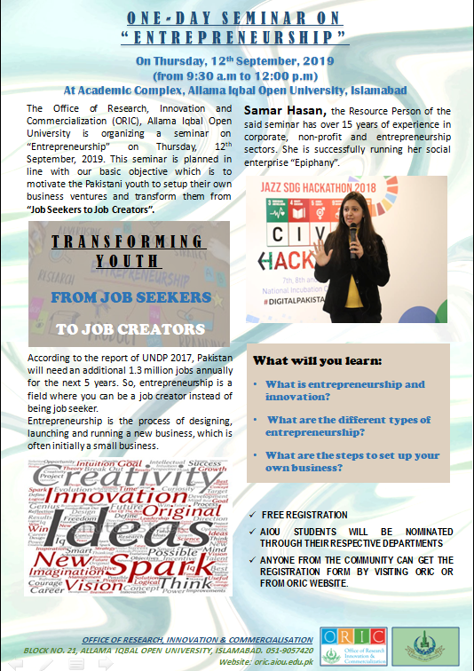
- 2/5th of our faculty members are females at AIOU. Also a large number of women are working on different positions at servicing departments of AIOU.
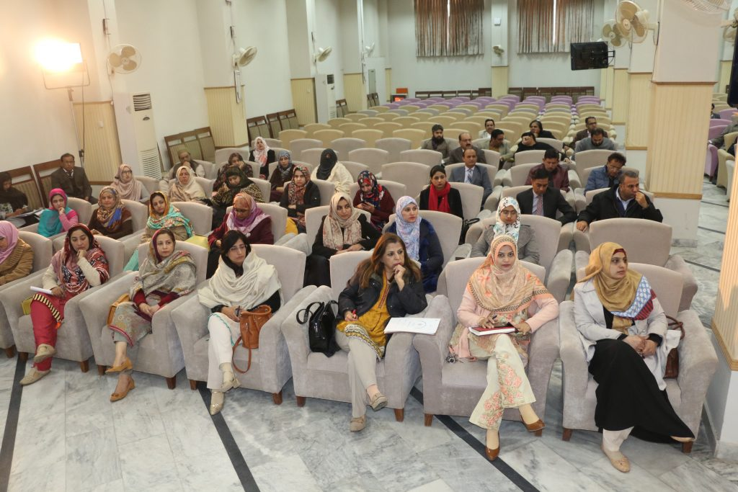
- At AIOU, 15 academic and servicing departments are being head by women.
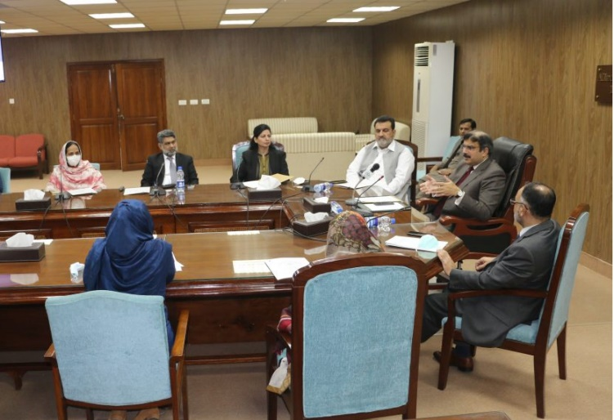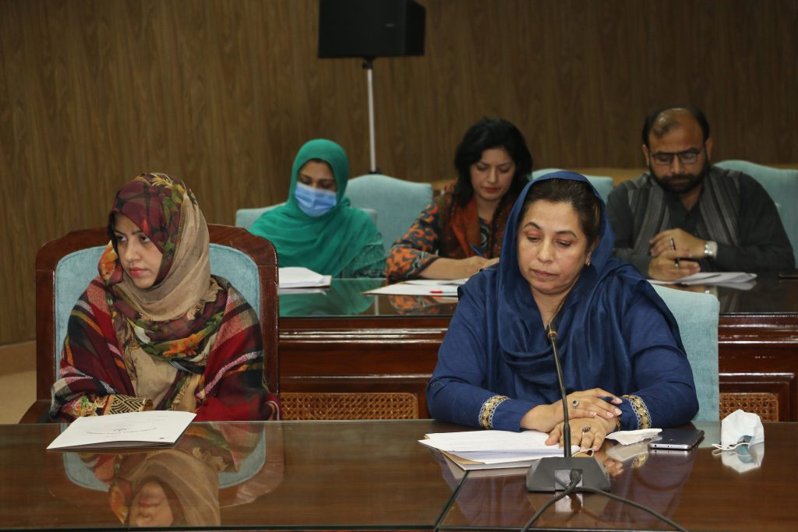
- Free Accessible Lecturers on SDG 5
https://www.youtube.com/watch?v=UhO8XHFUcDg

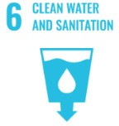
SUSTAINABLE DEVELOPMENT GOAL 6 - CLEAN WATER AND SANITATION

Ensure availability and sustainable management of water and sanitation for all

- RESEARCH & INNOVATION
- The university can proudly boast the work of its faculty members in the context of Clean Water and Sanitation, as in the last 10 years university has published 20 Research Publications that are relevant to SDG 6.
- 04 Research grants have been won by the various faculty members that are relevant to SDG 6.
- TEACHING& STUDENTS
- Various departments of the university are running about 16 courses that are relevant to SDG 6.
- Link to course inventory http://oric.aiou.edu.pk/?page_id=1748
- OPERATIONS
- The department of Environmental Design, Health and Nutritional Sciences are eagerly working with all their resources for the cause of clean water and sanitation by offering various academic courses, publications, activities and student internships. Overall, 19 faculty members are currently engaged in the working of this SDG and adding their due share in the betterment of life of people.
- Water
- Hand washing and sanitation facilities during Covid-19 pandemic
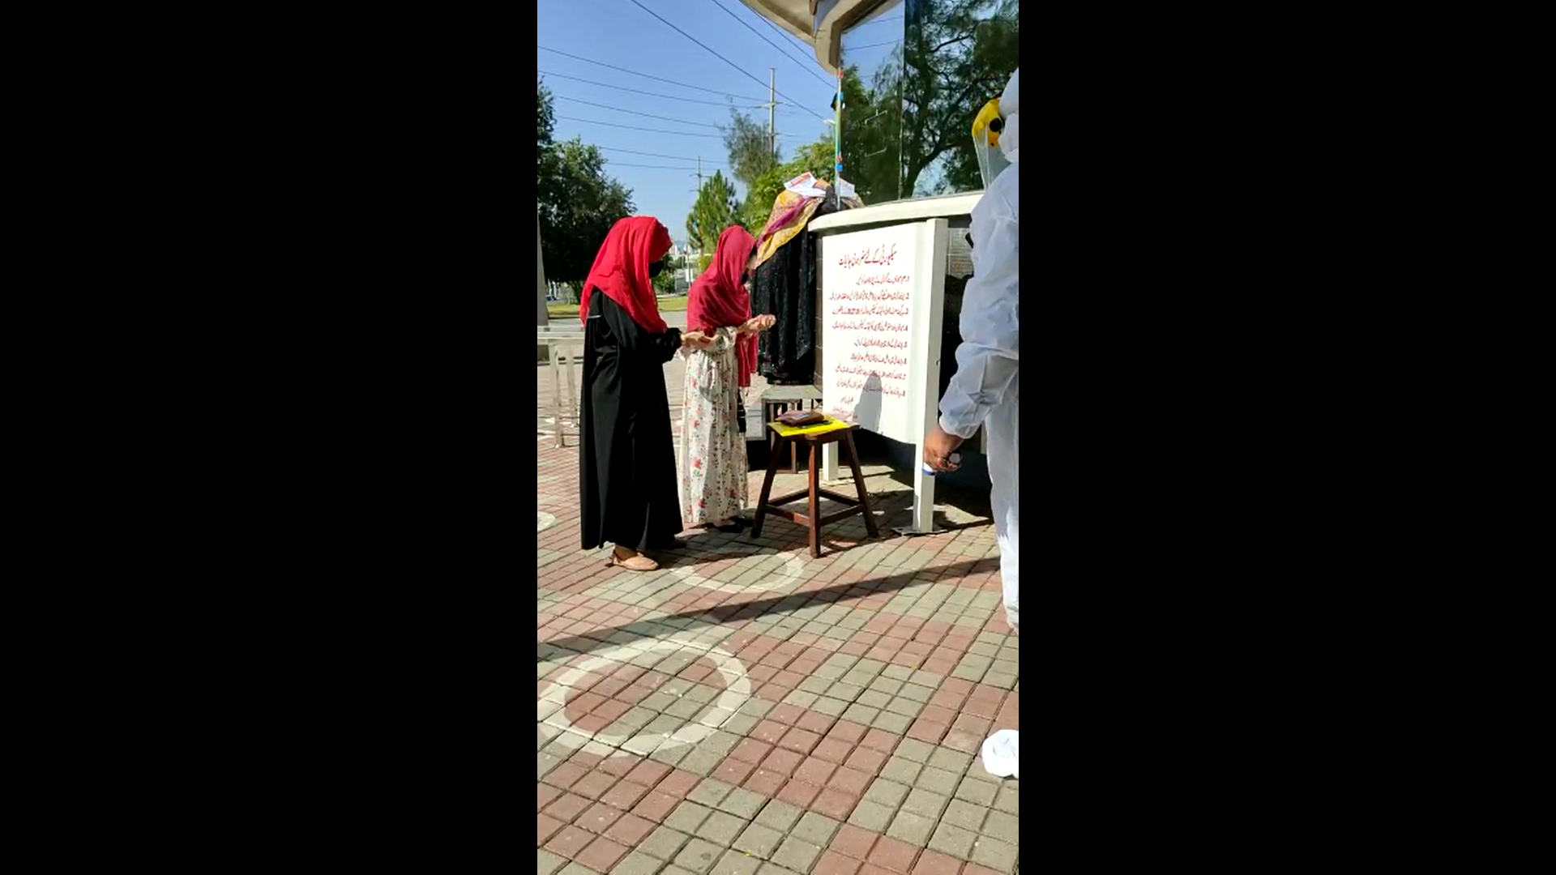 |  | 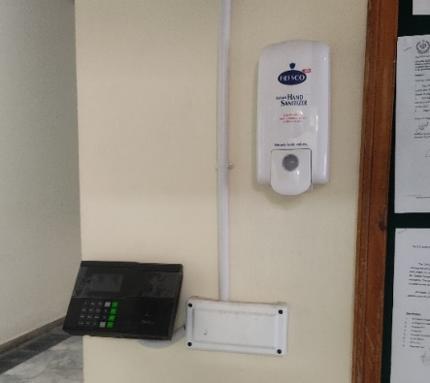
Temperature check and sanitizing facility at campus main gate during covid-19 |  | Sanitizers/Disinfection units installed at all buildings entrances
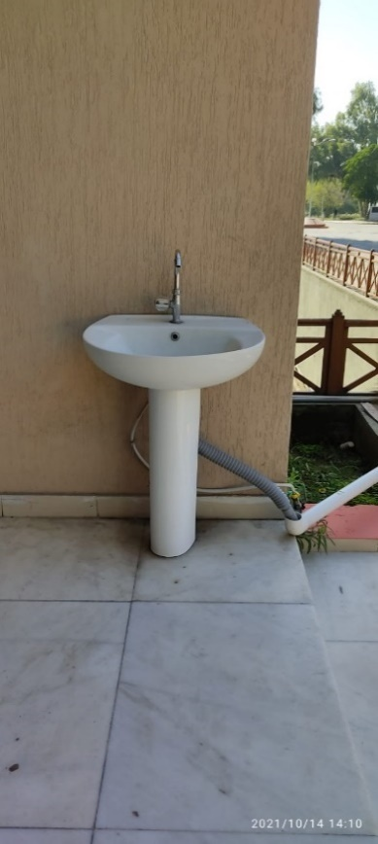 | 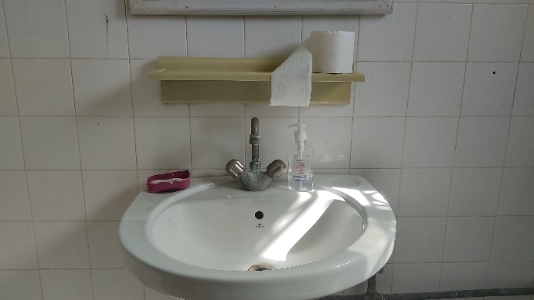
Outdoor hand washing Facilities in University Canteens and academic departments

- Sanitizers and surgical masks were provided to all the employees of the university throughout covid-19 pandemic.
- Free temperature check and sanitizing facility was provided on the campus main gate and other buildings of the university.
- Meanwhile, the figure shows the hand washing facilities placed near every entrance of buildings. Hand sanitizer containers were placed in every corner of the buildings, where hand washing facilities are impossible to install.
- Area on campus for water absorption besides the forest and planted vegetation
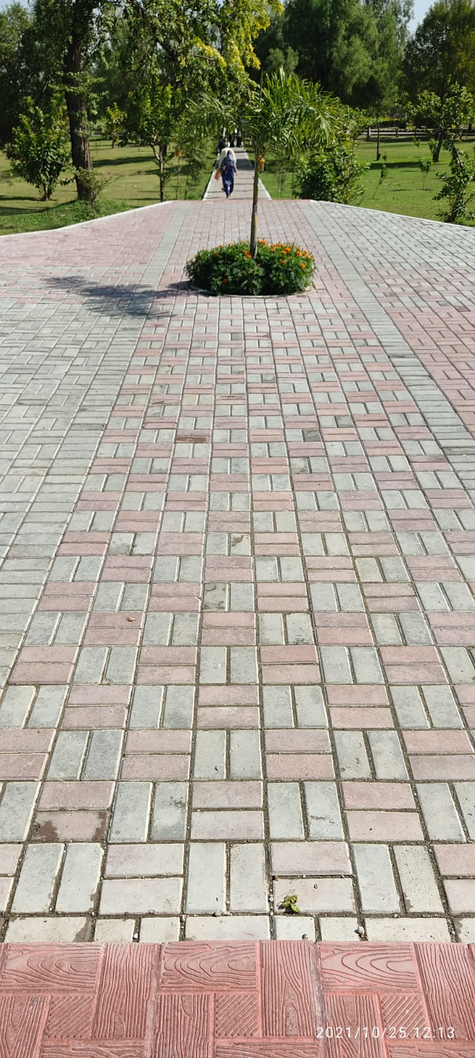 | 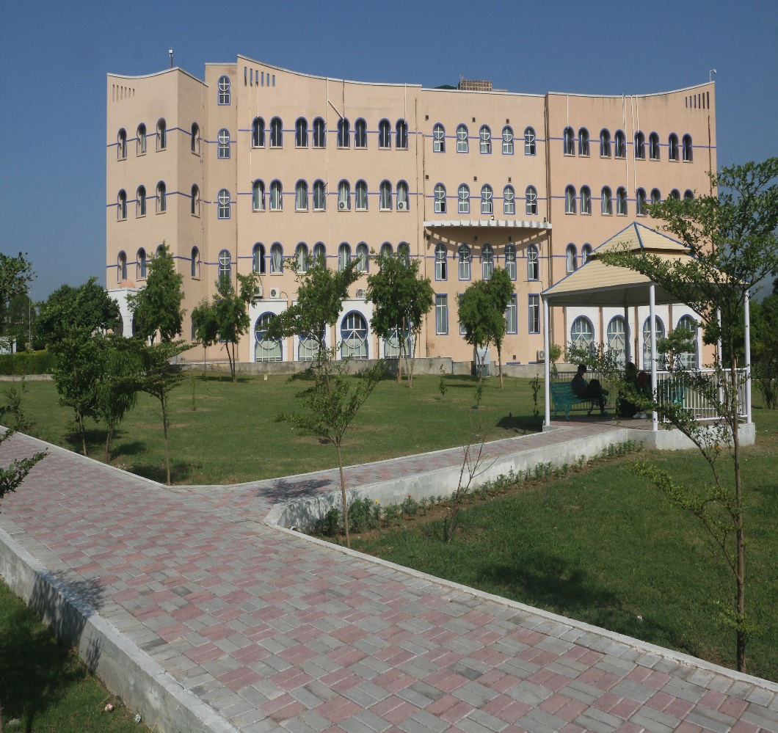
Total Area: 454508 m2 , Total water absorption area: 145442 m2, Percentage area: 32 %
- OUTREACH & PARTNERSHIP
- AIOU has signed LOI for development of rainwater harvesting sites for groundwater recharge at AIOU with the Pakistan Council for Research on Water Resources (PCRWR). The development is under progress these days.
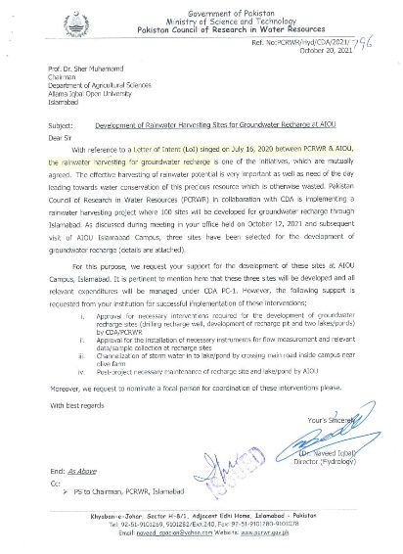
- Water Conservation Program Implementation
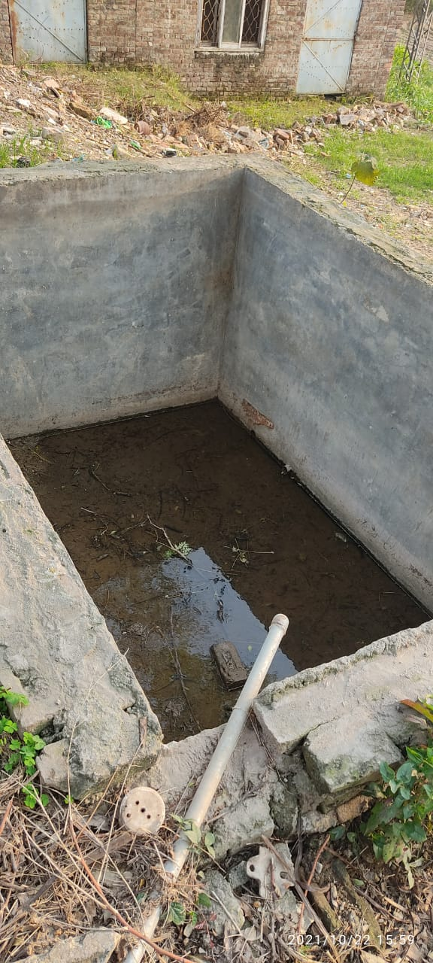 | 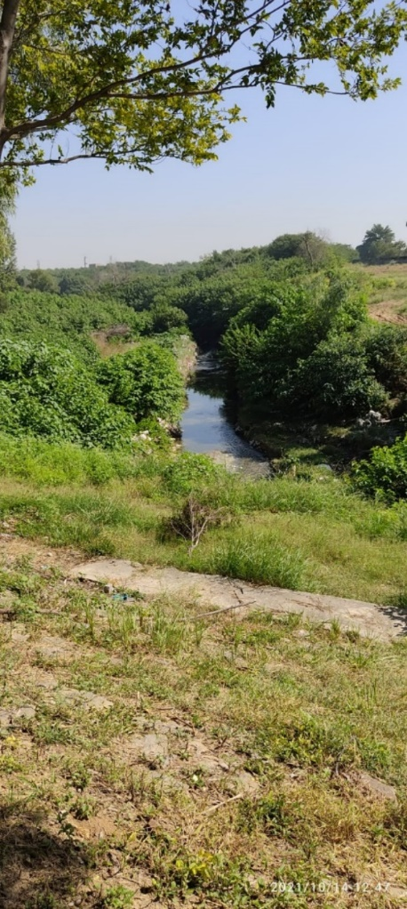
Water Conservation-In Ground Water Tank at AIOU | Water Conservation– forest Lake at AIOU
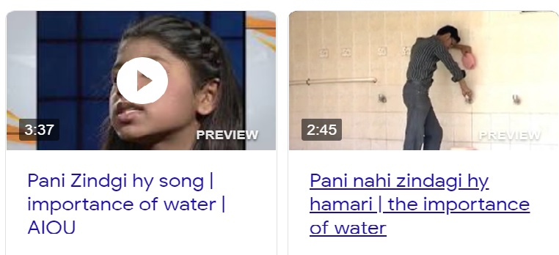
- Rain water collection points are installed at main campus and some of the regional campuses where collected rain water from the roofs of the buildings is discharged into the local ponds and canals around the buildings. The collected rainwater is used mainly for toilet flushing and for watering the plants inside the building and washing buses.
- AIOU plays an active role in creating mass awareness on water conservation.
- Water Recycling Program Implementation
Water Recycling in AIOU
- A water meter is installed to measure the amount of rainwater that has been used. The recycled water is also use for garden sprinkler system, toilet flush, cooling system and used in forests.
- Free Accessible Lecturers on SDG 6
https://www.youtube.com/watch?v=UhO8XHFUcDg

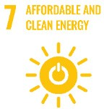
SUSTAINABLE DEVELOPMENT GOAL 7 – AFFORDABLE AND CLEAN ENERGY

Ensure access to affordable, reliable, sustainable and modern energy for all

- RESEARCH & INNOVATION:
- The university can proudly boast the work of its faculty members in the context of Affordable and Clean Energy, as in the last 10 years the university has published 39 Research Publications that are relevant to SDG 7.
- 34 Research grants have been won by the various faculty members that are relevant to SDG 7.
- TEACHING & STUDENTS
- Various departments of the university are running about 10 courses that are relevant to SDG 7.
- Link to course inventory http://oric.aiou.edu.pk/?page_id=1748
- OPERATIONS
- The department of Agricultural Sciences and department of Environmental design, Health and Nutritional Sciences are eagerly working with all their resources for Affordable and Clean Energy by offering various academic courses, publications, activities and student internships. Overall, 11 faculty members are currently engaged in the working of this SDG and adding their due share in the betterment of life of people.
- Renewable Energy Sources in Campus
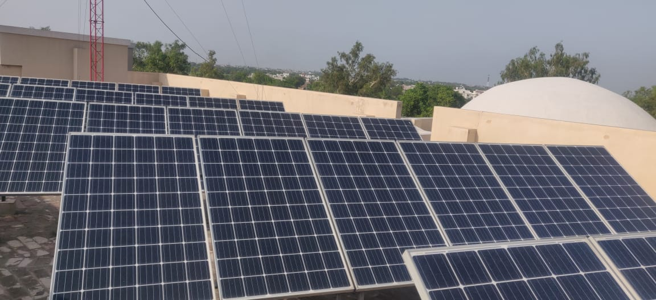
Energy efficient inverters ( Combined Cooling Heating and Power Integration Unit )
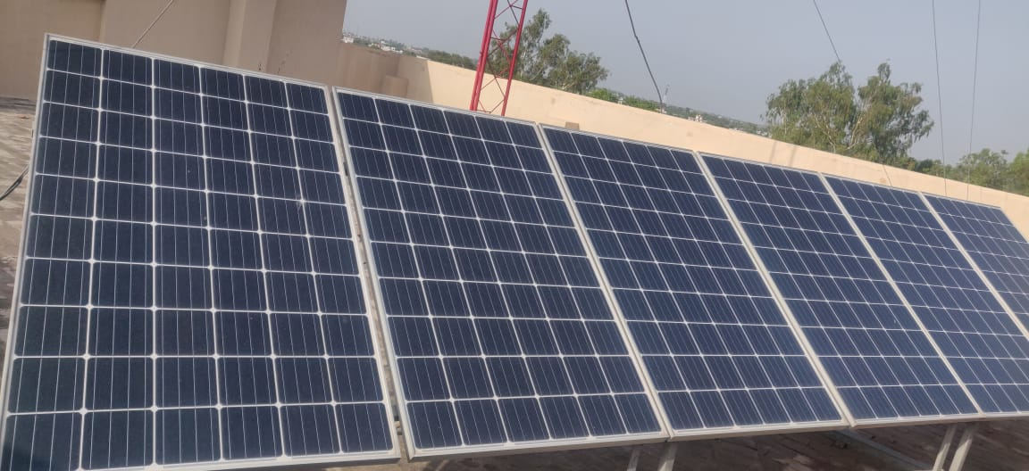 | 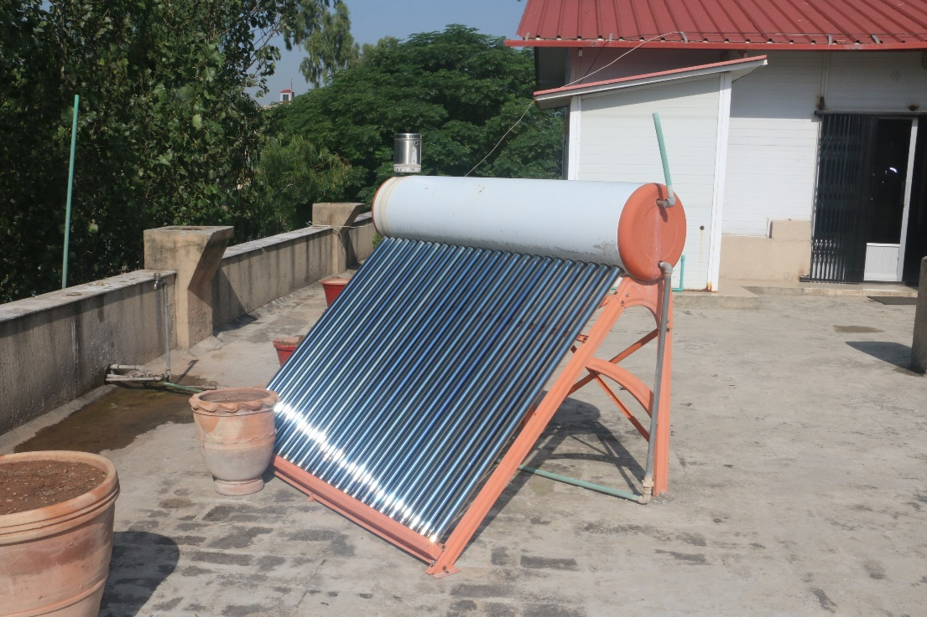
Solar Panels installed at main campus and some regional campuses

- The combined cooling and heating units, inverters, are installed in all regional campuses as well as in main campus providing the facility of cooling and heating.
- Solar power stations are installed at main campus and some regional campuses.
- The ratio of renewable energy production divided by total energy usage per year (2018-2020) is as follow:
No | Renewable Energy | Production (ink Wh)
3 | Solar panel | 79946
 | Total | 79946
=79946/711902(Average Electricity usage in 2018-2020)=11.23%
- Energy Efficient Appliances Usage
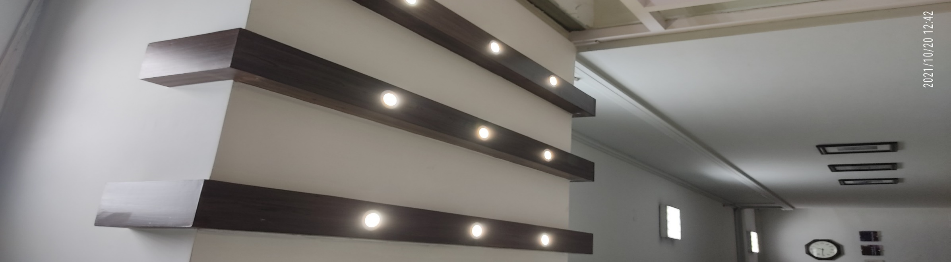
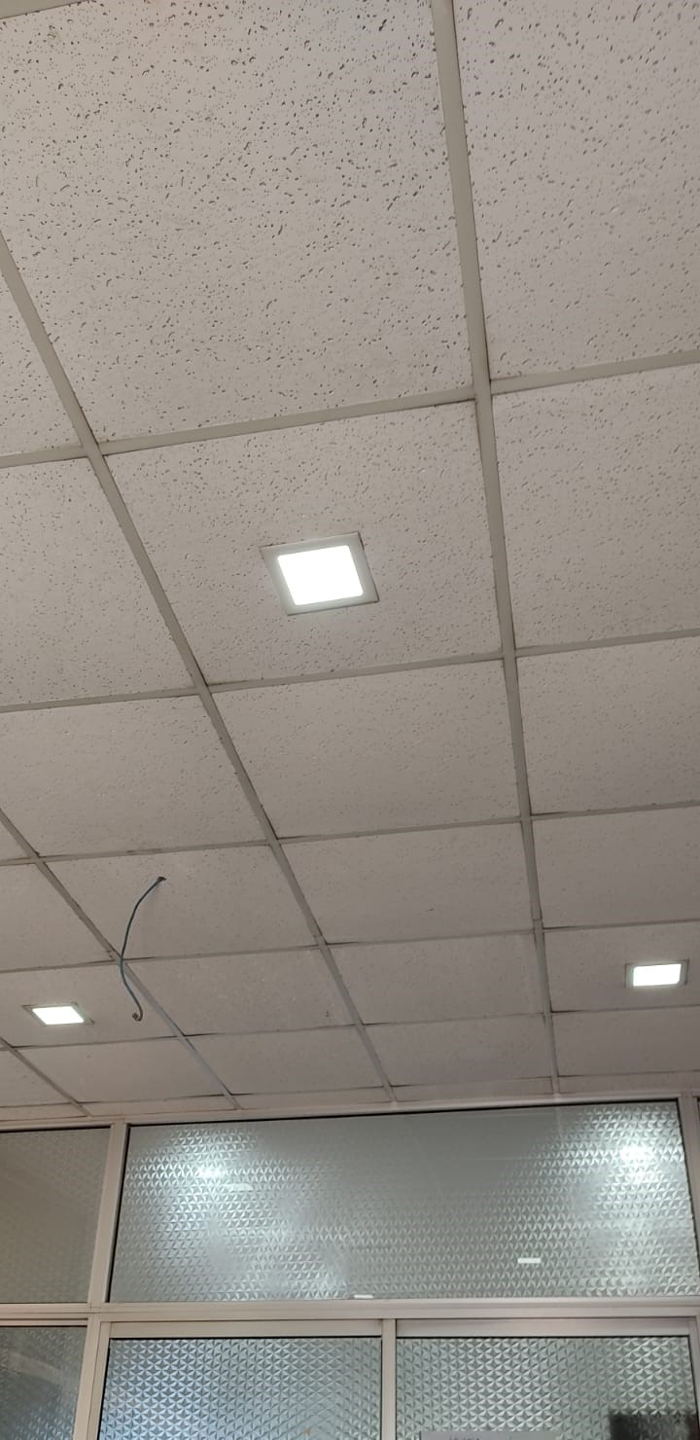
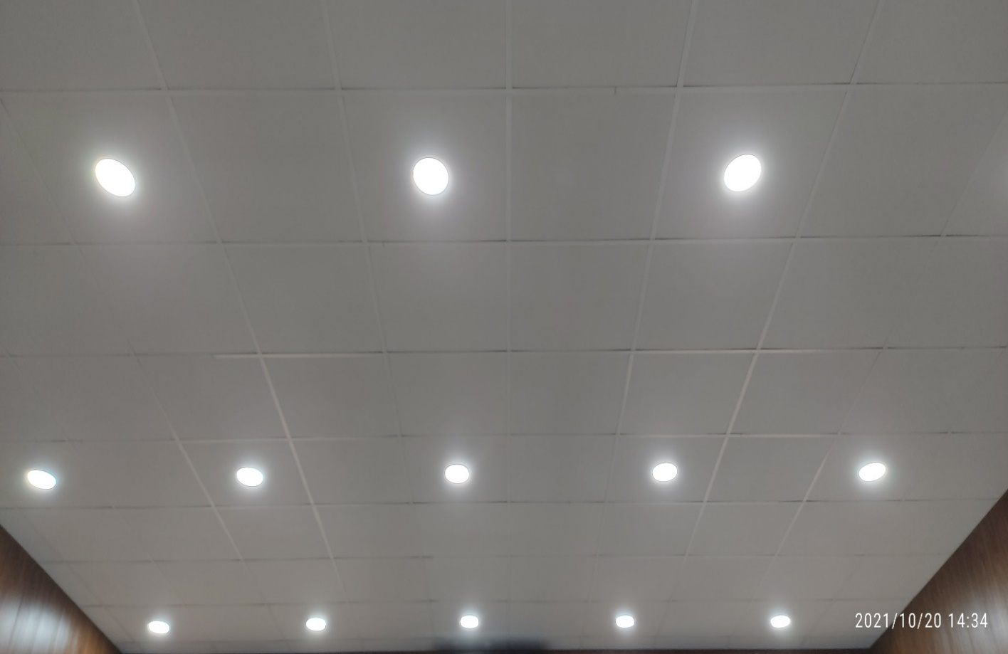
Example of Energy Efficient Appliances Usage :Use of LED lighting

Energy Efficient Appliances Usage: Solar absorption Air Conditioning system

- AIOU intends to realize further energy savings by paying close attention to energy management. All parts of the organization can assess their own energy consumption and realize their own energy-saving potential by means of, for example, insulation, LED lighting and the deployment of sustainable technology.
- Percentage of Energy Efficient Appliances:
Appliance | Total Number | Total number energy Efficient appliances | Percentage
LED Lamp | 6400 | 5900 | 92.18 %
Fan | 2280 | 2280 | 100 %
Inverter Air Conditioners | 600 | 400 | 66.66 %
 |  | Average Percentage | 86.28 %

- UNIVERSITY ACTIVITY/NEWS RELATED TO SDG
- International conference on nano-materials modelling held at AIOU

https://dailytimes.com.pk/357988/international-conference-on-nano-materials-modelling-held-at-AIOU/
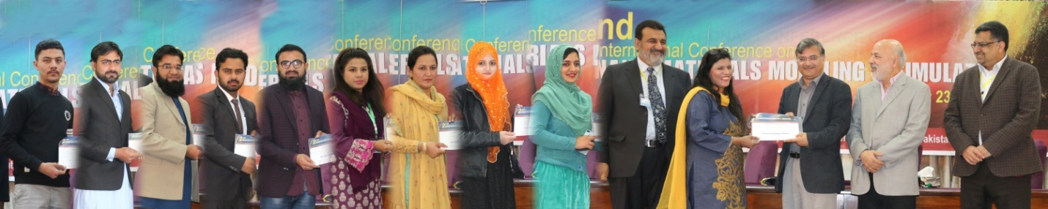
- National Conference on Emerging Sciences held at AIOU

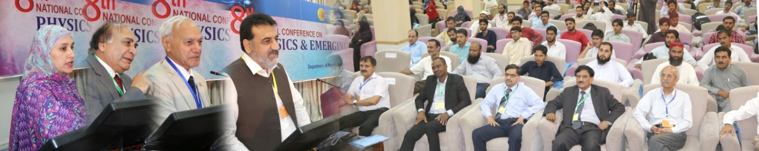
- Free Accessible Lecturers on SDG 7
https://www.youtube.com/watch?v=UhO8XHFUcDg

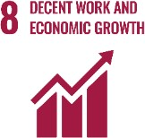
SUSTAINABLE DEVELOPMENT GOAL 8 – DECENT WORK AND ECONOMIC GROWTH

Promote sustained, inclusive and sustainable economic growth, full and productive employment and decent work for all

- RESEARCH & INNOVATION
- The university can proudly boast the work of its faculty members in the context of Decent Work and Economic Growth as in the last 10 years the university has published 55 Research Publications that are relevant to SDG 8.
- 19 Research grants have been won by the various faculty members that are relevant to SDG 8.
- TEACHING & STUDENTS
- 184 educational programs from basic level to doctorate level that are directly and indirectly related to SDG 8.
- 334 Various certificates, diplomas and professional courses to target the scheme of SDG 8.
- Link to course inventory http://oric.aiou.edu.pk/?page_id=1748
- AIOU is offering various financial support schemes to faculty, employees and students such as;
- Financial Support Scheme for Employees.
- Earn to Learn Scheme Providing decent work environment to students.
- Final Year Project Grant to research students.
- OPERATIONS
- All departments of AIOU especially those operating under faculty of Social Sciences are eagerly working with all their resources for Decent Work and Economic Growth by offering various academic courses, publications, activities and student internships. Overall, 11 faculty members are currently engaged in the working of this SDG and adding their due share in the betterment of life of people.
- University is providing all office equipments, space and furniture to all employees.
- University has bodies to represent every group of its employees e.g. ASA for academicians, EWA for lower grade staff members and OWA for officer grade staff members.
- University is helping its employees by offering various financing schemes such as:
  - House Building Finance
  - Car Advance
  - Umra Scheme
- PUBLIC ENGAGEMENT
- Webinar on “Innovation & Entrepreneurship”
- One Day Interactive Workshop on “Awareness of Opportunities for International Career Paths”- A Initiative for Faculty Development and Students Career Opportunities
- AIOU internal funded research project grants 2020-21
- One Day Workshop on ‘Startup Entrepreneurship- Owning your Future’ on 5th Dec 2019
- UNIVERSITY ACTIVITY/NEWS RELATED TO SDG 8
- COVID Honorarium to 500 employees
- Un-deducted salary in COVID crisis to employess
- AIOU Bodies extend full support to Dr. Zia-ul-Qayyum
https://en.baaghitv.com/aiou-bodies-extend-full-support-to-dr-zia-ul-qayyum/
- VC AIOU vows to collaborate with EWA for University's development
https://www.urdupoint.com/en/pakistan/vc-aiou-vows-to-collaborate-with-ewa-for-univ-1218094.html
- ANY OTHER
- Allama Iqbal Open University (AIOU) in collaboration with Qarshi University (QU), University of Veterinary and Animal Sciences (UVAS) and University of Management and Technology (UMT) organized two-day international conference on ‘Collective action for knowledge economy with technology (cake-tech) held at Allama Iqbal Open University (AIOU) Islamabad on February-25-26, 2019.
https://www.vu.edu.pk/newsdetails.aspx?type=&newsid=3011
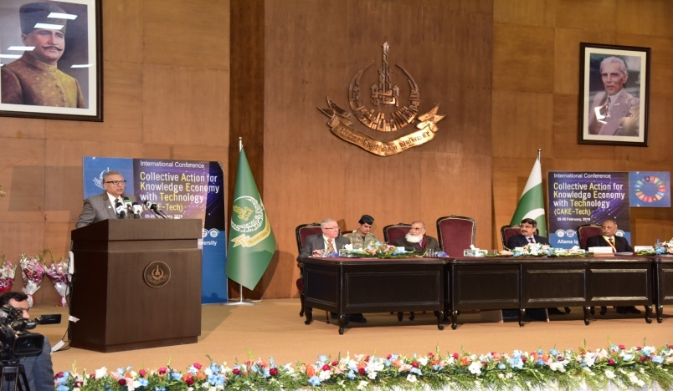
- Free Accessible Lecturers on SDG 8
https://www.youtube.com/watch?v=UhO8XHFUcDg

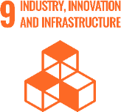
SUSTAINABLE DEVELOPMENT GOAL 9 – INDUSTRY, INNOVATION AND INFRASTRUCTURE

Build resilient infrastructure, promote inclusive and sustainable industrialization and foster innovation

- RESEARCH & INNOVATION
- The university can proudly boast the work of its faculty members in the context of INDUSTRY, INNOVATION AND INFRASTRUCTURE as in the last 10 years university has published 37 Research Publications that are relevant to SDG 9.
- 5 Research grants have been won by the various faculty members that are relevant to SDG 9.
- TEACHING & STUDENTS
- Various departments of the university are running around 40 academic courses that are relevant to SDG 9.
- Link to course inventory http://oric.aiou.edu.pk/?page_id=1748
- OPERATIONS
- The department of Engineering Sciences, department of Chemistry, department of Physics and department of Environmental design and health and nutritional Sciences are eagerly working with all their resources for Industry, Innovation AND Infrastructure by offering various academic courses, publications, activities and student internships. Overall, 36 faculty members are currently engaged in the working of this SDG and adding their due share in the betterment of life of people.
- PUBLIC ENGAGEMENT
- AIOUBig Ideas Competition
- One Day Webinar “Entrepreneurial Ideas in Humanities and Social Sciences”, on March 10, 2021
- AIOU Internal Funded Research Project Grants 2020-21
- One Day Workshop on ‘Startup Entrepreneurship- Owning your Future’ on 5th Dec 2019
- UNIVERSITY ACTIVITY/NEWS RELATED TO SDG
Allama Iqbal Open University (AIOU) in collaboration with Qarshi University (QU), University of Veterinary and Animal Sciences (UVAS) and University of Management and Technology (UMT) organized two-day international conference on ‘Collective action for knowledge economy with technology (cake-tech) held at Allama Iqbal Open University (AIOU) Islamabad on February-25-26, 2019.
https://www.vu.edu.pk/newsdetails.aspx?type=&newsid=3011
- AIOU considered best for distance learning: Digital transformation policy started for promotion of education via internet
https://dailytimes.com.pk/461817/AIOU-considered-best-for-distance-learning/
- AIOU striving to facilitate 1.4 mn students by incorporating use of latest technology

https://www.technologytimes.pk/2020/10/07/AIOU-striving-to-facilitate-1-4-mn-students-by-incorporating-use-of-latest-technology/
- AIOU to start 18 technical courses from January 15, 2020
https://www.geo.tv/latest/266338-AIOU-to-start-18-technical-courses-from-january-15
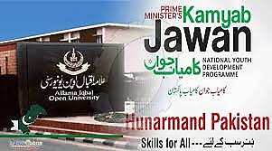
- Operation and maintenance activities at AIOU
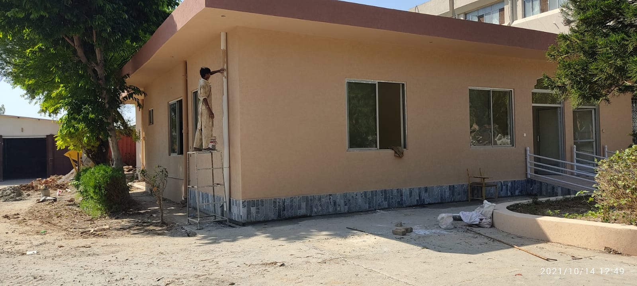 | 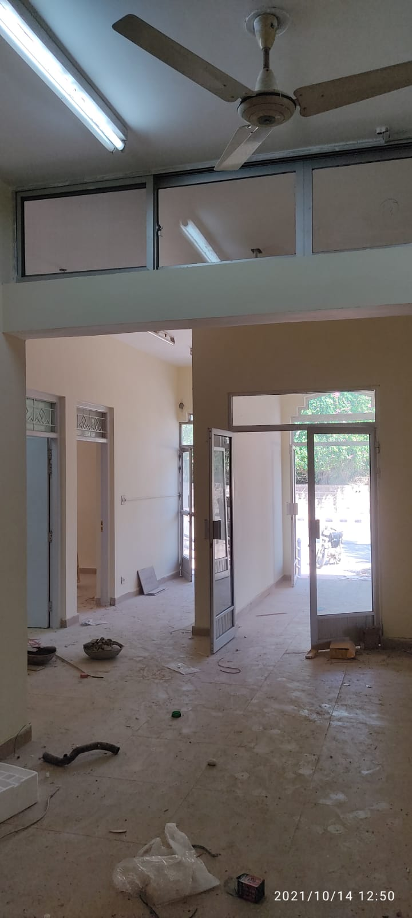
Medical CenterMaintenance and extension | Partition rooms construction
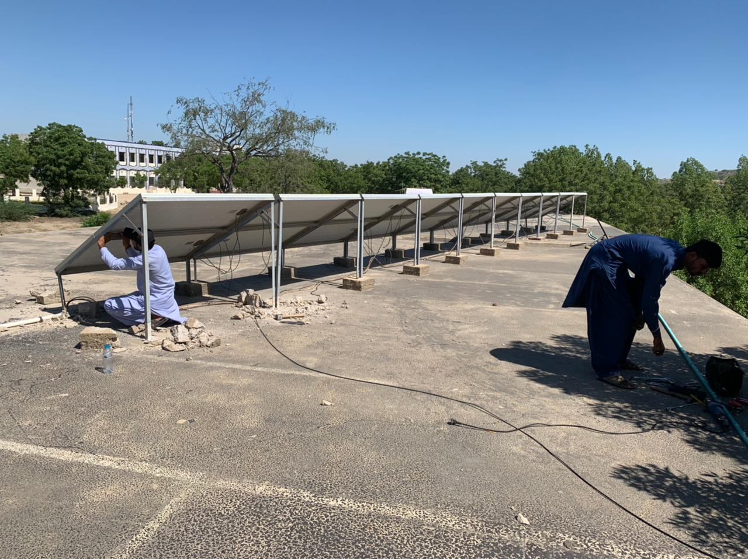
Solar Panels installation

- Free Accessible Lecturers on SDG 9
https://www.youtube.com/watch?v=UhO8XHFUcDg

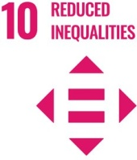
SUSTAINABLE DEVELOPMENT GOAL 10 – REDUCED INEQUALITIES

Reduce inequality within and among countries

- RESEARCH & INNOVATION
- The university can proudly boast the work of its faculty members in the context of Reduced Inequalities as in the last 10 years university has published 47 Research Publications that are relevant to SDG 10.
- 6 Research grants have been won by the various faculty members that are relevant to SDG 10.
- TEACHING & STUDENTS
- Various departments of the university are running about 03 courses that are relevant to SDG 10.
- Link to course inventory http://oric.aiou.edu.pk/?page_id=1748
- OPERATIONS
- The department of Special Education and Gender Studies are eagerly working with all their resources for Reduced Inequalities by offering various academic courses, publications, activities and student internships. Overall, 9 faculty members are currently engaged in the working of this SDG and adding their due share in the betterment of life of people.
- Adoption of Protection against Harassment of Women at the Workplace Act No. 6 of 2010 on 12th July, 2011.
- UNIVERSITY ACTIVITY/NEWS RELATED TO SDG
- AIOU VC Dr. Zia ul-Qayyum directed to offer free education to transgender
https://thefortress.com.pk/AIOU-vc-directed-to-offere-free-education-to-transgender/
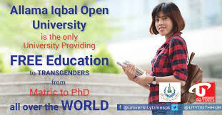
- AIOU holds solidarity walk to project Kashmir cause
https://www.thenews.com.pk/print/610211-AIOU-holds-solidarity-walk-to-project-kashmir-cause
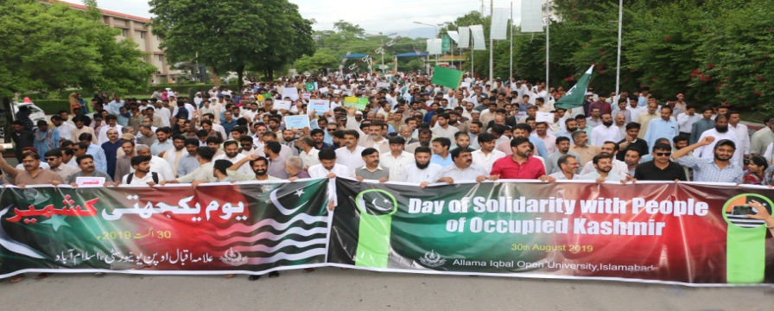
- Laptops distribution to disabled persons

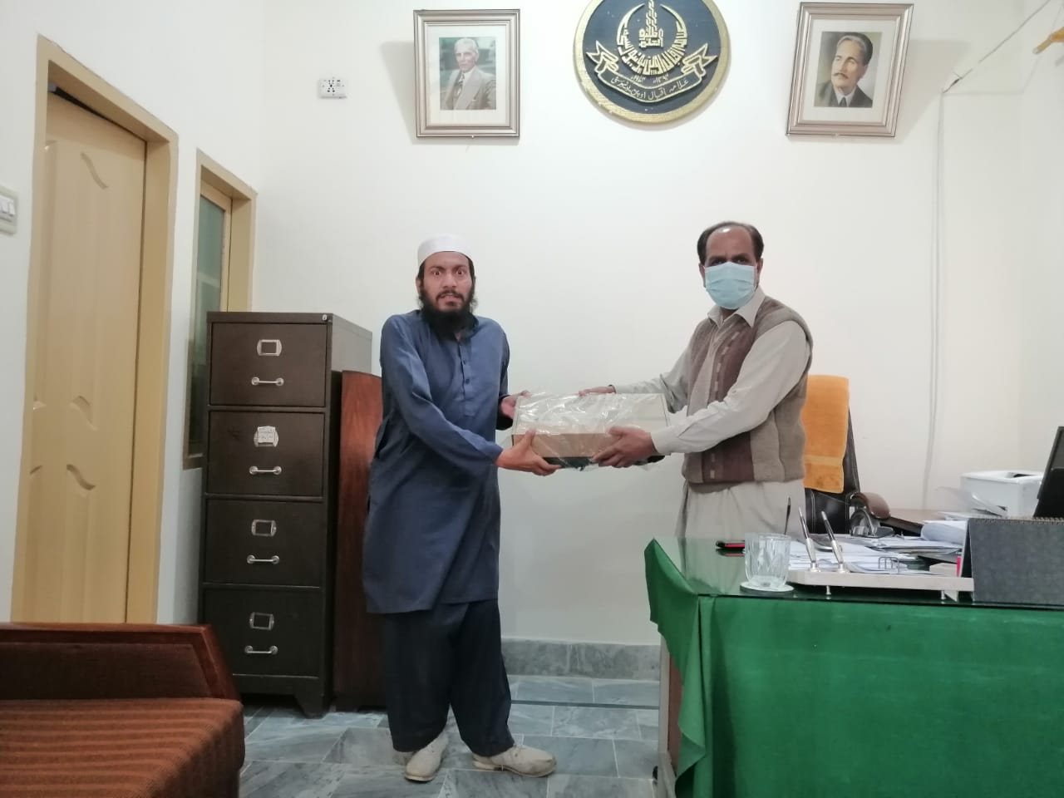
- Campus facilities for disable, special needs and or maternity care

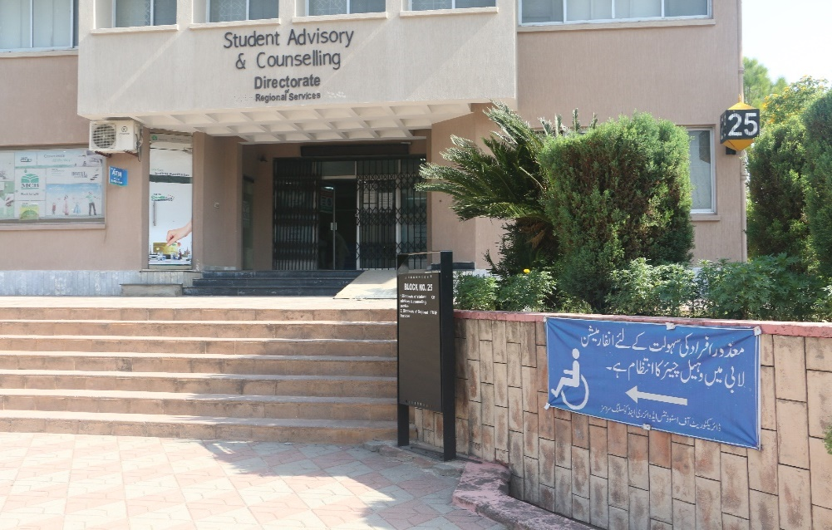 | 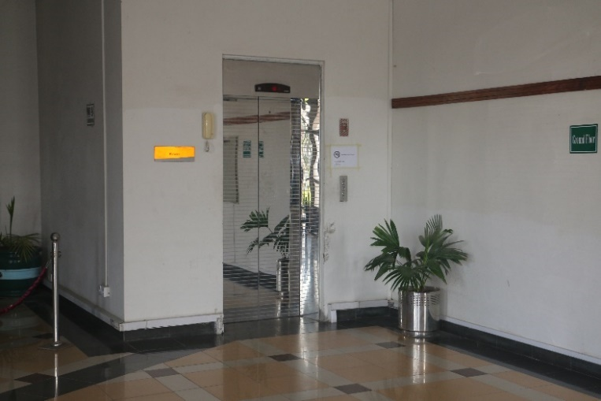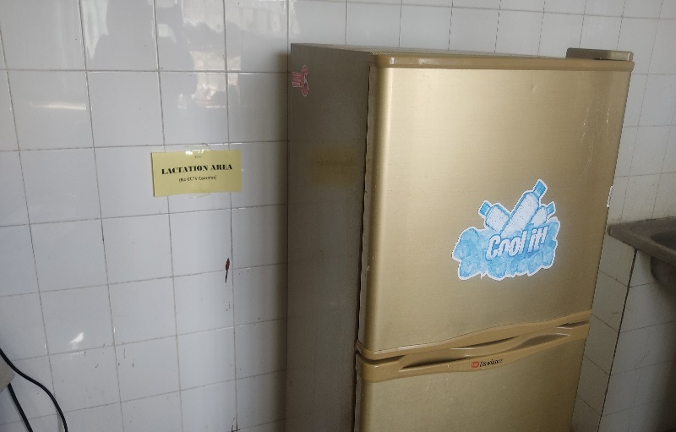
Wheel chair facility for Disabled | Elevators for disabled Feeding rooms for mothers
 |  | 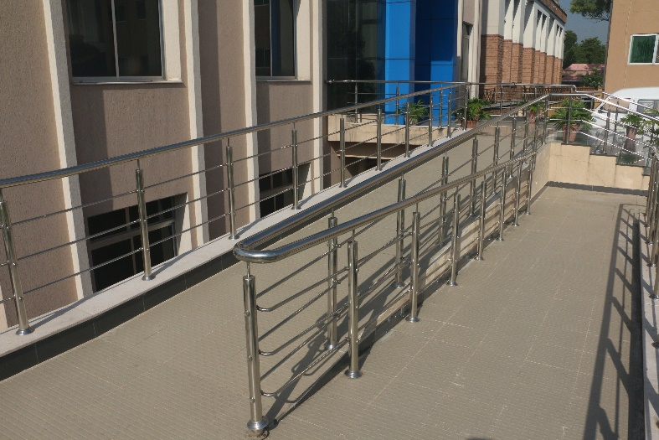
Accessibility Center at Main Library |  | Accessibility Paths

- Accessibility pathways and elevators are available in the campus
- Free wheelchair facility
- Disabled parking for disabled people to park their car which are located at the nearest space building
- Accessible room for disabled people
- Daycare Centers available at main campus and regional campuses
- Lactation room is private room available in all buildings for staff who are breastfeeding
- Free Accessible Lectures on SDG 10
https://www.youtube.com/watch?v=UhO8XHFUcDg

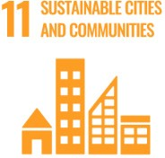
SUSTAINABLE DEVELOPMENT GOAL 11 – SUSTAINABLE CITIES AND COMMUNITIES

Make cities and human settlements inclusive, safe, resilient and sustainable

- RESEARCH & INNOVATION
- The university can proudly boast the work of its faculty members in the context of SUSTAINABLE CITIES AND COMMUNITIES as in the last 10 years university has published 15 Research Publications that are relevant to SDG 11.
- 34 Research grants have been won by the various faculty members that are relevant to SDG 11.
- TEACHING & STUDENTS
- Various departments of the university are running about 36 courses that are relevant to SDG 11.
- Link to course inventory http://oric.aiou.edu.pk/?page_id=1748
- OPERATIONS
- The department of Agricultural Sciences and department of Environmental Design, Health and Nutritional Sciences are eagerly working with all their resources for SUSTAINABLE CITIES AND COMMUNITIES by offering various academic courses, publications, activities and student internships. Overall, 11 faculty members are currently engaged in the working of this SDG and adding their due share in the betterment of life of people.
- The university is declared as Smoke Free Campus by adopting and enforcing the “Tobacco Control Laws in Universities of Pakistan” on 12th September, 2017.
- OUTREACH & PARTNERSHIP
The university has collaborated with the following organizations:
- Shifa International Hospital
- Scaling up nutrition Pakistan (SUN)
- UNISEF
- University of Dundee
- Security and safety facilities

 |  |  | 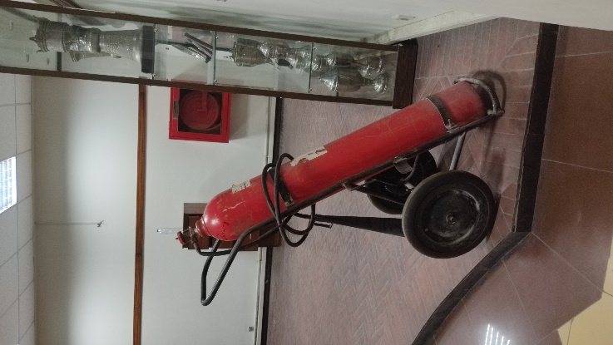
1. CCTV at entrance and all other buildings | 2. FireHydrant in all buildings
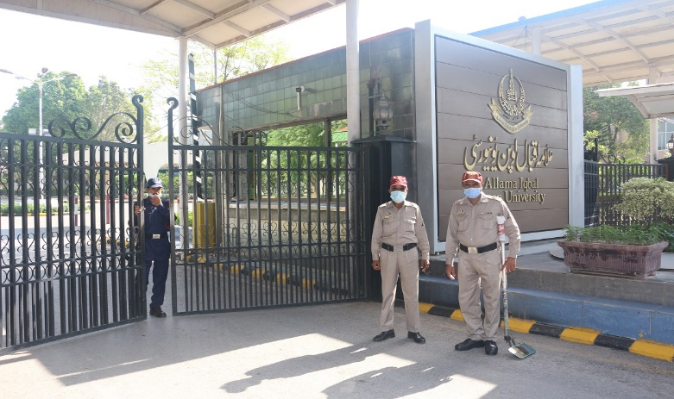 |  | 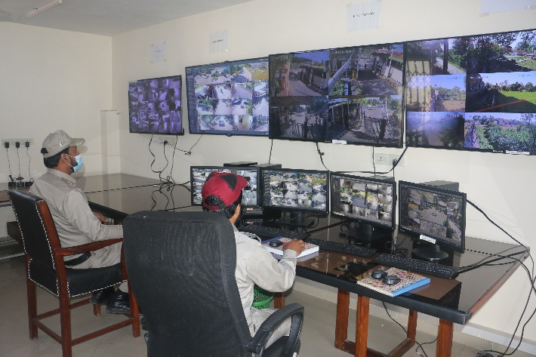
3. Security guards at entrance and at all major spots |  | 4. Security Control rooms

- Centralized security Control room.
- Regular security force headed by Chief Security Officer.
- Availability of Surveillance System with CCTVs at entrance and all other buildings.
- Fire Hydrants available at all buildings.
- Security staff deputed at gates.
- Gate entry is allowed only by showing identity.
- Security responding time for accident, crime, fire and natural disaster is less than 10 minutes.
- SOPs are available for all security and safety relevant activities.
- UNIVERSITY ACTIVITY/NEWS RELATED TO SDG
- National Conference on ‘Hum Pakistani’ Narrative
http://www.paighamepakistan.com/national-conference-on-hum-pakistani-narrative/
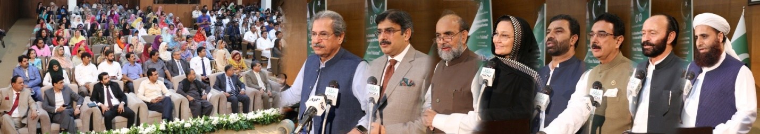
- Lecture conducted on “Road Safety” at AIOU

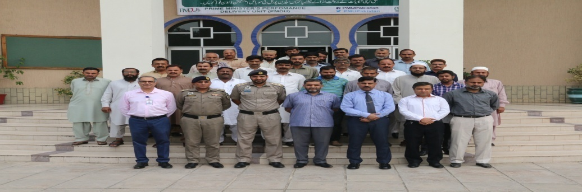
- Campus facilities for disable, special needs and or maternity care

Wheel chair facility for Disabled | Elevators for disabled Feeding rooms for mothers
Accessibility Center at Main Library |  | Accessibility Paths

- Accessibility pathways and elevators are available in the campus.
- Free wheelchair facility.
- Disabled parking for disabled people to park their car which are located at the nearest space building.
- Accessible room for disabled people.
- Day care Centers available at main campus and regional campuses.
- Lactation room is private room available in all buildings for staff who are breastfeeding.
- Free Accessible Lecturer on SDG 11
https://www.youtube.com/watch?v=UhO8XHFUcDg

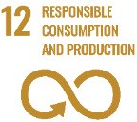
SUSTAINABLE DEVELOPMENT GOAL 12 – RESPONSIBLE CONSUMPTION AND PRODUCTION

Ensure sustainable consumption and production patterns

- RESEARCH & INNOVATION
- The university can proudly boast the work of its faculty members in the context of RESPONSIBLE CONSUMPTION AND PRODUCTION as in the last 10 years university has published 22 Research Publications that are relevant to SDG 12.
- 09 Research grants have been won by the various faculty members that are relevant to SDG 12.
- TEACHING & STUDENTS
- Number of academic courses relevant to SDG 12 are 19, among them 13 courses are being offered by department of Agricultural Sciences.
- Link to course inventory http://oric.aiou.edu.pk/?page_id=1748
- OPERATIONS
- The department of Agricultural Sciences and department of Environmental Design, Health and Nutritional Sciences are eagerly working with all their resources for SUSTAINABLE CITIES AND COMMUNITIES by offering various academic courses, publications, activities and student internships. Overall, 11 faculty members are currently engaged in the working of this SDG and adding their due share in the betterment of life of people.
- Free Accessible Lecturers on SDG 12
https://www.youtube.com/watch?v=UhO8XHFUcDg
- ANY OTHER
- “Carbon Foot Print Assessment of Allama Iqbal open University” is a report made by department of Biology declaring the institute as green university as the carbon consumption in AIOU per head is 0.7 tons.

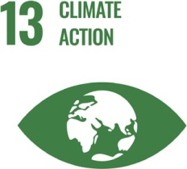
SUSTAINABLE DEVELOPMENT GOAL 13 – CLIMATE ACTION

Take urgent action to combat climate change and its impacts

- RESEARCH & INNOVATION
- The university can proudly boast the work of its faculty members in the context of CLIMATE ACTION as in the last 10 years university has published 29 Research Publications that are relevant to SDG 13.
- 60 Research grants have been won by the various faculty members that are relevant to SDG 13.
- TEACHING & STUDENTS
- Various departments of the university are running about 31 academic courses that are relevant to SDG 13.
- Link to course inventoryhttp://oric.aiou.edu.pk/?page_id=1748
- OPERATIONS
- The department of Agricultural Sciences and department of Environmental Design, Health and Nutritional Sciences are eagerly working with all their resources for CLIMATE ACTION by offering various academic courses, publications, activities and student internships. Overall, 11 faculty members are currently engaged in the working of this SDG and adding their due share in the betterment of life of people.
- The university is declared as Smoke Free Campus by adopting and enforcing the “Tobacco Control Laws in Universities of Pakistan” on 12th September, 2017.
- UNIVERSITY ACTIVITY/NEWS RELATED TO SDG
- AIOU holds awareness walk for PM’s Green Pakistan campaign
https://dailytimes.com.pk/335388/AIOU-holds-awareness-walk-for-pms-green-pakistan-campaign/
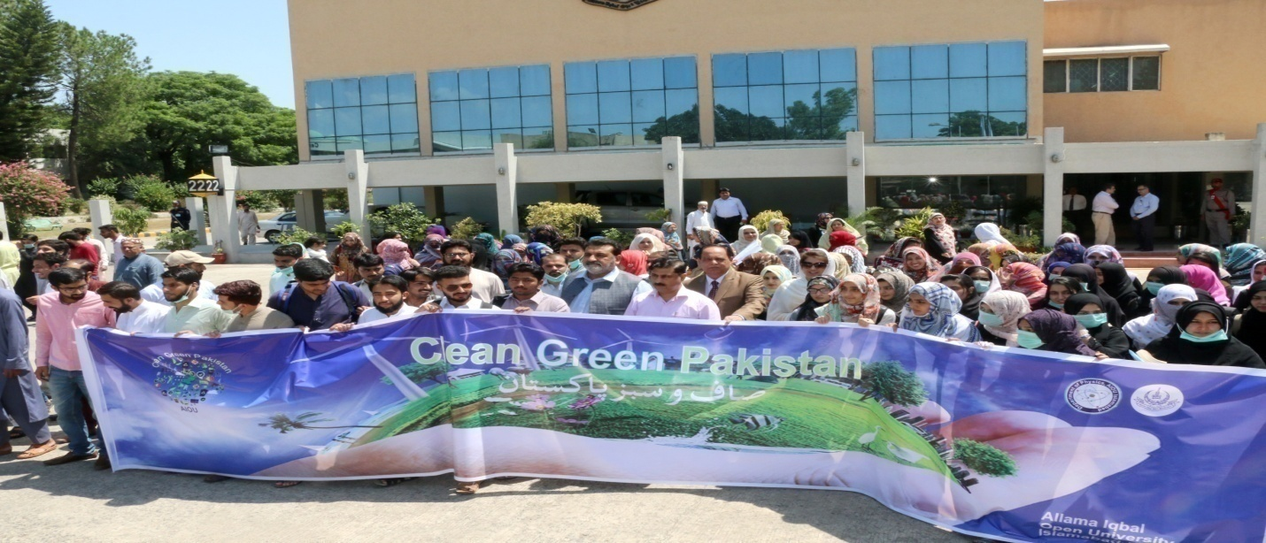
- AIOU Olive tree plantation drive at Main Campus, Islamabad

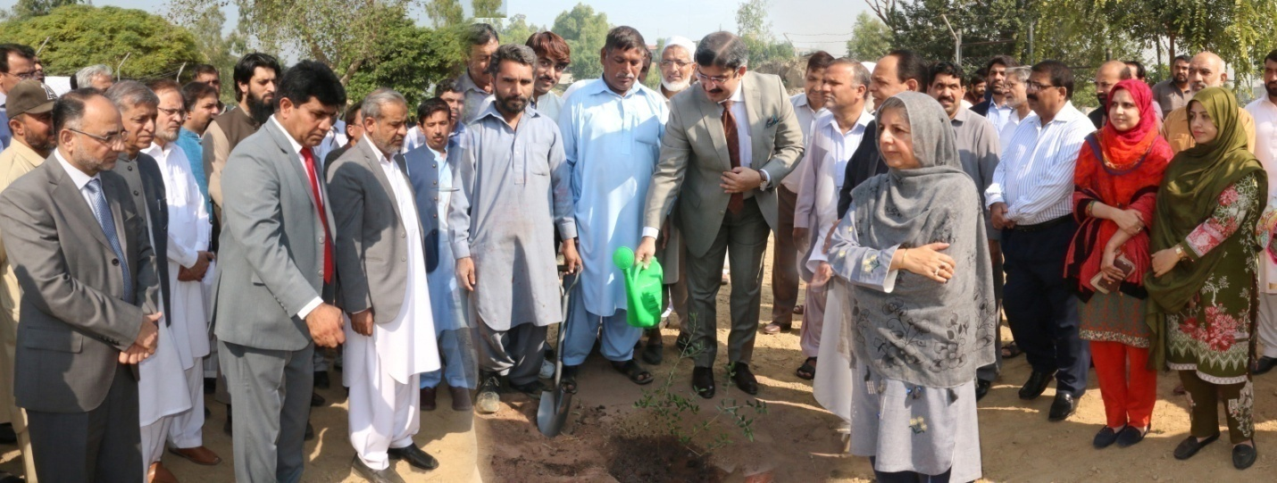
- Spring Tree Plantation Campaign begins at AIOU
https://www.pakistanpoint.com/en/story/576085/spring-tree-plantation-campaign-begins-at-allama-iqbal.html
- Free Accessible Lecturers on SDG 13
- https://www.youtube.com/watch?v=UhO8XHFUcDg

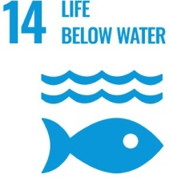
SUSTAINABLE DEVELOPMENT GOAL 14 – LIFE BELOW WATER

Conserve and sustainably use the oceans, seas and marine resources for sustainable development

- RESEARCH & INNOVATION
- The university can proudly boast the work of its faculty members in the context of LIFE BELOW WATER as in the last 10 years university has published 2 Research Publications that are relevant to target SDG 14.
- 02 Research grants have been won by the various faculty members that are relevant to target SDG 14.
- TEACHING & STUDENTS
- Various departments of the university are running about 08 academic courses that are relevant to SDG 14.
- Link to course inventory http://oric.aiou.edu.pk/?page_id=1748
- OPERATIONS
- The department of Agricultural Sciences is eagerly working with all their resources for LIFE BELOW WATER by offering various academic courses, publications, activities and student internships. Overall, 08 faculty members are currently engaged in the working of this SDG and adding their due share in the betterment of life of people.

- Free Accessible Lecturers on SDG 14
- https://www.youtube.com/watch?v=UhO8XHFUcDg

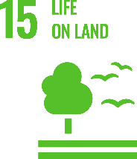
SUSTAINABLE DEVELOPMENT GOAL 15 – LIFE ON LAND

Protect, restore and promote sustainable use of terrestrial ecosystems, sustainably manage forests, combat desertification, and halt and reverse land degradation and halt biodiversity loss

- RESEARCH & INNOVATION
- The university can proudly boast the work of its faculty members in the context of LIFE ON LAND as in the last 10 years university has published 32 Research Publications that are relevant to this SDG 15.
- 03 Research grants have been won by the various faculty members that are relevant to SDG 15.
- TEACHING & STUDENTS
- Various departments of the university are running about 27 academic courses that are relevant to SDG 15.
- Link to course inventory http://oric.aiou.edu.pk/?page_id=1748
- OPERATIONS
- The department of Agricultural Sciences, Department of Biology and Department of Environmental Sciences are eagerly working with all their resources for LIFE ON LAND by offering various academic courses, publications, activities and student internships. Overall, 16 faculty members are currently engaged in the working of this SDG and adding their due share in the betterment of life of people.
- UNIVERSITY ACTIVITY/NEWS RELATED TO SDG
- Green Pakistan: AIOU holds plantation drive
https://tribune.com.pk/story/1661390/green-pakistan-AIOU-holds-plantation-drive
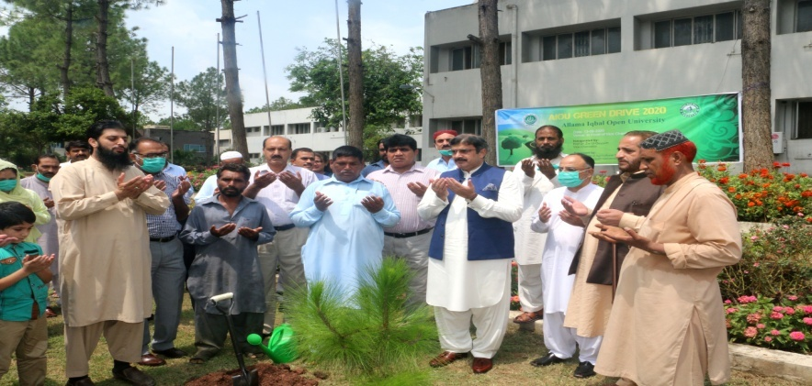
- AIOU holds awareness walk for PM’s Green Pakistan campaign
https://dailytimes.com.pk/335388/AIOU-holds-awareness-walk-for-pms-green-pakistan-campaign/
- AIOU Olive tree plantation drive at Main Campus, Islamabad

- Spring Tree Plantation Campaign begins at AIOU
https://www.pakistanpoint.com/en/story/576085/spring-tree-plantation-campaign-begins-at-allama-iqbal.html
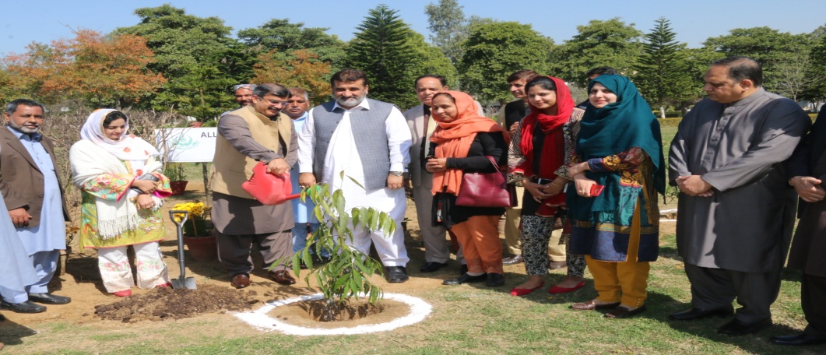
- Free Accessible Lecturers on SDG 15
https://www.youtube.com/watch?v=UhO8XHFUcDg

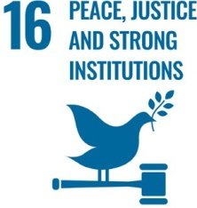
SUSTAINABLE DEVELOPMENT GOAL 16 – PEACE, JUSTICE AND STRONG INSTITUTIONS

Promote peaceful and inclusive societies for sustainable development, provide access to justice for all and build effective, accountable and inclusive institutions at all levels

- RESEARCH & INNOVATION
- The university can proudly boast the work of its faculty members in the context of PEACE, JUSTICE AND STRONG INSTITUTIONS as in the last 10 years university has published 34 Research Publications that are relevant to SDG 16.
- 03 Research grants have been won by the various faculty members that are relevant to SDG 16.
- TEACHING & STUDENTS
- Various departments of the university are running about 10 courses that are relevant to SDG 16.
- Link to course inventory http://oric.aiou.edu.pk/?page_id=1748
- OPERATIONS
- The department of Sociology, Law Department and Department of Islamic Jurisprudence are eagerly working with all their resources for PEACE, JUSTICE AND STRONG INSTITUTIONS by various courses, publications, activities and student internships. Overall, 09 faculty members are currently engaged in the working of this SDG and adding their due share in the betterment of life of people
- UNIVERSITY ACTIVITY/NEWS RELATED TO SDG
- AIOU holds solidarity walk to project Kashmir cause
https://www.thenews.com.pk/print/610211-AIOU-holds-solidarity-walk-to-project-kashmir-cause

- Christmas Celebration at AIOU

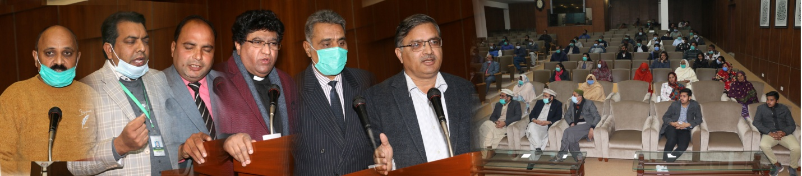
- Free Accessible Lecturers on SDG 16
https://www.youtube.com/watch?v=UhO8XHFUcDg

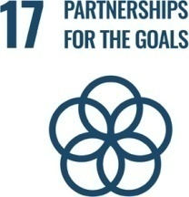
SUSTAINABLE DEVELOPMENT GOAL 17 – PARTNERSHIPS FOR THE GOALS

Strengthen the means of implementation and revitalize the global partnership for sustainable development

- RESEARCH & INNOVATION
- The university can proudly boast the work of its faculty members in the context of PARTNERSHIPS FOR THE GOALS as in the last 10 years the university has published 16 Research Publications that are relevant to SDG 17.
- 06 Research grants have been won by the various faculty members that are relevant to SDG 17.

- TEACHING & STUDENTS
- Various departments of the university are running about 5 courses that are relevant to SDG 17.
- Link to course inventory http://oric.aiou.edu.pk/?page_id=1748

- OPERATIONS
- The faculty of sciences, faculty of education, department of Business Administration and Commerce Department are eagerly working with all their resources for PARTNERSHIPS FOR THE GOALS by offering various academic courses, publications, activities and student internships. Overall, 114 faculty members are currently engaged in the working of this SDG and adding their due share in the betterment of life of people.

- OUTREACH & PARTNERSHIP
- The International collaborations with the other academic institutes are as follow:
- USEFP Fulbright Scholarship
- Commonwealth
- Association of Commonwealth Universities (ACU) / Chevening
- Erasmus +
- Australia Award Scholarship
- DAAD, Germany
- Chinese Scholarship Council (CSC)
- Jiangsu University, China
- University of Leicester, UK
- UNIVERSITY ACTIVITY/NEWS
- AIOU to provide education to afghan refugees
https://nation.com.pk/20-apr-2020/AIOU-to-provide-education-to-afghan-refugees

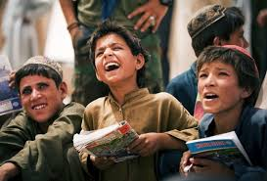

AIOU and Zong ink MoU to facilitate students, employees
https://islamabadpost.com.pk/AIOU-zong-ink-MoU-to-facilitate-students-employees/

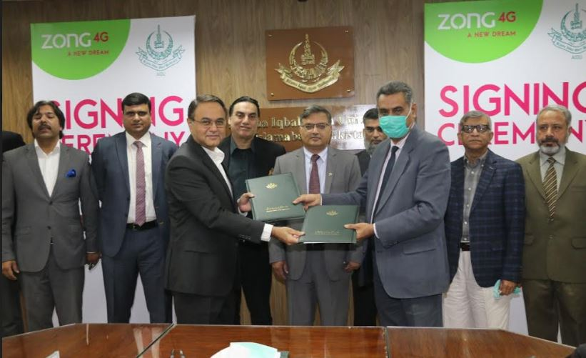

- AIOU signs MOU with Hazara University for cooperation
https://dnanews.com.pk/AIOU-signs-MoU-hazara-university-cooperation/
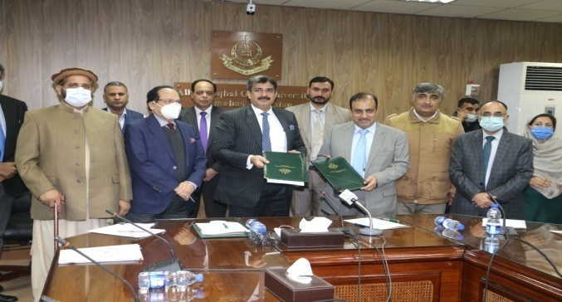

Alight Pakistan signs MOU with AIOU

http://millionkidstoschool.org/p_detail.php?act=news-events&post=alight-pakistan-signs-MoU-with-AIOU&i=iyiwe

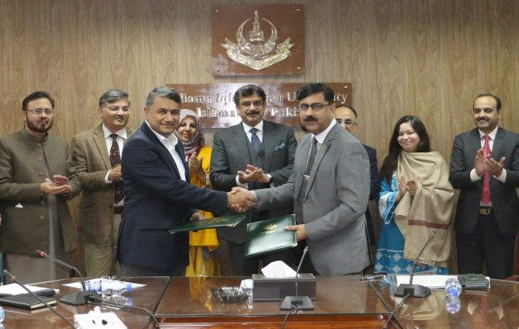

Universitas Terbuka (UT) signed a memorandum of understanding (MOU) with Allama Iqbal Open University (AIOU)

https://www.ut.ac.id/en/news/2019/10/ut-collaborates-AIOU-pakistan

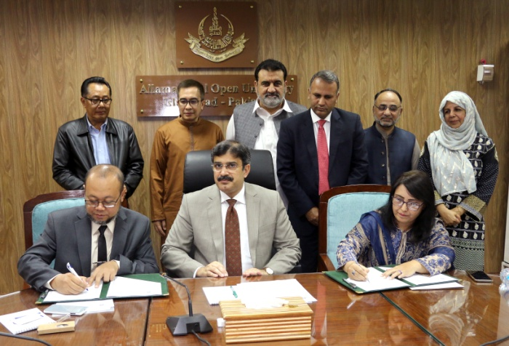
Two Chinese language centers being set up at AIOU

https://dailytimes.com.pk/405677/two-chinese-language-centres-being-set-up-at-AIOU/

- Free Accessible Lecturers on SDG 17
https://www.youtube.com/watch?v=UhO8XHFUcDg

ALLAMA IQBAL OPEN UNIVERSITY, ISLAMABAD PAKISTAN
Office of Research, Innovation & Commercialization (ORIC)

