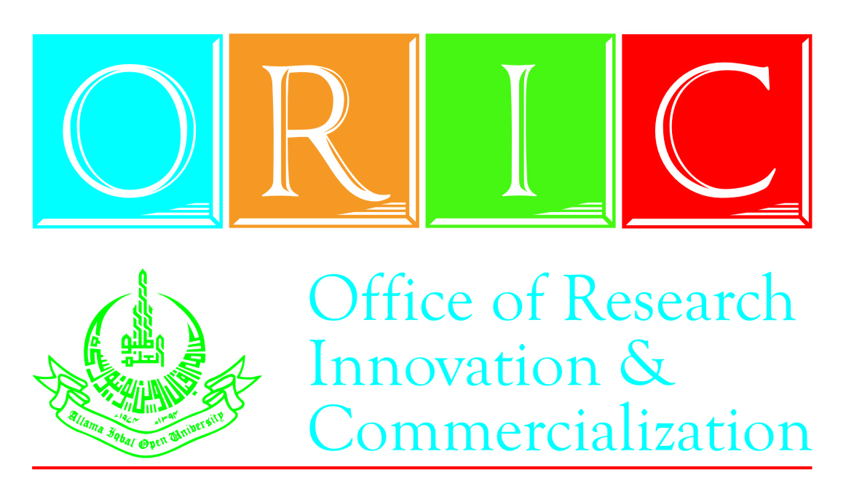
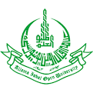
One-Day Seminar on
“Effective Time & Stress Management”
(24th August, 2016)
Office of Research, Innovation and Commercialization
Allama Iqbal Open University, H-8, Islamabad.
Phone: 051-9057419/9057420, Cell: 0300-9797369

REGISTRATION FORM

I intend to participate in a One-Day Seminar on “Effective Time & Stress Management” scheduled to be held on 24th August, 2016 at AIOU. My particulars are as follows:

Name: _______________________________________________
Father’s Name: ________________________________________
Designation (if applicable): __________________________________________
Organization (if applicable): _________________________________________
Tel: _____________________ Cell: ____________________
E-mail: ____________________

Note: Please attach Challan Form (Treasurer`s Copy in original).

Date: ________________ Applicant`s Signature: _________________________

In case of official nomination, kindly fill the following:
Signature: _________________________
(Head of Department)

