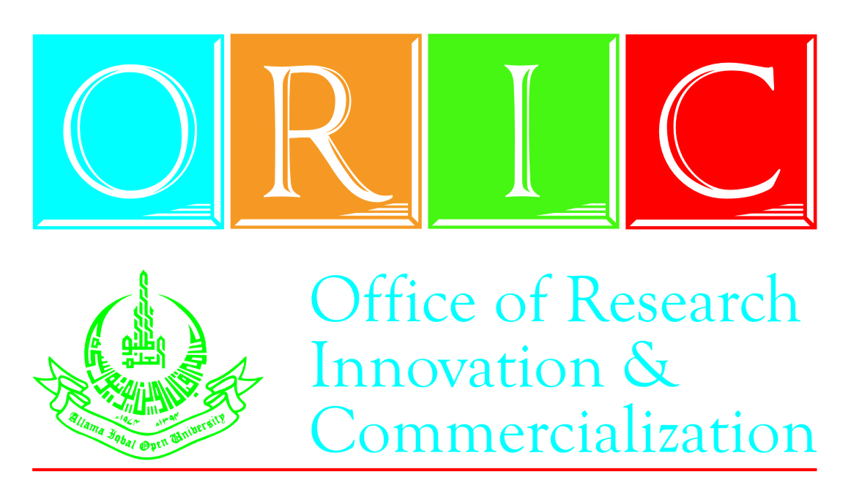
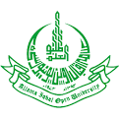
Seminar on
“Effective Time & Stress Management”
(31st August, 2016)
Office of Research, Innovation and Commercialization
Allama Iqbal Open University, H-8, Islamabad.
Phone: 051-9057419/9057420, Cell: 0300-9797369

REGISTRATION FORM
I intend to participate in a One-Day Seminar on “Effective Time & Stress Management” scheduled to be held on 24th August, 2016 at AIOU. My particulars are as follows:

Name: _______________________________________________
Father’s Name: ________________________________________
Designation (if applicable): __________________________________________
Organization (if applicable): _________________________________________
Tel: _____________________ Cell: ____________________
E-mail: ___________________________
Date: ________________ Applicant`s Signature: _________________________
In case of official nomination, kindly fill the following:
Signature: _________________________
(Head of Department)
Registration Process:

- The filled Challan Form in the name of Treasurer, AIOU, Islamabad to be deposited in any branch of Allied Bank Ltd or Muslim Commercial Bank Ltd.
- Filled Registration Form along with Treasurer`s Copy of deposited Challan Form (in original) to be delivered at the address given below by 23rd August 2016:

Mr. S. Athar Hussain
Office of Research Innovation & Commercialization (ORIC)
Block No. 21, Allama Iqbal Open University, Sector H/8, Islamabad
Phone: 051-9057419/9057420. Cell: 0300-9797369

