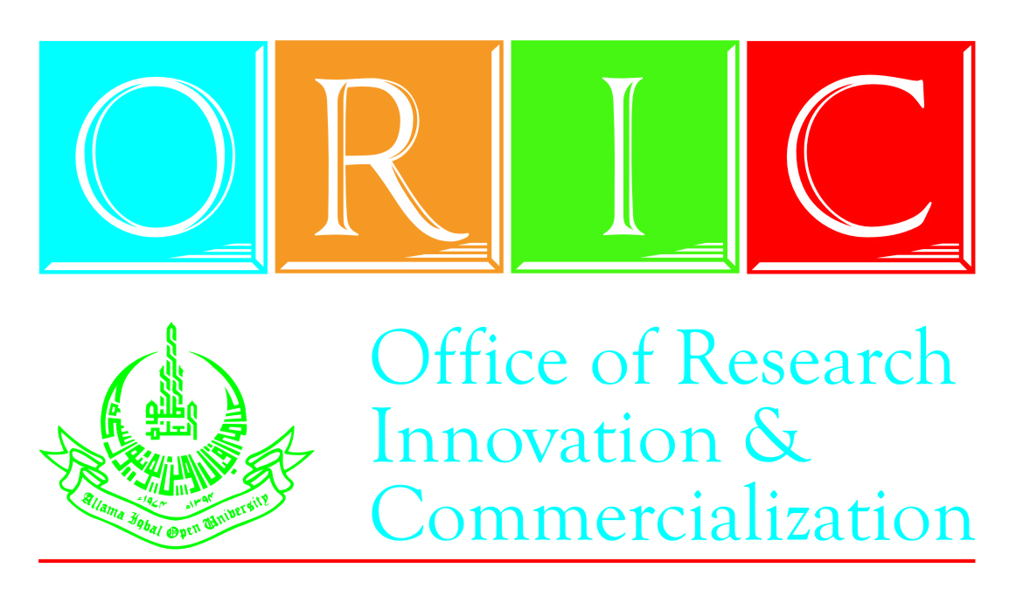
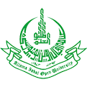
Seminar on “Management Skills for Professionals”
(29th December, 2015)
Office of Research, Innovation and Commercialization
Allama Iqbal Open University, H-8, Islamabad.
Phone: 051-9057423, Cell: 03015980585

REGISTRATION FORM

I intend to participate in the Seminar on “Management Skills for Professionals” to be held on 29th December, 2015 at AIOU. My particulars are as follows:

Name: _______________________________________________
Father’s Name: ________________________________________
Designation: __________________________________________
Organization: _________________________________________
Tel: _____________________ Mobile: ____________________
E-mail: ______________________________________________
Postal Address: _______________________________________
____________________________________________________
____________________________________________________
Attached bank draft/pay order No. _________________________________
dated ___________________ of bank ______________________________
Signature: ________________________ Date: _______________________

Signature: _________________________
(Head of Department)
Date: _____________________________

